Grades 3-5 Korean War Inquiry

Whose Voices Are
Heard in History?

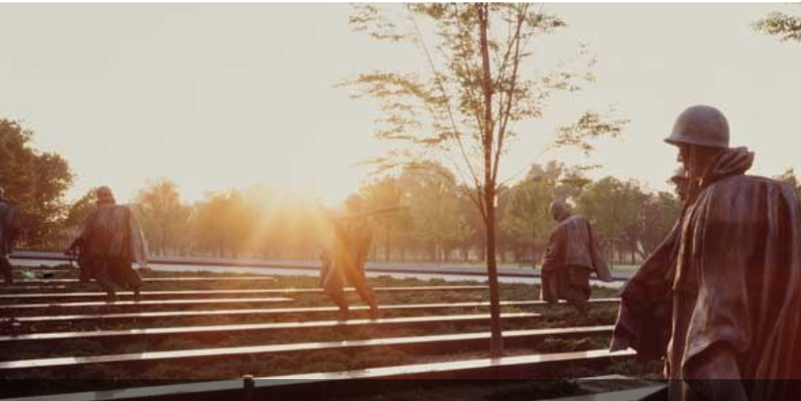

https://www.nps.gov/kowa/

Supporting Questions
    - Whose experiences are recognized in Korean War monuments?
    - What role did soldiers of color play in the Korean War?
    - What contributions did women make to the Korean War?
    - Why are some voices omitted in the telling and honoring of history?

Grades 3-5 Korean War Inquiry

Whose Voices Are Heard in History?

C3 Framework Indicators | D2.His.3.3-5. Generate questions about individuals and groups who have shaped significant historical changes and continuities.  D2.His.16.3-5. Use evidence to develop a claim about the past.
Staging the Compelling Question | Examine a photograph of a Korean War monument from the National Mall. Consider the race, gender, age, and nationality of the people memorialized.  https://www.nps.gov/kowa/index.htm

Understand |  |  |  |  |  | Assess
Supporting Question 1 |  | Supporting Question 2 |  | Supporting Question 3 |  | Supporting Question 4
Whose experiences are recognized in Korean War Monuments? |  | What role did soldiers of color play in the Korean War? |  | What contributions did women make to the Korean War? |  | Why are some voices omitted in the telling and honoring of history?
Formative Performance Task |  | Formative Performance Task |  | Formative Performance Task |  | Formative Performance Task
Create a list of the groups of people you see in the monument. |  | Create a table organizing examples of contributions that people of color made in the Korean War. |  | Identify three quotes from women regarding their roles and positions in, and contributions to, the Korean War. |  | Write a one-paragraph summary of each of these articles’ claims and the evidence they provide.
Featured Sources |  | Featured Sources |  | Featured Sources |  | Featured Sources
Source A: Image of, and artist’s design rationale for, Washington State Memorial  Source B: Image, New Jersey State Memorial  Source C: Image, Harry S. Truman at a war memorial in St. Joseph, Missouri |  | Source A: Oral history, Congressman Charles Rangel  Source B: Image and link, Patriot Nations exhibit, National Museum of the American Indian  Source C: Fact sheet, African Americans in the Korean War |  | Source A: Oral history, Voelia “Jean” Thompson  Source B: Oral history, Shirley Toepfer  Source C: Oral history, Mary Reid |  | Source A: Excerpt from article, “Whitewashing the Past”  Source B: Excerpt from article, “Army Removes Cloud Over Black Korean War Unit”

Summative Performance Task | ARGUMENT Construct an argument (e.g., detailed outline, poster, or essay) that discusses the compelling question using specific claims and relevant evidence from historical sources while acknowledging competing views.
Taking Informed Action | ACT Create an oral history project to contribute to the KWDH archives that adds to the diversity of the collection.

Overview

Inquiry Description
This inquiry leads students through an investigation of the Korean War by investigating the compelling question “Whose voices are heard in history?” through the evaluation of oral histories, newspaper articles, photographs, and monuments. The formative performance tasks build on knowledge and skills through the course of the inquiry and help students identify points of view that are either present or missing in historical narratives. Students create an evidence-based argument about why some voices are left out of history.
It is important to note that this inquiry requires prerequisite knowledge of historical events and ideas. Thus, students should have been introduced to the ideas of historical perspectives and point of view prior to completing this inquiry.
NOTE: This inquiry is expected to take four to five 30 minute class periods. The inquiry time frame could expand if teachers think their students need additional instructional experiences (i.e., supporting questions, formative performance tasks, and featured sources). Teachers are encouraged to adapt the inquiries​ in order to meet the requirements and interests of their particular students. Resources can also be modified as necessary to meet individualized education programs (IEPs) or Section 504 plans for students with disabilities.

Structure of the Inquiry
In addressing the compelling question—“Whose voices are heard in history?”—students work through a series of supporting questions, formative performance tasks, and featured sources in order to construct an argument supported by evidence while acknowledging competing perspectives.

Staging the Compelling Question
In staging the compelling question—“Whose voices are heard in history?”—teachers may prompt students by looking at the Korean War Monument on the National Mall in Washington, DC, and considering who is included. Who is memorialized in this monument?
If students lack grounding in the idea of historical perspectives, teachers may also lead students through an activity to challenge them to consider that history is subjective rather than objective, and that some voices and experiences have been more highly valued than others.

Supporting Question 1
The first supporting question—“Whose experiences are shown in Korean War Monuments?”—has students identify the groups of people present in memorialization of the Korean War by considering the genders, races, nationalities, and ages of the people depicted in the monument. The formative performance task asks students to list these groups of people and notice trends. The featured sources for this question are all images of Korean War Monuments; the selected images represent geographic diversity and the wide variety of stylistic choices. Students analyze the memorial in Washington, DC’s National Mall in the staging activity, so these sources look at state and local Korean War memorials. Source A is an image of the Washington State Korean War Memorial and the artist’s statement explaining her design rationale. Source B is an image of the New Jersey State Korean War Memorial and Source C is an image of President Harry S. Truman in front of a memorial in St. Joseph, Missouri. These are just a small sampling of the hundreds of Korean War Memorials around the country and the world.
Supporting Question 2
To answer the second supporting question—“What role did soldiers of color play in the Korean War?”—students create a table organizing examples of contributions made by people of color during the war. Building on the resources from the previous supporting question, the featured sources here provide students with additional materials that allow them to construct an understanding of the vast and important contributions of Native American and African American soldiers to US efforts in Korea. Featured Source A is an oral history from Congressman Charles Rangel, who describes his service during the Korean War, the segregation and racism he experienced in the service, and his life after the service. Featured Source B is an image of Master Sergeant Woodrow Wilson Keeble (Eastern Sioux), a highly decorated Native American who served in the Korean War; this source also includes a link to more information and images from the Patriot Nations exhibit at the National Museum of the American Indian (Smithsonian Institution, Washington, DC). Featured Source C is a fact sheet about the many contributions made by African Americans during the Korean War.
Supporting Question 3
The third supporting question—“What contributions did women make to the Korean War?”—asks students to identify at least three quotes from women regarding their roles, positions, and contributions to the war. In addition to the previous featured sources, the sources here highlight the voices and experiences of women during the war. Sources A, B, and C are oral histories collected from three women—Voelia “Jean” Thompson, Shirley Toepfer, and Mary Reid, each of whom served in the military and made unique contributions during the Korean War.

Supporting Question 4
The fourth supporting question—“Why are some voices omitted in the telling and honoring of history?”—asks students to summarize the claims and evidence presented in two featured sources that present reasons and explanations for the exclusion of certain people in the telling of history. Featured Source A is an excerpt from Bob Peterson’s article, “Whitewashing the Past.” Featured Source B is an excerpt from Michael Kilian’s Chicago Tribune article about a Black infantry unit that was recently restored to full honor based on a review that showed their failure on the battlefield during the Korean War was the result of institutional racism.
Summative Performance Task
At this point in the inquiry, students have examined which groups of people are most frequently recognized in public memorials, identified important contributions of women and soldiers of color during the Korean War, and begun to explore why some voices and experiences might be omitted in the telling and honoring of history.
Students should be able to demonstrate the breadth of their understanding and their ability to use evidence from multiple sources to support their claims. In this task, students construct an evidence-based argument using multiple sources to answer the compelling question “Whose voices are heard in history?” Students’ arguments will take a variety of forms, including a detailed outline, poster, or essay.
Students’ arguments will vary, but could include any of the following:
- The voices of women and people of color are largely excluded from history.
- The voices of white men are highlighted throughout history.
- The voices of the “victors” are recorded more than any other voices.
- The American perspective is captured in the dominant narrative of history.
- The experiences of Native Americans are usually omitted from the telling of history.
To extend their arguments, students might rewrite their US history textbook’s passage about the Korean War in a way that is inclusive of a greater number of people and stories, suggest additions or changes that expand our understanding of the diverse groups of people that contributed greatly to the US efforts in the Korean War, or design a Korean War monument that also values the contributions of women and people of color.
Students have the opportunity to Take Informed Action by drawing on their understandings of the voices included and excluded in the dominant narratives in history. To understand, students can explore the Korean War Digital History Project Interview Initiative and identify local veteran groups or other community members who are Korean War veterans. To assess the issue, students can explore the diversity of veterans including their nationalities, genders, and races. Determine the ways in which students can contribute to the initiative. To act, students can create an oral history project to contribute to the KWDH archives, adding to the diversity of the collection.

Staging the Compelling Question
Featured Source | Source A: Images of Korean War Monument on the National Mall, Washington, DC. Additional images and information at: https://www.nps.gov/kowa/learn/index.htm

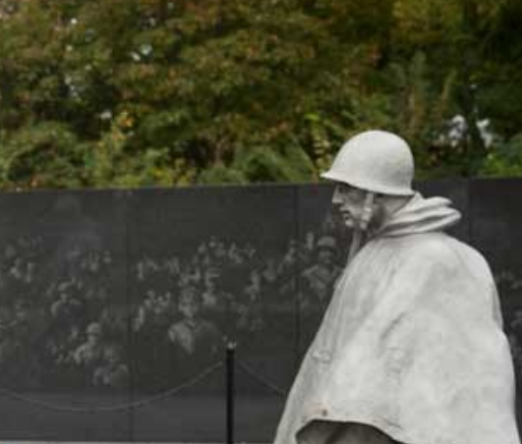
Retrieved from: https://www.nps.gov/kowa/learn/index.htm

Retrieved from: https://www.nps.gov/kowa/learn/index.htm

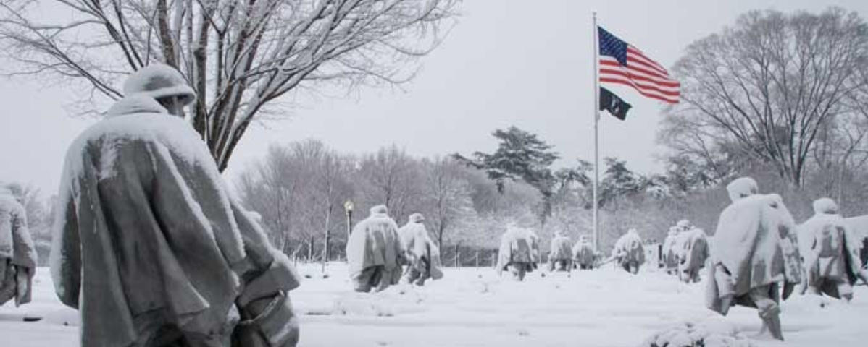
Retrieved from: https://www.nps.gov/kowa/learn/index.htm

Supporting Question 1
Featured Source | Source A: Image of, and artist Deborah Copenhaver Fellow’s design rationale for, the Washington State Korean War Memorial

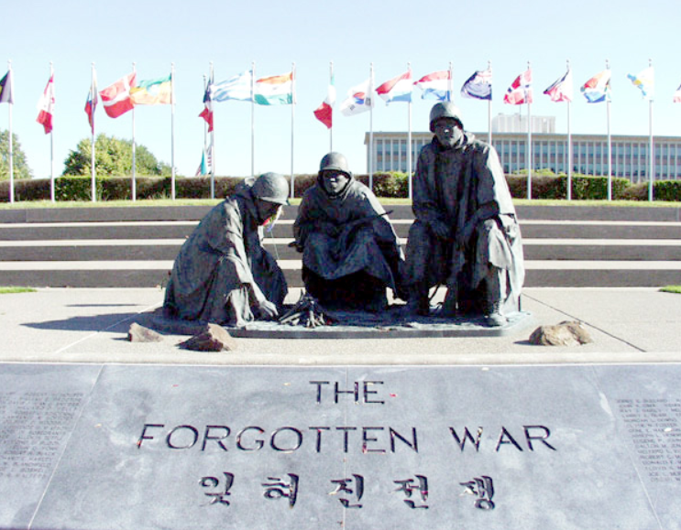

Montana artist Deborah Copenhaver Fellow’s idea was chosen for the memorial after a three-month design competition. Fellow’s father is a Korean War veteran. Her two-ton bronze statue features three weary-faced men of different nationalities huddled around a pile of sticks in the rain, with one soldier attempting to light a fire. Behind the figures fly 22 flags, representing each of the nations that joined the US in the war effort. In front of the bronze statue are stone tablets with the names of those Washington soldiers killed in battle.

The Korean War began on June 25, 1950, when the North Korean Army invaded the Republic of (South) Korea. Three days later, President Harry Truman ordered US troops to help defend South Korea. Soon, and for the first time in history, the United Nations created a United Nations Command to repel the attack. Approximately 1,500,000 American troops served in Korea during the conflict, nearly 53,000 of whom lost their lives. A total of 580,000 United Nations troops were killed, and 1.6 million communist (North Korean and Chinese) soldiers were killed or wounded.

Retrieved from: https://des.wa.gov/services/facilities-leasing/capitol-campus/memorials-and-artwork/korean-war-memorial

Used with permission from the Washington State Department of Enterprise Services

Supporting Question 1
Featured Source | Source B: Image of New Jersey Korean War Memorial

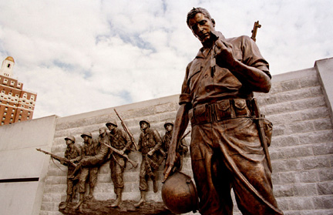

Retrieved from: http://www.kwva.org/memorials/nj/p_mem_nj.htm
Used with permission from KWVA

Supporting Question 1
Featured Source | Source C: Image, President Harry S. Truman standing for a picture during a visit to the war memorial in St. Joseph, Missouri, September 26, 1953 Image, former President

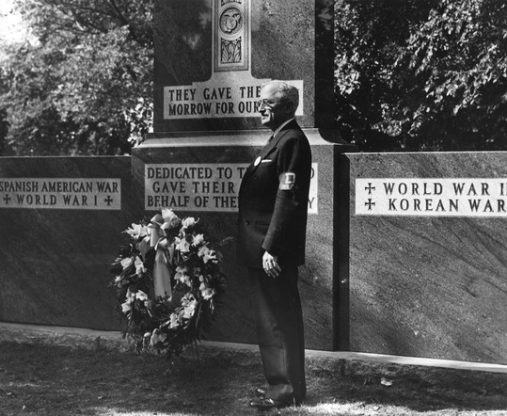

Retrieved from: https://www.trumanlibrary.org/photographs/view.php?id=57945

Credit: Harry S. Truman Library & Museum.

Supporting Question 2
Featured Source | Source A: Oral history, in which Congressman Charles Rangel shares his reflections on serving in the Korean War

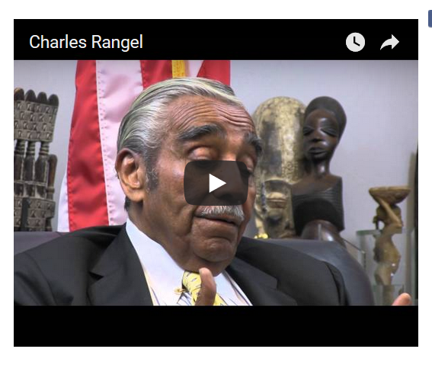
Retrieved from: http://kwvdm.org/detail_oral.php?no=141

Supporting Question 2
Featured Source | Source B: Image, Master Sergeant Woodrow Wilson Keeble (Eastern Sioux), a highly decorated veteran of both World War II and the Korean War, 1955, from the exhibit Patriot Nations: Native Americans in Our Nation’s Armed Forces, National Museum of the American Indian at the Smithsonian Institution; additional images and information at: http://nmai.si.edu/static/patriot-nations/korea-vietnam.html#korea

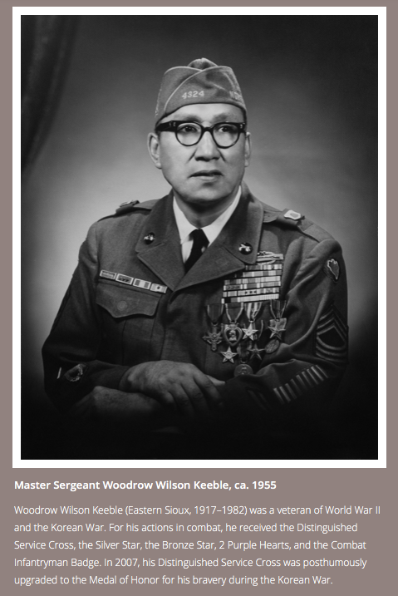

Supporting Question 2
Featured Source | Source C: Fact sheet on African Americans in the Korean War, “The Beginnings of a New Era for African-Americans in the Armed Forces” (excerpt); full text available at:  http://www.nj.gov/military/korea/factsheets/afroamer.html
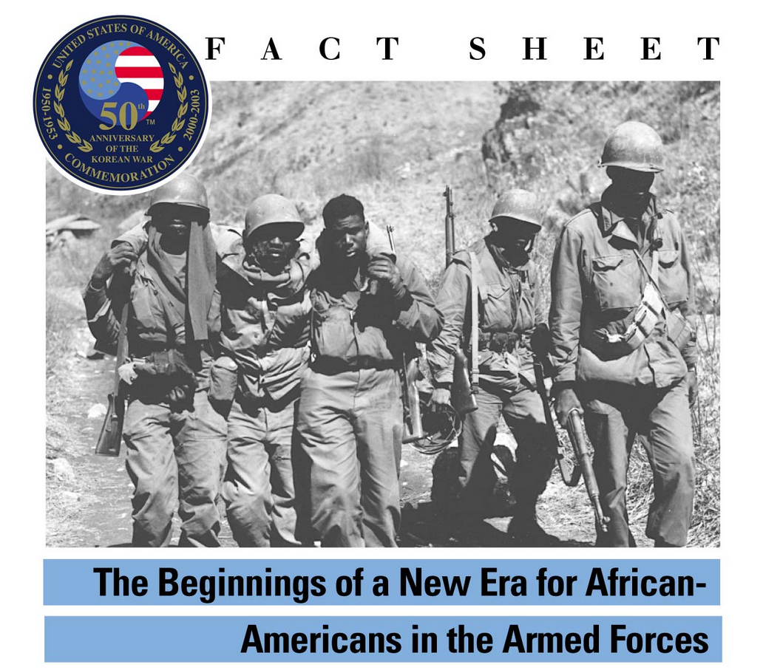
Photo Caption: Buddies aid a wounded man of the 24th Infantry Regiment, 25th Division after a battle 10 miles south of Chorwon.

African-Americans served in all combat and combat service elements during the Korean War and were involved in all major combat operations, including the advance of United Nations Forces to the Chinese border. In June 1950, almost 100,000 African Americans were on active duty in the US armed forces, equaling about 8 percent of total manpower. By the end of the war, probably more than 600,000 African Americans had served in the military.
Changes in the United States, the growth of Black political power and the US Defense Department's realization that African Americans were being underutilized because of racial prejudice led to new opportunities for African Americans serving in the Korean War. In October 1951, the all-Black 24th Infantry Regiment, a unit established in 1869, which had served during the Spanish-American War, World War I, World War II, and the beginning of the Korean War, was disbanded, essentially ending segregation in the US Army. In the last two years of the Korean War throughout the services, hundreds of Blacks held command positions, were posted to elite units such as combat aviation, and served in a variety of technical military specialties. Additionally, more Blacks than may have done so in a segregated military, chose to stay in the armed forces after the war because of the improved social environment, financial benefits, educational opportunities, and promotion potential.
Distinguished Service
African American servicemen distinguished themselves in combat during the ground battles with the North Korean Army and in the air war over Korea. On July 21, 1950, a battalion combat team commanded by Lieutenant Colonel Samuel Pierce, Jr., composed of three infantry companies and an engineer company, recaptured Yech’on.
The action, which received national attention in the United States, was considered the first significant successful offensive operation by the US Army in the war. Captain Charles Bussey, commander of the engineer company, was awarded the Silver Star for having prevented a flanking operation by a North Korean battalion during the battle. Bussey’s platoon-size unit killed more than 250 enemy soldiers. Captain Bussey’s bravery inspired his regiment and exemplified the preparedness and leadership capabilities of African American soldiers.
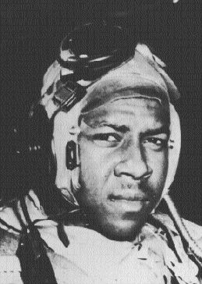

Photo Caption: Ensign Jesse L. Brown, US Navy, in the cockpit of a “Corsair” fighter plane. He was the first Black naval aviator to die in combat and flew with VF-32 from the USS Leyte Gulf (CV-32).

Heroes in the Air War
In 1950, the Air Force had 25 Black pilots in integrated fighter squadrons led by Captain Daniel “Chappie” James, Jr., who was assigned to the 36th Squadron, 5th Air Force. Captain James was an exceptional fighter pilot who often flew his F-86 Sabre jet on dangerous, unarmed reconnaissance missions behind enemy lines—a task reserved for a select group of the most able and trusted flyers. James flew 101 combat missions in Korea and earned the Distinguished Flying Cross before being reassigned stateside. In July 1951, he became the first African American in the Air Force to command a fighter squadron.
Second Lieutenant Frank E. Peterson, Jr., was the first Black Marine Corps pilot. Peterson flew 64 combat missions before the war ended. He earned the Distinguished Flying Cross and six Air Medals in the final months of the Korean War.
Ensign Jesse L. Brown, the Navy’s first African American fighter pilot to die in combat, was shot down while providing close-air support for units of the 7th Marines during the Chosin Reservoir breakout in December 1950. Brown was posthumously awarded the Distinguished Flying Cross for performing dangerous combat actions that resulted in his fatal crash. In March 1972, Brown’s widow christened a Knox-class ocean escort ship the USS Jesse Brown.
African Americans Who Gave Their Lives During the Korean War
Of the more than 600,000 African Americans who served in the armed forces during the Korean War, it is estimated that more than 5,000 died in combat. Because casualty records compiled by the services in the 1950s did not differentiate by race, the exact number of Blacks killed in action cannot be determined.
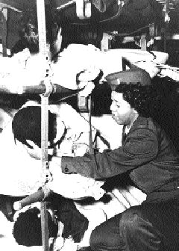
Numerous African Americans were awarded medals including the Distinguished Service Cross, Silver Star, and Bronze Star for service during the Korean War. Two African Americans, Private First Class William Thompson and Sergeant Cornelius Charlton were posthumously awarded the Medal of Honor. Thompson was killed in action on August 2, 1951, at a critical juncture in the 8th Army’s attempt to stop the North Korean Army’s southward movement. Charlton displayed extraordinary heroism in rallying his platoon to continue its assault on a hill near Chipo-ri, just north of the 38th parallel.
The Korean War changed the face of the American military. African Americans served side by side in the same units with service members of all races and were afforded the opportunity to lead in combat.
Photo Caption: A combat wounded soldier gets a helping hand from a flight nurse en route from Korea to Japan aboard the 374th Troop Carrier C-54 "Skymaster." October 1953
In June 1950, almost 100,000 African Americans were on active duty in the US armed forces, equaling about 8 percent of total manpower. In the Army, 9.7 percent of active duty service members were Black, including 72,000 enlisted men and approximately 1,200 officers. In the Air Force, 4.4 percent of active duty personnel were Black, including 21,000 enlisted men and 300 officers. About 6,000 African Americans, or about 3 percent of personnel, served in the Navy and Marine Corps. By the end of the war, probably more than 600,000 Blacks had served in the armed forces.

Used with permission from the State of New Jersey

Supporting Question 3
Featured Source | Source A: Oral history, interview with Voelia “Jean” Thompson, a Korean War Air Force veteran who was later stationed in Japan as a top-secret control officer; the full interview can be accessed at http://koreanwarlegacy.org/interviews/voelia-jean-thompson/
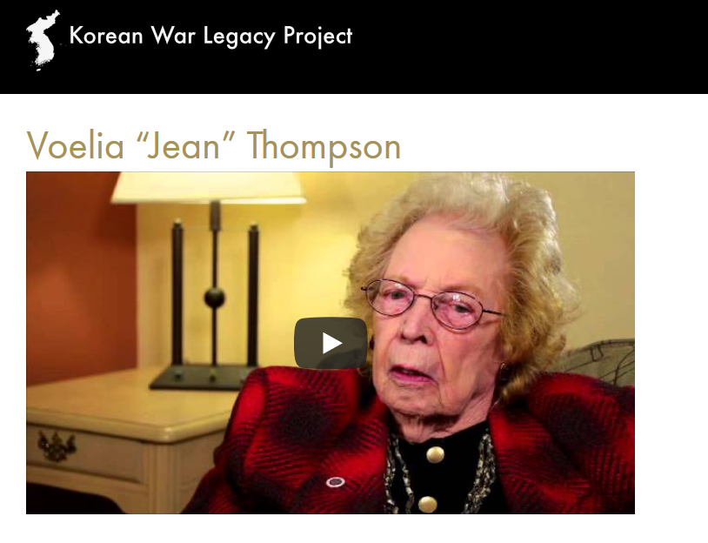
Retrieved from: http://koreanwarlegacy.org/interviews/voelia-jean-thompson/
Used with permission from the Korean War Legacy Project

Supporting Question 3
Featured Source | Source B: Oral history, interview with Shirley Toepfer, a Korean War Army veteran who worked with the counter-intelligence detachment; the full interview can be accessed at http://koreanwarlegacy.org/interviews/shirley-toepfer/
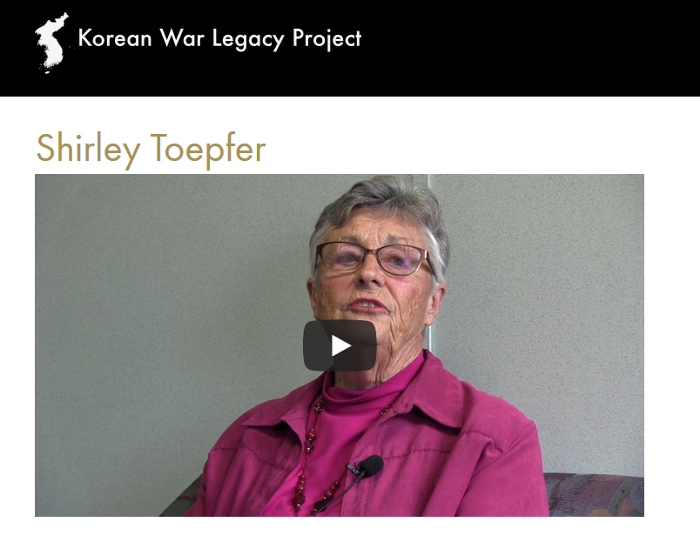
Retrieved from: http://koreanwarlegacy.org/interviews/shirley-toepfer/
Used with permission from the Korean War Legacy Project
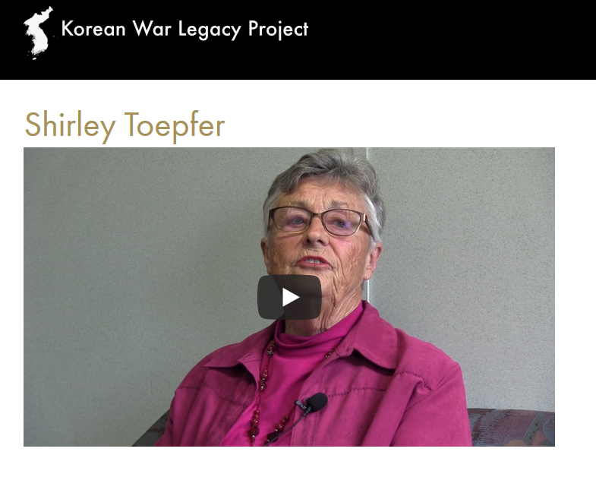

Supporting Question 3
Featured Source | Source C: Oral history, interview with Mary Reid, a Korean War veteran who served as an Army nurse in Korea during the war; the full interview can be accessed at http://koreanwarlegacy.org/interviews/mary-reid/

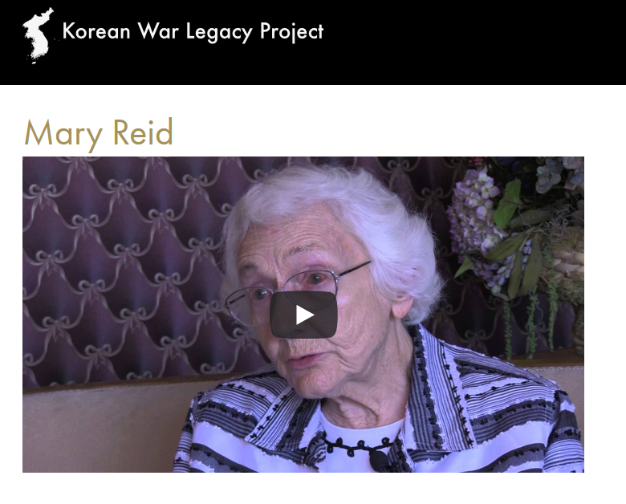
Retrieved from: http://koreanwarlegacy.org/interviews/mary-reid/
Used with permission from the Korean War Legacy Project

Supporting Question 4
Featured Source | Source A: Article, “Whitewashing the Past” (excerpt), Bob Peterson, from Rethinking Schools, (www.rethinkingschools.org), Vol. 23, No. 1, Fall 2008

Ever since the Civil Rights Movement, there has been grassroots pressure by educators and community activists to change the textbooks used in US schools. Progress was made. Blatantly racist references to Africa and favorable comments about slavery were eliminated, photos were diversified, and stories of famous African Americans and women started appearing, if not in the main text, at least in scattered sidebars. Despite improvements, however, most mainstream social studies textbooks remain tethered to sanitized versions of history that bore students and mislead young minds.
This was brought home to me in 2008 when I examined the social studies textbook series being considered for adoption by the Milwaukee Public Schools. The books were from the dwindling constellation of large textbook publishers—Houghton Mifflin, Macmillan McGraw-Hill, and Scott Foresman. In keeping with state social studies standards, the 5th-grade textbooks in each series focus on United States history. Even though publishers make claims about being “multicultural” and honoring our nation’s “diversity,” none of the 5th-grade United States history textbooks—even those exceeding 800 pages—examines the role of racism in US history or even mentions the word “racism.” In two textbooks, the word “discrimination” doesn’t even appear. Nor do the texts tell students that any United States president ever owned slaves, even though 12 of the first 18 did, and all of the two-term presidents up until Lincoln owned and sold human beings.
As my colleagues and I examined the books more closely, a picture emerged that profoundly disturbed us. With important issues like racism, inequality, and conquest falling through the cracks of the historical narrative, there is little reason to recount the resistance to those types of oppression. There are occasional terse summations of resistance, but the bountiful history of people working together, crossing racial boundaries, and building social movements to make this country more democratic and just is omitted. Instead, history is more often viewed from the vantage point of the rich and powerful, the conquerors.

Used with permission from Rethinking Schools

Supporting Question 4
Featured Source | Source B: Article, “Army Removes Cloud Over Black Korean War Unit” (excerpt), Michael Kilian, Washington Bureau, Chicago Tribune, April 30, 1996; full article accessible at:  http://articles.chicagotribune.com/1996-04-30/news/9604300190_1_24th-infantry-regiment-white-units-official-army-report
WASHINGTON — An all-black U.S. Army infantry regiment, disbanded and singled out for cowardice and unreliability in the Korean War, has had its honor restored in an official Army report made public Monday.
Its failures were directly attributable to neglect, inferior white leadership and institutional racism, according to the study, which is based on 400 interviews and took nine years to complete.

Excerpted from full story: http://articles.chicagotribune.com/1996-04-30/news/9604300190_1_24th-infantry-regiment-white-u

