Grades 9-12 Korean War Inquiry

How Should We Talk with North Korea?

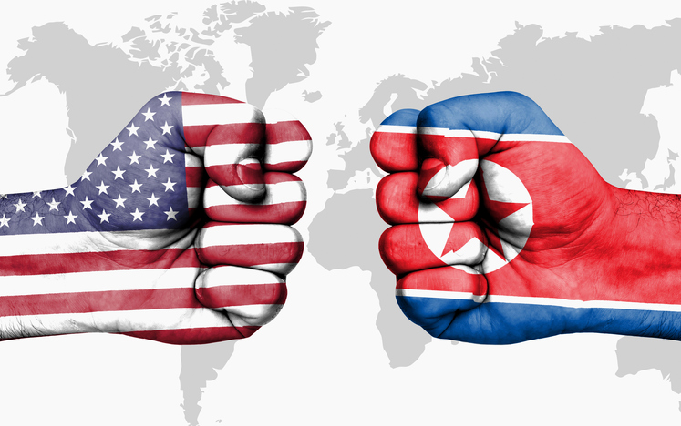

Supporting Questions
    - How has the United States talked with North Korea?
    - What are the advantages and disadvantages of how the United States talks with North Korea?
    - How is the United States talking with North Korea right now?

Grades 9-12 Korean War Inquiry
How Should We Talk with North Korea?
C3 Framework Indicator | D2.Civ.6.9-12. Critique relationships among governments, civil societies, and economic markets.
Staging the Compelling Question | Analyze a series of political cartoons about the relationship between the United States and North Korea to make inferences about tensions in the relationship.

Supporting Question 1 |  | Supporting Question 2 |  | Supporting Question 3
How has the United States talked with North Korea? |  | What are the advantages and disadvantages of how the United States talks with North Korea? |  | How is the United States talking with North Korea right now? (Research Opportunity)
Formative  Performance Task |  | Formative  Performance Task |  | Formative  Performance Task
List the approaches used by the United States when talking with North Korea and provide examples of each. |  | Create a graphic organizer that lists both benefits and drawbacks to the approaches of talking with North Korea. |  | Update the graphic organizer by adding benefits and drawbacks to how the United States is talking with North Korea right now.
Featured Sources |  | Featured Sources |  | Featured Sources
Source A: Article by Priyanka Boghani, “The US and North Korea on the Brink: A Timeline,” PBS Frontline, April 18, 2018  Source B: Article by Arshad Mohammed and Matt Spetalnick, “US Pursues Direct Diplomacy with North Korea Despite Trump Rejection,” Reuters, October 31, 2017  Source C: Tweets from President Donald Trump about North Korea, January 2, 2018  Source D: Video excerpt highlighting what the US wants the United Nations to do with North Korea: "Inside Story: Are US and North Korea on the verge of nuclear war?" |  | Source A: Article by Michael E. O’Hanlon, “Americans Have Military Options for North Korea (but They’re All Bad),” National Interest, January 4, 2018  Source B: Article by Russell Korobkin, “Why a Petulant, Erratic Trump May Succeed in North Korea,” Los Angeles Times, August 11, 2017  Source C: Video debate between former ambassadors and nuclear negotiators Robert L. Gallucci and Christopher Hill, hosted by and held at the Asia Society, March 22, 2018 |  | Sources will vary.

Summative Performance Task | ARGUMENT How should we talk with North Korea? Construct a claim and a counterclaim that address the compelling question using evidence.
 | EXTENSION Have an informed conversation with an adult about how we should talk with North Korea.

Overview

Inquiry Description
The compelling questions for this inquiry call on students is to research the history of diplomatic relations between the United States and North Korea. How to talk with North Korea has been an important diplomatic question for US presidents from Truman to Trump. At times that question has been answered with the use of direct diplomacy with North Korea, and at other times with the use of indirect diplomacy—compelling other countries to impose sanctions and other punitive measures on North Korea. At the present time, Kim Jong-un, the current leader of North Korea, has pushed forward on nuclear armament at a much faster pace than his predecessors, fueled by worsening political relations with the international community. Additionally, despite assertions that North Korea would have to choose between its pursuit of nuclear weapons and its economic development, the North Korean economy has continued to grow amid worsening sanctions and waning international trade. These developments have brought the relationship between the United States and North Korea to the forefront of international relations. Students will attempt to understand how we have talked—and are talking—with North Korea, weighing the benefits and drawbacks of each approach to answer the question, “How should the United States talk with North Korea, and why is it important in the resolution of North Korean issues?”

NOTE: This inquiry is expected to take three to five 50-minute class periods. The inquiry time frame could expand if teachers think their students need additional instructional experiences (i.e., supporting questions, formative performance tasks, and featured sources). Inquiries are not scripts, so teachers are encouraged to modify and adapt them​ in order to meet the needs and interests of their particular students. Resources can also be modified as necessary to meet individualized education programs (IEPs) or Section 504 plans for students with disabilities.

Structure of the Inquiry
In addressing the compelling question, “How should the United States talk with North Korea?,” students will work through supporting questions, a performance task, and a number of sources in order to construct a claim and counterclaim with evidence.

Staging the Compelling Question

The focused inquiry opens with students analyzing a series of political cartoons that parody the relationship between US President Donald Trump and Kim Jong-un of North Korea. In analyzing the sources, students will make inferences about the state of diplomatic relations between the two leaders, and what the impact of that relationship might be. Teachers may want students to analyze the political cartoons by using the National Archives’ political cartoon analysis worksheet at:

https://www.archives.gov/files/education/lessons/worksheets/cartoon_analysis_worksheet_former.pdf

Supporting Question 1

The first supporting question, “How does the United States talk with North Korea?,” helps students build content knowledge by having them review the different ways in which the United States has attempted to talk with (or about) North Korea. The formative performance task calls on students to list the different approaches used by the United States when talking with North Korea, and give an example of each. Featured Source A is an article from PBS Frontline that has students examine the different tactics the US government has used to talk with North Korea since the ceasefire in the Korean War. Source B is a Reuters article that explores how the United States is still pursuing a diplomatic relationship with North Korea, even as President Trump is taking a hardline stance through social media. Source C consists of two tweets that President Trump sent on January 2, 2018. The first discusses a meeting between North and South Korea, while the second attacks North Korea for its testing of Intercontinental Ballistic Missiles (ICBMs), with Trump alluding to the superiority of the United States’ nuclear arsenal. Teachers may want to point out that the president sent the tweets under his @realDonaldTrump twitter handle and not the official presidential account, @POTUS. Source D is an Al Jazeera article that discusses the ways in which the United States, especially President Trump, talks to and about North Korea, and how those linguistic choices are interpreted by North Koreans and others.

Supporting Question 2

Building from the first supporting question, the second supporting question, “What are the advantages and disadvantages of how the United States talks with Korea?,” has students create a graphic organizer that lists possible benefits and drawbacks to the different approaches the United States has used in talking with North Korea. Ultimately, students will have to weigh those benefits and drawbacks when answering the compelling question. Featured Source A is an op-ed piece by Michael E. O’Hanlon, Senior Fellow for Foreign Policy at the Brookings Institution. O’Hanlon discusses the pros and cons of potential military options against North Korea and why none are likely to solve the problem. Featured Source B is an article by Russell Korobkin published by the Los Angeles Times; Korobkin explains how President Trump’s unconventional approach to communication might be effective in his talks with Kim Jong-un. Source C is a video debate, hosted by the Asia Society, between former ambassadors and nuclear negotiators Robert L. Gallucci and Christopher Hill in which they discuss their experiences and lessons learned while negotiating with North Korea.

Supporting Question 3
The third supporting question, “How is the United States talking with North Korea right now?,” asks students to research current articles that detail the way the United States currently engages with North Korea. Students will use information from relevant articles to add to their graphic organizer and strengthen their argument before answering the compelling question. The need for a third supporting question in this inquiry is due to the volatile nature of the relationship between the United States and North Korea, in which the two countries vacillate between the brink of war and civil diplomacy with disconcerting frequency. Thus the third supporting question focuses on examining the way the relationship is changing in as close to real time as possible. Sources will vary, but teachers will want to encourage students to evaluate each with respect to credibility and bias.

Summative Performance Task

In the summative performance task, students construct an evidence-based argument responding to the prompt, “How should the United States talk with North Korea?” Teachers will want to have students focus their responses by referring to the graphic organizers they created for this inquiry. In this focused inquiry, students are asked to develop a claim and counterclaim supported by evidence they examined during the inquiry. Students’ arguments will vary, but could include any of the following:
- The United States should take a strong stance when talking with North Korea. Diplomatic relations with the country have been difficult for many years, and with North Korea developing nuclear capabilities, the stakes are extremely high.
- The United States should take a strong stance when talking with North Korea. Although war would not be ideal, the threat of North Korea’s growing nuclear capabilities is too great a risk to the United States, our partners in Asia (including South Korea), and to the world.
- The United States should take a strong stance when talking with North Korea, but must use the appropriate channels for defining that stance—not twitter statements by the President.
- The United States should take a diplomatic stance when talking with Korea, because diplomacy represents the wishes of our partners in the region, including South Korea and Japan, and is promoted also by China and Russia.
- The United States should take a diplomatic stance when talking with Korea. While diplomatic relations have fallen through in the past, an invasion of North Korea could have negative consequences for US relations in the region and for our allies, such as South Korea and Japan.
- The United States should not talk with North Korea, but instead focus on talking with other countries, especially China, to put sanctions and other punitive measures on North Korea for its continued pursuit of a nuclear weapons program.
Students could extend these arguments by having an informed conversation about how the United States should talk with North Korea.

Staging the Compelling Question
Featured Source | Michael Cavna, collection of four political cartoons depicting the current relationship between the United States and North Korea, Washington Post, compiled August, 9, 2017

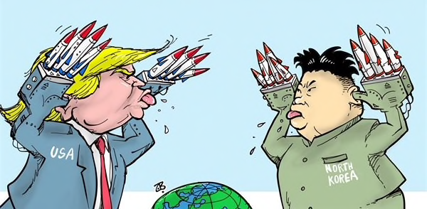
by Emad Hajjaj/Jordan (CagleCartoons.com) 2017

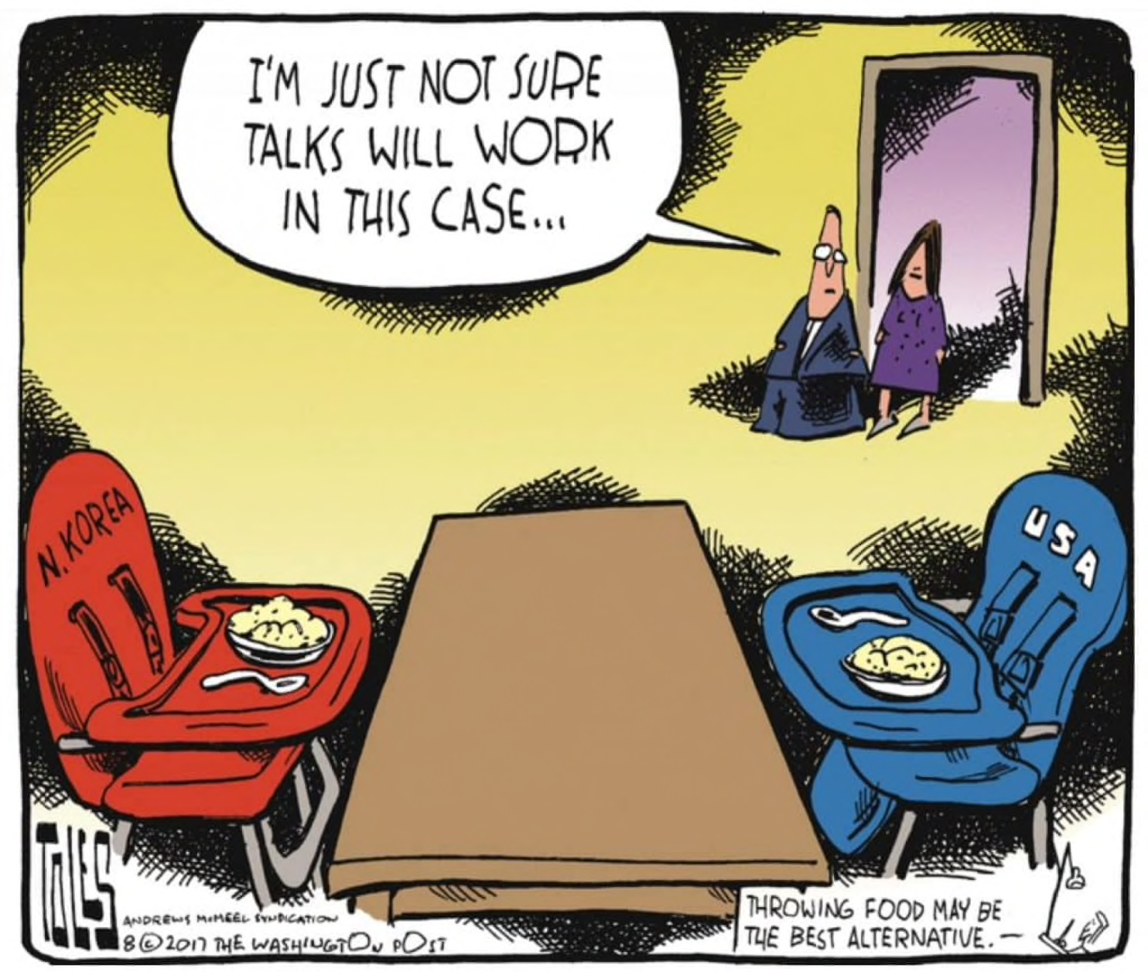
by Tom Toles/The Washington Post 2017

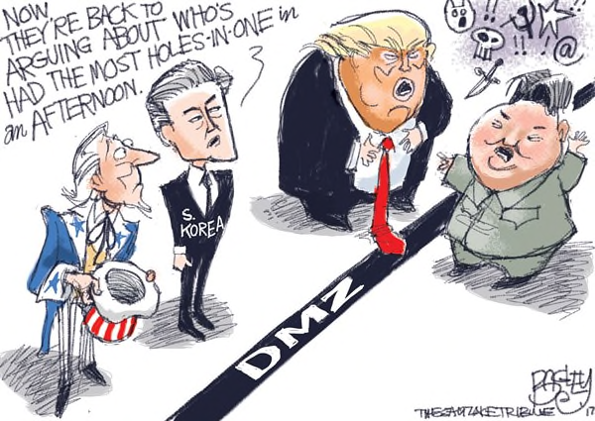

by Pat Bagley/Salt Lake Tribune (CagleCartoons.com) 2017

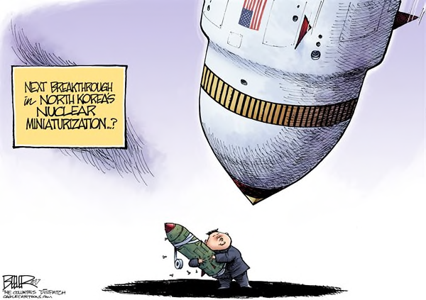

by Nate Beeler/Columbus Dispatch (CagleCartoons.com) 2017

The full document can be accessed here: https://www.washingtonpost.com/news/comic-riffs/wp/2017/08/09/how-trump-and-north-korea-are-skewered-with-satires-fire-and-fury-according-to-cartoons/?utm_term=.7c002d344cc4

Supporting Question 1
Featured Source | Source A: Priyanka Boghani, timeline-format article detailing the state of relations between the United States and North Korea, “The US and North Korea on the Brink: A Timeline,” PBS Frontline, April 18, 2018
The last few months have seen President Donald Trump and North Korean leader Kim Jong-un locked in an escalating war of words. As the rhetoric has intensified, so have fears that words could spill over into military confrontation.
Threats, sanctions and missile tests are not new developments in the US-North Korea relationship. What’s different now, experts say, is that the gap in knowledge about what the other side is thinking seems wider than ever, with North Korean officials puzzling over President Trump’s threats, and Americans trying to understand Kim Jong-un’s motivations.
Here, we examine the turbulent history between the two countries, from North Korea’s work to develop nuclear and missile programs, to US efforts to stop them.

Early Ambitions
North Korea’s quest for a nuclear weapon can be traced back decades to the Korean War.
“They felt that they needed to develop a capability that would deter an American attack,” said Duyeon Kim, a visiting senior fellow at the Seoul-based Korean Peninsula Future Forum.
The fear was not unfounded. In 1950, President Harry Truman said there was “active consideration” of using the atomic bomb in the conflict. “Ever since the Korean War, they always assumed that Washington would attack them any day and wipe them out,” Kim said. “The only way for them to survive and not get attacked would be to develop the most powerful weapon on Earth, which would be the nuclear bomb.”
With the help of the Soviet Union, North Korea began work on a nuclear complex, and in the early 1980s, built its first nuclear power plant in Yongbyon.
In these early days, Pyongyang insisted that its aims were peaceful. It became party to the Nuclear Nonproliferation Treaty (NPT) in 1985, and signed an agreement in 1991 with its rival South Korea in which both countries agreed not to produce or use nuclear weapons. But as the International Atomic Energy Agency (IAEA) pressed for access to the North’s nuclear waste sites, the country warned that it would withdraw from the NPT.

1994-2001: Clinton Tries for a Deal
In early 1994, North Korea threatened to reprocess fuel rods from its nuclear reactor, a step that would give it enough weapons-grade plutonium for five or six nuclear weapons. The Clinton administration considered various responses, including a strike on the Yongbyon facility, but eventually chose to negotiate with Pyeongyang. Amid the crisis, Kim Il-sung—the founding dictator of North Korea, who ruled for more than four decades—died. His son, Kim Jong-il, took over as leader.
By October 1994, negotiations resulted in a deal known as the Agreed Framework. Under the framework, North Korea agreed to freeze and eventually dismantle its nuclear facilities, in exchange for a move toward normalizing relations with the United States. North Korea would also receive shipments of fuel oil and assistance with constructing light-water reactor power plants (which would have safeguards to ensure that fuel could not be diverted to weapons).
“The North Koreans agreed to the deal because there was a shift in the geopolitical situation in the late 1980s, early 1990s,” said Joel Wit, a senior fellow at the US-Korea Institute at the Johns Hopkins School of Advanced International Studies and one of the negotiators of the Agreed Framework.

“First of all, they lost the Soviet Union as their main ally, and secondly, the Chinese were shifting towards establishing better relations with South Korea,” Wit said. “And so the North Koreans made a strategic decision that if they could secure better relations with the United States, they were willing to pay the price. And the price was, of course, their nuclear program.” North Korea shut down its nuclear reactor, and stalled construction of two others.
In 1998, it test-fired an intermediate-range missile—the Taepo Dong-1, with an estimated range of 900 to 1,800 miles—that failed. Nevertheless, negotiations kept on. North Korea agreed to a moratorium on testing medium- and long-range missiles as long as talks with the US continued.
Madeleine Albright, then the secretary of state, visited North Korea’s capital in 2000 and met Kim Jong-il. The North Koreans hoped [President Bill] Clinton would also visit before he left office, moving North Korea and the United States closer to normalizing relations. But time ran out with the end of the Clinton presidency.

2001-2003: The Framework Collapses
When President George W. Bush took office in 2001, his administration took a more hardline approach to North Korea, postponing talks and expressing skepticism about whether Pyongyang was adhering to the Agreed Framework. North Korea warned Washington that such tough talk would force it to “strongly react.”
Bush listed North Korea among one of three nations in an “axis of evil” in his 2002 State of the Union [address]. Later that year, in October, the administration said that North Korea was secretly enriching uranium—a claim Pyeongyang denied. A month later, the fuel-oil shipments agreed to under President Clinton were suspended. By the end of 2002, North Korea ordered IAEA inspectors out of the country. The Agreed Framework had collapsed.
Experts have described this period as a missed opportunity. Had North Korea not begun enriching uranium, they say, and had the US moved faster to implement its portion of the agreed framework—including the construction of light-water reactors—things may have gone differently. The Bush administration, said Wit, “thought they could bully the North Koreans into stopping cheating.”
By January 2003, the relationship hit a new low with North Korea’s official withdrawal from the Non-Proliferation Treaty. Four months later, US officials said North Korea admitted to having at least one nuclear weapon.

2003-2006: Six-Party Talks Begin
The Bush administration would re-engage with North Korea later in 2003, joining South Korea, Japan, Russia, and China in what came to be known as the Six Party Talks.
The talks produced a joint statement in 2005 in which North Korea once again agreed in principle to give up its nuclear weapons program, rejoin the Non-Proliferation Treaty, and accept IAEA inspections, while maintaining that it had the right to peaceful nuclear energy.
In exchange, the five other countries agreed to energy assistance and to discuss giving North Korea light-water reactors “at an appropriate time.” The US and South Korea said they would not deploy nuclear weapons on the Korean Peninsula, and the US and Japan said they would move toward normalizing relations.
However, progress was short lived. In July 2006, North Korea—angered by US targeting of its financial assets and the pace of the light-water reactor project—broke its 1999 moratorium on testing medium- and long-range missiles. It launched seven ballistic missiles, including the long-range Taepo Dong-2, which if perfected, would have the ability to hit Alaska. The missile failed.
“Under Kim Jong-il’s rule, a useful way of understanding the dynamics of North Korea and the US is the idea of cycles,” says Jung H. Pak, a senior fellow at the Brookings Institution’s Center for East Asia Policy Studies. “North Korea comes to dialogue, then retracts, using the US’s ‘hostile policy’ as an excuse to conduct missile or nuclear tests, then re-enters dialogue to dampen sanctions implementation or reduce tension.”

2006: A First Nuclear Test
In October 2006, the situation reached a dangerous new stage with North Korea’s first nuclear test. The explosion yielded less than a kiloton, per the Nuclear Threat Initiative. For comparison, the atomic bomb that devastated Hiroshima was 15 kilotons.
The United Nations responded swiftly with a resolution requiring North Korea to stop testing nuclear weapons and to abandon its missile program. In response, a representative for the regime said the nuclear test was “entirely attributable to United States threats, sanctions, and pressure.” He accused the Bush administration of responding to North Korea’s “patient and sincere efforts with sanctions and blockades.”
The regime’s rhetoric aside, the Six Party talks began to show dividends. In July 2007, North Korea shut down its nuclear facilities at Yongbyon, a move confirmed by a visiting IAEA team. It also agreed to disable the facilities, which would make it harder to restart them. In return, it would receive fuel oil and be removed from the US list of state sponsors of terrorism. However, disagreements on how to verify North Korea’s actions once again led to a stalemate.

2009: A Second Nuclear Test
President Barack Obama began his first term with an inaugural address telling “leaders around the globe who seek to sow conflict” that “we will extend a hand if you are willing to unclench your first.”
Just three months later, North Korea launched a Unha-2 rocket with the goal of putting a satellite in space. The US and its allies had warned Pyongyang they would consider the launch a violation of UN resolutions.
The launch failed, and the Security Council again tightened sanctions. Pyongyang, in turn, said it would no longer adhere to any agreements from the Six Party talks and threatened to reactivate its nuclear facilities. Days later, it ordered IAEA inspectors out of the country.
Then, on May 24, North Korea conducted its second underground nuclear test, estimated to measure four kilotons, according to the Nuclear Threat Initiative. In a statement, it said the test helped “settle the scientific and technological problems” in increasing the power of its nuclear weapons.
Again, sanctions followed—first from the UN Security Council and then the United States. By the fall of 2011, Pyongyang hinted that it would be willing to resume multilateral talks, but then suddenly, North Korean leader Kim Jong-il died in December, after holding power for 17 years. His youngest son, Kim Jong-un, was named North Korea’s leader.

2012-2016: Testing Accelerates
The pace of ballistic missile tests and nuclear tests would significantly escalate under Kim Jong-un.
Despite agreeing to a moratorium on nuclear and long-range missile tests with the Obama administration in February 2012, North Korea once again attempted a space launch with the Unha-3 that April. But the test was a failure—the rocket disintegrated shortly after launch. The US halted food aid in response.
In December 2012, North Korea tried again, this time successfully launching the Unha-3 rocket and putting an object into orbit for the first time in its history. It maintained that the launch was for peaceful purposes. The rocket was similar in design to a missile that could possibly carry a warhead as far as California. The UN Security Council passed a new resolution a month later, condemning the launch and expanding travel bans and asset freezes for certain individuals and organizations.
The international response would do little to slow the new leader’s nuclear ambitions. Between 2013 and 2016, North Korea held three more nuclear tests, each more powerful than the last. In September 2016, North Korea claimed to test its first hydrogen bomb, a claim that experts greeted with skepticism. It also continued to make strides in its ballistic missile program.
North Korea used the nuclear and missile tests to establish “strategic relevance in the region,” according to Pak. “We can’t underestimate how North Korea was devastated during the Korean War, so the Kim family’s goal is to ensure the country’s survival, but also their own survival.” The missile program, she noted, was “for all of those things—deterring the US, deterring South Korea, deterring Japan.”

2017: A War of Words with Trump
In 2017, North Korea reached two significant milestones. It successfully test-fired its first intercontinental ballistic missiles in July, capable of reaching Alaska. It once again claimed to successfully test a hydrogen bomb. Whether it was indeed a hydrogen bomb has not been confirmed, but its nuclear test in September was recorded as North Korea’s most powerful yet, at an estimated 250 kilotons.
When he addressed the UN General Assembly in September, Trump said that if the US was forced to defend itself or its allies, it would have “no choice but to totally destroy North Korea.” Referring to Kim Jong-un as “rocket man,” Trump said the North Korean leader was “on a suicide mission for himself and for his regime.”
Kim Jong-un responded to Trump’s speech by calling the US president “mentally deranged” and warning that he would “pay dearly” for threatening to destroy North Korea. He also said Trump’s comments “have convinced me, rather than frightening or stopping me, that the path I chose is correct and that it is the one I have to follow to the last.”

Full Source: https://www.pbs.org/wgbh/frontline/article/the-u-s-and-north-korea-on-the-brink-a-timeline/
Reprinted with permission from PBS Frontline

Supporting Question 1
Featured Source | Source B: Arshad Mohammed and Matt Spetalnick, article highlighting diplomatic efforts by the United States, “US Pursues Direct Diplomacy with North Korea Despite Trump Rejection” (excerpt), Reuters, October 31, 2017
Using the so-called “New York channel,” Joseph Yun, US negotiator with North Korea, has been in contact with diplomats at Pyongyang’s United Nations mission, the official said, at a time when an exchange of bellicose insults between Trump and North Korean leader Kim Jong Un has fueled fears of military conflict.

While US Secretary of State Rex Tillerson on Oct. 17 said he would continue “diplomatic efforts ... until the first bomb drops,” the official’s comments were the clearest sign the United States was directly discussing issues beyond the release of American prisoners, despite Trump having dismissed direct talks as pointless.

The full document is accessible at: https://www.reuters.com/article/us-northkorea-missiles-usa-exclusive/exclusive-u-s-pursues-direct-diplomacy-with-north-korea-despite-trump-rejection-idUSKBN1D136I

Supporting Question 1
Featured Source | Source C: Tweets from President Donald Trump, via his personal (rather than official) Twitter handle, about North Korea, January 2, 2018

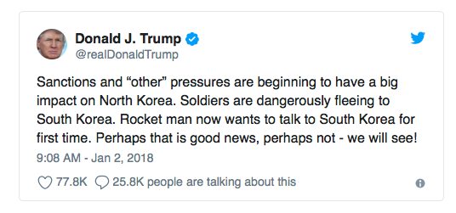

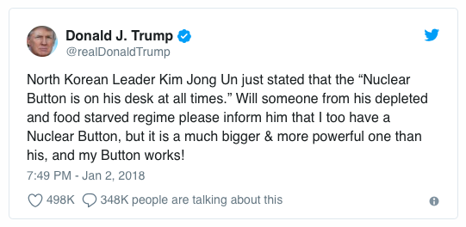
Retrieved from: https://twitter.com/realDonaldTrump

Supporting Question 1
Featured Source | Source D: Video excerpt highlighting what the US wants the United Nations to do with North Korea, Inside Story.  Unknown author, article discussing the ways in which the United States talks to and about North Korea, and the effect of those choices, “North Korea: US Planning a ‘Bloody Nose’ First Strike,” Al Jazeera, February 6, 2018

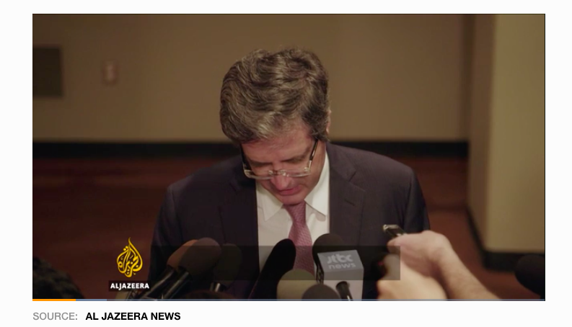

A "bloody nose" attack refers to a limited military strike against the North’s nuclear weapons sites that allegedly would not result in large-scale death and destruction.
The Rodong Sinmun, the North's ruling party newspaper, said on Tuesday US criticism of Pyongyang's weapons programmes and its human rights record was setting the stage for an attack.

The full document and related embedded video is accessible at: https://www.aljazeera.com/news/2018/02/north-korea-planning-bloody-nose-strike-180206210238738.html

The video is embedded at the end of the article. The video is titled, "Inside Story: Are US and North Korea on the verge of nuclear war?" The clip runs the first 03:54 of the show.

Supporting Question 2
Featured Source | Source A: Michael E. O’Hanlon, article discussing the pros and cons of potential military options against North Korea, “America Has Military Options for North Korea (but They’re All Bad),” National Interest, January 4, 2018

Is the Trump administration considering preventive military action of some sort against the North Korean regime of Kim Jong-un? With various US officials saying that “time is running out” for a diplomatic solution to the nuclear and missile standoff with the DPRK, that may be the case—or at least the intended message.

A review of the plausible military options available to the United States underscores two central points. First, the Trump administration is not alone in thinking about them. Previous US administrations, including Democratic ones, have done so, too. Second, however, none of those options really hold water. The risks of escalation are not worth the potential benefits. Consider these options:

Shoot Down Long-Range Missile Launches
One military option would be to prevent North Korea from completing any more long-range missile tests to perfect ICBM technology. This idea was proposed in 2006 by two Democratic secretaries of defense, William Perry and Ashton Carter. The missiles could be destroyed by precision munitions launched from aircraft just before launch. Or they could be shot down in flight by a US missile defense system; based on previous testing, any such shot might have a 25 to 75 percent chance of success.

However, in response, North Korea might accelerate its development of solid-fueled ICBMs, which have a launch preparation process that is difficult to detect. The United States might not shoot down such ICBMs effectively in peacetime or in war. North Korea might also request permission from China or Russia to launch test ICBMs northward or westward rather than eastward, which means the missiles would land in Siberia or the Gobi Desert (or even the Arctic Ocean).

Furthermore, this idea does not address North Korea’s growing inventory of perhaps several dozen nuclear warheads (and shorter-range missiles that could carry them) that already put Seoul and Tokyo at risk, including the hundreds of thousands of Americans living there.

Blockade North Korean Ports
To the credit of the Trump administration, the UN Security Council has just imposed additional sanctions on the DPRK. These would, among other things, reduce certain types of fuel imports up to 90 percent and severely squeeze the remittances sent home by North Korean workers living in places like Russia.

A blockade by the United States and allied navies could seem a logical way to ensure that such sanctions were actually respected. Of course, a military blockade is, by standard international law, an act of war. Enforcing it could require the use of lethal ordnance against any North Korean or other ships that refused to allow boarding and inspection. In response to such a blockade, North Korea could be expected, at a minimum, to shoot at any nearby ships that were targeting its own vessels, risking American casualties.

Even more importantly, this option would not curtail trade across North Korean land borders or airspace. Thus, it would neither reduce the existing threat posed by North Korea, nor likely slow further growth of nuclear and missile arsenals in the future. It would tighten the economic squeeze, but fail to reduce the military threat.

Destroy North Korean Nuclear Infrastructure
Just as Israel preemptively attacked Iraqi and Syrian nuclear reactors in 1981 and 2007, the United States and/or South Korea could take aim at parts of North Korea’s nuclear infrastructure, most likely with stealthy attack aircraft. Specifically, the nuclear reactor that is under construction but not yet operational could be destroyed without dispersal of highly radioactive material, as could the uranium centrifuge complex at that same site.

Unfortunately, such preventive strikes could not eliminate any second uranium enrichment facility that North Korea may have built at an unknown site. Nor could they humanely destroy the operational research reactor that has produced all of North Korea’s plutonium to date. An attack on such a site would create a miniature Chernobyl or Fukushima-like outcome, lethally spreading highly radioactive reactor waste over an area of hundreds of square miles downwind. Such an attack would be unlikely to reach any of the several dozen warheads North Korea already likely possesses, since US officials do not know where they are located.

Target Kim Jong-un Directly
Like the start of Operation Iraqi Freedom in 2003, when the Bush administration attempted to kill Saddam Hussein in an early “shock and awe” strike, the United States and South Korea could target Kim Jong-un. US law prohibits assassinating foreign political leaders.

But if Kim were declared the military commander of a nation still technically at war with the United Nations and in violation of its cease-fire obligations (due to frequent repeated aggressions against South Korea over the years), this issue might be finessed, at least legalistically.

However, the United States might miss Kim Jong-un in any such attempt, as the 2003 Iraqi case demonstrates. Whether successful or not, North Korea might respond with similar attempts against western leaders.

And where would even a successful operation get the United States? Unless US officials were able to message virtually all other senior North Korean leaders in advance, and persuade them to accept amnesty and exile if they chose not to resist, killing Kim Jong-un might just lead to the replacement of one extremist leader with another. North Korean military command and control might also splinter, with some elements opting for a violent response against the United States and ROK [the Republic of Korea—the official name for South Korea] rather than for surrender.

In short, whatever their individual appeal, each of these options would appear to promise only mediocre effects against the North Korean threats that matter most to the United States. Let us hope the Trump administration understands as much, and that it is using its threats of military action to create a sense of urgency about the need for North Korean concessions rather than to signal looming attack.

Michael O’Hanlon is a senior fellow and director of research at the Brookings Institution’s Foreign Policy Program.

The original document is accessible at: http://nationalinterest.org/feature/america-has-military-options-north-korea-theyre-all-bad-23940

Supporting Question 2
Featured Source | Source B: Russell Korobkin, article about the unique character and approach of President Donald Trump and how it might be beneficial to his meetings with Kim Jong-un, “Why a Petulant, Erratic Trump May Succeed in North Korea,” Los Angeles Times, August, 11, 2017
Donald Trump is a narcissistic, short-tempered, uninformed, unpredictable bully. In almost every context, this combination of traits is exactly what you would not want in a president of the United States. But one exception might be in dealing with Kim Jong Un and North Korea.

As I tell students in my negotiation class, in hard-nosed, brass-knuckles bargaining, the crazy person wins because he can force a rational counterpart to make concessions in order to avoid mutual disaster. And no one does crazy like Trump.

So-called normal American administrations have been outfoxed by the Kim family for decades. The reclusive leaders of the Hermit Kingdom have known that the only thing the United States can do to prevent them from developing nuclear weapons and long-range ballistic missiles to carry them is to start a war that would devastate the Korean peninsula. That option was, and is, so bad that the Kims have calculated that they could bluster, stall, make agreements only to break them, and generally thumb their noses at the West with no risk of serious consequences.

Sure, the United States can organize economic sanctions, but the Kims have never cared if their people starved by the millions, just as long as there was enough money to feed the military and finance weapons programs. North Korea is certainly displeased with the latest United Nations sanctions regime, which is expected to reduce its exports by a third, but there is almost no chance this will be painful enough to convince Kim to give up his warheads. The sanctions, even if they are enforced, still permit North Korea to earn plenty of hard currency trading in what isn't forbidden by the UN and sending guest workers to labor abroad.

The only way to stop North Korea's march toward deliverable nuclear weapons, short of a bloodbath, would be for China to embargo all trade with and economic support of Pyongyang, effectively starving Kim's military. But while China doesn't love the idea of a nuclear North Korea, it has always preferred that to the risk of a destabilized regime perched on its border.

North Korea’s threat to take “physical action” and retaliate “thousands of times over” for the latest sanctions was bluster typical for that country's propaganda ministry. But Trump’s “fire and fury” rejoinder is in sharp contrast to America’s usual careful diplomatic language. Military and foreign affairs experts in the West have uniformly criticized Trump. When crazy goes toe to toe with crazy, escalation can potentially get out of hand and lead to war. North Korea has already raised the ante by specifically threatening to shoot missiles near Guam, which could trigger an American response.

But the obvious danger of Trump facing off with Kim is precisely why rational Chinese leaders might reassess their nation’s long-standing approach and intervene more decisively. If Beijing continues to allow Kim’s pariah state to develop its nuclear capabilities, two events might occur that never before seemed likely. First, the United States might preemptively attack North Korea’s nuclear weapons facilities, starting a conventional or even nuclear war along the 38th parallel. Trump’s generals will probably prevent this from happening, but given the president’s daily antics, who could possibly believe an attack is impossible? Second, fearing increasing unpredictability in Washington, Japan or South Korea could decide to develop its own nuclear deterrent rather than continuing to rely solely on American protection.

Either a hot war or nuclear proliferation in its backyard would be much worse for China than any risks it might run by putting an end to Kim’s nuclear ambitions. Its best strategy now is to finally take serious action against Pyongyang, completely shutting off all commerce, including oil shipments, until North Korea gives up its nuclear program. In return, China can demand that the United States, along with South Korea and Japan, enter a treaty promising not to seek regime change that could threaten the existence of the Kim dynasty.

A petulant, erratic North Korea has successfully defied the West for decades. A bombastic response from an equally petulant and erratic President Trump is both scary and dangerous, but it might just succeed where prior, rational American administrations have failed.

Used with permission from Russell Korobkin

th-

Supporting Question 2
Featured Source | Source C: Video debate between former ambassadors and nuclear negotiators Robert L. Gallucci and Christopher Hill, moderated by Daniel Russel (Diplomat in Residence and Senior Fellow at the Asia Society Policy Institute), about the ambassadors’ experiences and lessons learned when negotiating with North Korea, “North Korea and the Art of the Deal: Lessons in Hands-On Diplomacy,” hosted by and held at the Asia Society, March 22, 2018

The videotape of the debate (84 minutes long) can be accessed at: https://asiasociety.org/video/north-korea-and-art-deal-complete

