Grades 6-8 Korean War Inquiry
What Does It Mean
to Sacrifice?

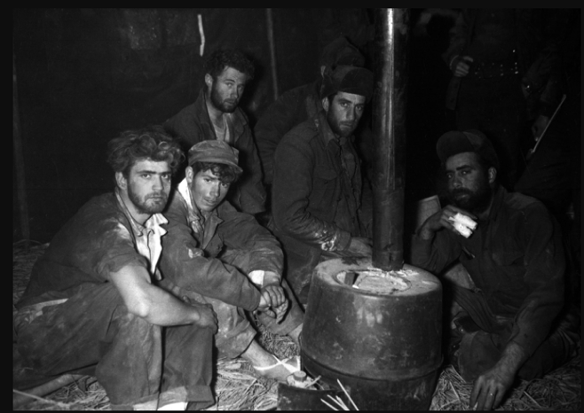

Image credit: Contributed by Jongwoo Han
Used with permission from KWVA Veterans & KWVDA

Supporting Questions
    - How did soldiers sacrifice during the war?
    - How did Koreans sacrifice during the war?

Grades 6-8 Inquiry
What Does It Mean to Sacrifice?
C3 Framework Indicator | D2.His.3.6-8. Use questions generated about individuals and groups to analyze why they, and the developments they shaped, are seen as historically significant.  D2.His.5.6-8. Explain how and why perspectives of people have changed over time.
Staging the Compelling Question | Discuss the historical significance of individual and group sacrifice in times of conflict and war.

Supporting Question 1 |  | Supporting Question 2
How did soldiers sacrifice during the war? |  | How did Koreans sacrifice during the war?
Formative Performance Task |  | Formative Performance Task
Make a list of examples of the sacrifices of soldiers in the Korean War. |  | Write a paragraph about the sacrifices of Koreans in the Korean War.
Featured Sources |  | Featured Sources
Source A: Chapter from the Korean War Legacy Project, “POW Experience”  Source B: Personal narrative by Bob Mitchell, a Marine Corps veteran, on his extensive front-line combat experience  Source C: Personal narrative by Fred Liddell, Korean War veteran, on his capture by Chinese troops in 1951  Source D: Link to the Korean War Legacy Project’s Memory Bank to search for other veteran interviews describing soldiers’ sacrifices |  | Source A: Chapter from the Korean War Legacy Project, “The Human Experience”  Source B: Personal narrative of Donald J. Zoeller, 140th Anti-Aircraft Battalion, on his experiences near the main line of resistance (MLR)  Source C: Personal narrative of Clarence Jerke, 2nd Infantry Division Headquarters Battery, on his work maintaining communications lines behind enemy lines  Source D: Photograph of Seoul, October 18, 1950; also, link to the Korean War Legacy Project’s Memory Bank to search for additional photographs of and veteran interviews about Koreans’ sacrifices

Summative Performance Task | ARGUMENT “What does it mean to sacrifice?” Construct an argument (e.g., detailed outline, poster, or essay) that discusses the compelling question using specific claims and relevant evidence from the sources provided, as well as one other source, while acknowledging competing views.
 | EXTENSION Using the argument as a foundation, engage in small-group brainstorming to create an original poem or song responding to the compelling question, “What does it mean to sacrifice?”
Taking Informed Action | UNDERSTAND Examine the historical significance of sacrifices made by individuals and groups during a current or recent conflict or war.  ASSESS Determine some ways the stories of soldiers fighting abroad might be shared in the community.  ACT Organize a school- or community-wide effort to share poems or songs of appreciation from students with local veterans’ associations.

Overview

Inquiry Description
This inquiry leads students through an investigation of individual and group sacrifices made during times of conflict and war. By investigating the compelling question, “What does it mean to sacrifice?,” students evaluate the historical significance of individuals and groups during the Korean War. The formative performance tasks build on knowledge and skills through the course of the inquiry and help students to understand the sacrifices made by soldiers and civilians on both sides during the Korean War. Students create an evidence-based argument about the sacrifice of all in times of conflict and war.

This inquiry requires prerequisite knowledge of historical events and ideas. Thus, students should have already briefly studied segregation policies in America and have a general understanding of the concept of prisoners of war (POWs).

NOTE: This inquiry is expected to take five 40-minute class periods. The inquiry time frame could expand if teachers think their students need additional instructional experiences (i.e., supporting questions, formative performance tasks, and featured sources). Teachers are encouraged to adapt the inquiries​ in order to meet the requirements and interests of their particular students. Resources can also be modified as necessary to meet individualized education programs (IEPs) or Section 504 plans for students with disabilities.

Structure of the Inquiry
In addressing the compelling question, “What does it mean to sacrifice?,” students work through a series of supporting questions, formative performance tasks, and featured sources in order to construct an argument supported by evidence while acknowledging competing perspectives.

Staging the Compelling Question

In staging the compelling question, “What does it mean to sacrifice?,” teachers may prompt students with the short documentary, Beyond the Bridge of No Return: Legacy of a Korean War Veteran. The documentary is available online at https://vimeo.com/hellofuturestories/review/250984755/85a5000301#.

Supporting Question 1

The first supporting question, “How did soldiers sacrifice during the war?,” urges students to think critically about the role of individuals and group sacrifice among soldiers during the Korean War. The formative performance task asks students to make a list of examples of the sacrifices of soldiers in the Korean War using two video clips of interviews with veterans about their experiences with sacrifice during the Korean War.

Featured Source A is a chapter, “POW Experience,” from the Korean War Legacy Project. Featured Source B is the personal narrative of Bob Mitchell, a Marine Corps veteran who had extensive front-line combat experience in the Korean War. Mitchell recalls the guilt of living through the war while the rest of his friends and comrades died. Featured Source C is the personal narrative of Fred Liddell, who was captured in 1951 by Chinese troops. Liddell provides an account of his capture and the details surrounding it, including the policy of “lenient treatment.” Further research about this policy would be a valuable learning exercise for students, as it offers insight into propaganda techniques used on POWs. Students might also search the Korean War Legacy Project Memory Bank to locate other veteran interviews describing the sacrifices made by soldiers.

Supporting Question 2

The second supporting question, “How did Koreans sacrifice during the war?,” asks students to think about the ways Koreans sacrificed during the war. The formative performance task asks students to write a paragraph about the sacrifices of Koreans in the Korean War.

Featured Source A is a chapter, “The Human Experience,” from the Korean War Legacy Project. It is available at https://koreanwarlegacy.org/chapters/the-human-experience/.

Featured Source B is the personal narrative of Donald Zoeller, member of the 140th Anti-Aircraft Battalion near the main line of resistance (MLR). Zoeller reflects on helping an orphaned Korean boy. The clip, full interview, and transcript are available at https://koreanwarlegacy.org/interviews/donald-j-zoeller-2/.

Featured Source C is the personal narrative of Clarence Jerke, member of the 2nd Infantry Division Headquarters Battery, who worked behind enemy lines maintaining communications. In his interview, Jerke describes how starving civilians would jump on the back of his truck as it was moving and throw food out to their friends. The clip, full interview, and transcript are available at https://koreanwarlegacy.org/interviews/clarence-jerke/.

Featured Source D is a photograph of a residential neighborhood in Seoul that was largely destroyed by the Korean War. The capitol building can be seen in the background. Students are encouraged to use the link provided to search the Korean War Legacy Project Memory Bank to locate more photographs and other veteran interviews describing the sacrifices made by Koreans during the war.

These sources provide students with primary and secondary sources of data about the sacrifices made by Koreans during the war. After students examine the sources, they will write a paragraph about the sacrifices of Koreans during the Korean War.

Summative Performance Task

At this point in the inquiry, students have examined the sacrifices of US and Korean soldiers and Koreans civilians on both sides of the war.

Students should be able to demonstrate the breadth of their understanding and their ability to use evidence from multiple sources to support their claims. In this task, students construct an evidence-based argument using multiple sources to answer the compelling question “What does it mean to sacrifice?” Students’ arguments will take a variety of forms, including a detailed outline, poster, or essay.

Students’ arguments will vary, but could include either of the following:
- Sacrifice means putting the needs of others before yourself.
- Sacrifice means fighting for the freedom and democracy of others.

To extend students’ arguments, teachers may have them engage in small-group brainstorming sessions to create an original poem or song responding to the compelling question, “What does it mean to sacrifice?”

Students have the opportunity to Take Informed Action by drawing on their understandings of individual and group sacrifices during times of conflict and war. To understand, students can examine the historical significance of sacrifices made by individuals and groups during times of conflict and war. To assess the issue, students can determine some ways the stories of soldiers fighting abroad might be shared with the local community. To act, students can organize a school- or community-wide effort to share poems or songs of appreciation from students with local veterans’ associations.

Staging the Compelling Question
Featured Source | Source: Documentary short, The Legacy: A Documentary from the Korean War Legacy Project; accessible at https://vimeo.com/hellofuturestories/review/250984755/85a5000301#

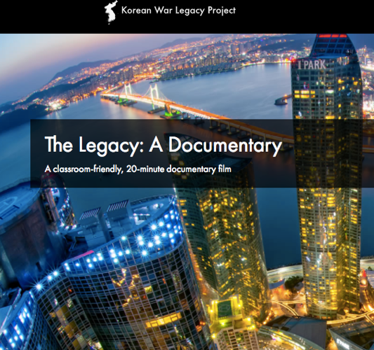

Image used with permission from the Korean War Legacy Project

Supporting Question 1
Featured Source | Source A: Chapter, “POW Experience,” Korean War Legacy Project; accessible at http://koreanwarlegacy.org/chapters/the-pow-experience/.

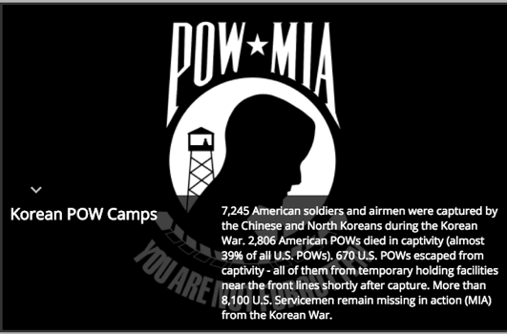

Image used with permission from the Korean War Legacy Project

Supporting Question 1
Featured Source | Source B: Bob Mitchell, personal narrative discussing his experience with survivor guilt; the clip is accessible (on YouTube) HERE, and the full interview and transcript are accessible at https://koreanwarlegacy.org/interviews/bob-mitchell/.

Bob Mitchell is a Marine Corps veteran with extensive front-line combat experience in the Korean War. In this video clip, Mitchell recalls with great emotion the survivor guilt he experienced after surviving the war while the rest of his company was overwhelmed and killed by the Chinese. Mitchell says he eventually reached the realization that such experiences are simply the reality of war—some people make it and others don't.

Supporting Question 1
Featured Source | Source C: Fred Liddell, personal narrative discussing his experience being captured by Chinese troops in 1951; the clip is accessible (on YouTube) HERE, and the full interview and transcript are accessible at https://koreanwarlegacy.org/interviews/fred-liddell/.

In this video clip, Fred Liddell vividly discusses his 1951 capture by Chinese troops. He provides a detailed, articulate account of his capture and the details surrounding it. Mr. Liddell also mentions the policy of “lenient treatment” in this clip.

Image credit: Jongwoo Han

Used with permission from the Korean War Legacy Project

Supporting Question 1
Featured Source | Source D: Link to the Korean War Legacy Project’s Memory Bank, to search for other veteran interviews describing soldiers’ sacrifices: https://koreanwarlegacy.org/interactive-library/

Used with permission from the Korean War Legacy Project

Supporting Question 2
Featured Source | Source A: Chapter, “The Human Experience,” Korean War Legacy Project; accessible at https://koreanwarlegacy.org/chapters/the-human-experience/.

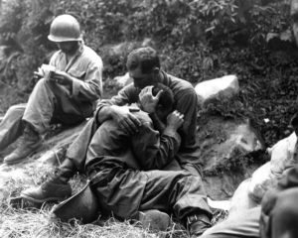

Used with permission from the Korean War Legacy Project

Supporting Question 2
Featured Source | Source B: Donald J. Zoeller, personal narrative discussing his experience helping an orphaned Korean boy; the clip is accessible (on YouTube) HERE, and the full interview and transcript are accessible at https://koreanwarlegacy.org/interviews/donald-j-zoeller-2/.

Donald J. Zoeller was a member of the 140th Anti-Aircraft Battalion near the main line of resistance (MLR) in the Korean War. In this video clip, Zoeller says that he did not get to know many Korean people, as he was always outside of the cities. However, he goes on to detail an exceptional experience in which he met a young Korean boy who was orphaned. Zoeller invited the boy to stay with the soldiers, and later brought him safely to an orphanage.

Supporting Question 2
Featured Source | Source C: Clarence Jerke, personal narrative detailing his work maintaining communications lines behind enemy lines during the Korean War; the clip is accessible (on YouTube) HERE, and the full interview and transcript are accessible at https://koreanwarlegacy.org/interviews/clarence-jerke/.

Clarence Jerke, a member of the 2nd Infantry Division Headquarters Battery, worked behind enemy lines maintaining communications lines during the Korean War. In this interview, Jerke describes seeing starving civilians jump onto his truck while it was moving and attempt to steal food by throwing it over the sides of the truck to their friends.

Supporting Question 2
Featured Source | Source D: Photograph of the destruction of Seoul, the capitol building visible in the background, October 18, 1950. The Korean War Legacy Project’s searchable Memory Bank includes additional images and veteran interviews related to this inquiry; accessible at https://koreanwarlegacy.org/interactive-library/

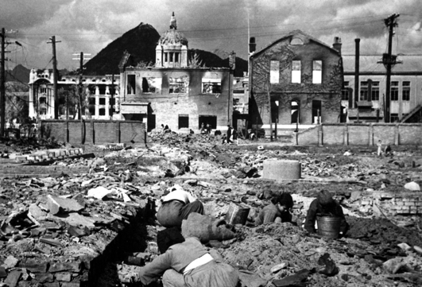

Photo: Korean War - HD-SN-99-03160Korean War - HD-SN-99-03160
Scene of a residential section of Seoul, Korea damaged during the war. The capitol building can be seen in the background (right). October 18, 1950. Sfc. Cecil Riley. (Army)
NARA FILE #: 111-SC-351356
WAR & CONFLICT BOOK #: 1501

Used with permission from the Korean War Legacy Project

