Grades 3-6 Korean War Inquiry

What Is the Best Way
to Remember History?
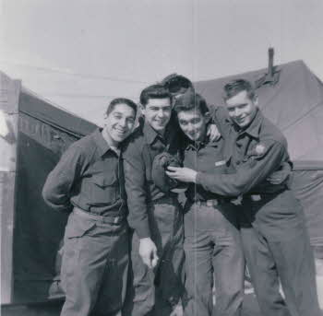

Retrieved from: http://www.kwvdm.org/detail_artifact.php?no=95

Used with permission from the Korean War Legacy Project

Supporting Questions
    - What are some of the ways the Korean War has been memorialized?
    - How do we remember all the parts of history?
    - How does the memory of history help us make better choices today?

Grades 3-6 Korean War Inquiry
What Is the Best Way to Remember History?
C3 Framework Indicators | D2.His.4.3-5. Explain why individuals and groups who experienced the same historical period differed in their perspectives.
Staging the Compelling Question | Discuss why people study history, and create a class-generated list of the tools available for learning about and remembering history.

Supporting Question 1 |  | Supporting Question 2 |  | Supporting Question 3
What are some of the ways the Korean War has been memorialized? |  | How do we remember all the parts of history? |  | How does the memory of history help us make better choices today?
Formative  Performance Task |  | Formative  Performance Task |  | Formative  Performance Task
Create a T-chart that lists the ways the Korean War has been memorialized and the strengths and weaknesses of each of these types of memorials. |  | Make a list of some of the parts of history we forget to include in memorials, textbooks, or stories about history. |  | Create a claim about how history might help us learn to make better choices in the future.
Featured Sources |  | Featured Sources |  | Featured Sources
Source A: Image bank: Korean War Veterans Memorial, Washington, DC  Source B: Memorial songs about Korea, “There’s Peace in Korea” and “Forgotten Men”  Source C: Videotaped oral history interviews with two Korean War veterans |  | Source A: Illustrated oral history, War and Children  Source B: Veterans Affairs fact sheet, “Korean War Exposures”  Source C: Article about an unexpected benefit of the demilitarized zone for wildlife species, Guardian  Source D: Article about bias and discrimination against African American soldiers in the Korean War, Chicago Tribune |  | Source A: Article, “Why Study History?,” Humboldt University, Berlin, Germany  Source B: Article about the importance of preserving heritage sites, GoUNESCO

Summative Performance Task | ARGUMENT What is the best way to remember history? Construct an argument (e.g., detailed outline, poster, or essay) that addresses the compelling question using specific claims and relevant evidence from both historical and current sources.
 | EXTENSION Conduct research on historical markers and monuments in your town and answer the question, “What stories do they tell?”
Taking Informed Action | UNDERSTAND Working with a team, discuss how history can teach important lessons and support us in making better choices in the future. Discuss your examples from Supporting Question 3.  ASSESS Identify problems in your community that might be solved by learning a lesson from history.  ACT Create a memorial design that you would put in your town to help your community learn from history, so that it can make the best choices for the future.

Overview

Inquiry Description
This inquiry leads students through an investigation of the ways we remember history, including a variety of memorials and consideration of the omissions in our collective memory. By investigating the compelling question, “What is the best way to remember history?,” students evaluate and explore a variety of types of memorialization, omissions in our collective memory, and the possible ways that historical memory can help people make better contemporary choices. The formative performance tasks build on knowledge and skills through the course of the inquiry and help students identify and compare some of the ways history is memorialized and remembered. Students create an evidence-based argument about the best ways to engage in the process of preserving the past.
It is important to note that this inquiry requires little prerequisite knowledge of historical events and ideas; however, skills for decoding historical and new source texts are helpful.
NOTE: This inquiry is expected to take three to four 30-minute class periods. The inquiry time frame might expand if teachers think their students need additional instructional experiences (i.e., supporting questions, formative performance tasks, and featured sources). Teachers are encouraged to adapt the inquiries​ to meet the requirements and interests of their particular students. Resources can also be modified as necessary to meet individualized education programs (IEPs) or Section 504 plans for students with disabilities.

Structure of the Inquiry
In addressing the compelling question, “What is the best way to remember history?,” students work through a series of supporting questions, formative performance tasks, and featured sources in order to construct an argument supported by evidence while acknowledging competing perspectives.

Staging the Compelling Question
In staging the compelling question, “What is the best way to remember history?,” teachers may prompt students with two tasks. First, students should discuss with a partner some of the reasons studying and remembering history might be important. Second, the class should work together to generate a list of sources for remembering history. These might include textbooks, songs, murals in the school, family stories, community or national memorials, and posters or other works of art. Creating a rich list of sources for remembering history will provide students with scaffolding for creating an argument about which ways of remembering history are best.

Supporting Question 1
The first supporting question, “What are some of the ways the Korean War has been memorialized?,” has students consider a variety of memorializations and consider the strengths and weaknesses of each type of memorial. The formative performance task asks students to create a T-chart with this information. The featured sources for this question represent three ways the Korean War has been memorialized. The class list generated in the staging activity demonstrates that this is not an exhaustive list, but a small selection for student consideration. Featured Source A is a captioned image bank from the Korean War Veterans Memorial on the National Mall in Washington, DC. Featured Source B is a pair of war-era songs and their lyrics commemorating the Korean War and honoring its veterans. Featured Source C is a pair of interviews with Korean War veterans providing oral histories. In addition to the histories’ content, this featured source allows students to see that the act of recording, and then listening to, the lived experiences of veterans are both forms of memorialization, as well.
Supporting Question 2
For the second supporting question,“How do we remember all the parts of history?,” students will identify some of the hard, unflattering, or simply forgotten parts of history sometimes omitted from our collective memory. For the formative performance task, students are asked to list parts of history that are often forgotten. In addition to the resources from Supporting Question 1, the featured sources here provide students with additional materials that allow them to summarize and identify some of the omissions in our remembrances. Featured Source A is a document set about the experiences of children in war, including several photos (these are not graphic, and are appropriate for young students) and a videotaped oral history on the orphanages and starvation faced by children during and after the Korean War. Featured Source B is a Veterans Affairs fact sheet on some of the occupational and environmental hazards faced by soldiers and veterans. Featured Source C is an article from the Guardian that briefly discusses the adaption of wildlife to the Korean demilitarized zone. Featured Source D is an article from the Chicago Tribune that addresses the racism experienced by soldiers of color during and after the Korean War. Additional instructional resources on the experiences of African American soldiers in the war and the racism they encountered can be found in the Korean War Legacy Project’s archives (https://koreanwarlegacy.org/).

Supporting Question 3
The third supporting question, “How does the memory of history help us make better choices today?,” asks students to consider the ways in which we can learn from the past. In addition to the previous featured sources for this inquiry, the sources for this task explore the reasons to study and preserve history. Featured Source A is an article from the Department of History at Humboldt University in Berlin, Germany outlining the reasons to study history. Featured Source B is an article from GoUNESCO listing the reasons to preserve history. The formative performance task asks students to create a claim about how remembering history might help us make better choices today and in the future.

Summative Performance Task
At this point in the inquiry, students have examined some of the ways history is typically memorialized, identified topics and people who are sometimes omitted from the dominant narrative, and considered the uses of memorials in helping us make better choices now and in the future.
Students should be able to demonstrate the breadth of their understanding and their ability to use evidence from multiple sources to support their claims. In this task, students construct an evidence-based argument using multiple sources to answer the compelling question, “What is the best way to remember history?” Students’ arguments could take a variety of forms, including a detailed outline, poster, or essay.
Students’ arguments will vary, but could include any of the following:
- The best way to remember history is to…
  - listen to the stories of people who were there.
  - create art or music to memorialize the experiences of people who were there.
  - read about history in books.
  - create posters and share them widely in your town or via the internet.
  - talk about the experiences of people, places, and issues that have been omitted.
To extend students’ arguments, teachers may have students conduct research on local historical markers and monuments and write about their value. Teachers could provide the prompts: What story does this memorial tell us about history? What can we learn from this monument that is helpful today? What monuments might be missing from our town?
Students have the opportunity to Take Informed Action by drawing on their understanding of collective memory and historical memorialization. To understand, small groups of students can discuss how history can teach important lessons and support us in making better choices now and in the future. Discuss examples from Supporting Question 3 and collectively add examples that are both personal and historical. To assess the issue, students can identify problems in the community that might be solved by learning a lesson from history. To act, students can create a memorial design that could be put in their town to help their community learn from history and make the best choices for the town’s future.

Supporting Question 1
Featured Source | Source A: Image bank with captions, Korean War Veterans Memorial, National Mall, Washington, DC (excerpted from http://www.koreanwarvetsmemorial.org/the-memorial/)

The Memorial
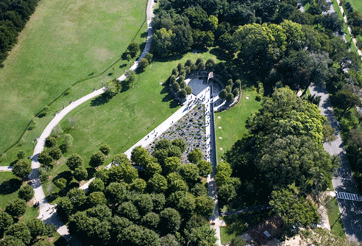
The Korean War Veterans Memorial is located near the Lincoln Memorial on the National Mall in Washington, D.C. It was dedicated on July 27, 1995. The Memorial was designed and financed by private contributions and erected under the auspices of the Korean War Veterans Memorial Advisory Board composed of Korean War veterans appointed by President Reagan. The memorial commemorates the sacrifices of the 5.8 million Americans who served in the US armed services during the three-year period of the Korean War. The War was one of the most hard fought in our history. During its relatively short duration from June 25, 1950 to July 27, 1953, 36,574 Americans died in hostile actions in the Korean War theater. Of these, 8,200 are listed as missing in action or lost or buried at sea. In addition, 103,284 were wounded during the conflict. The Memorial consists of four main parts [the statues, the Mural Wall, the Pool of Remembrance, and the United Nations Wall].

The Statues
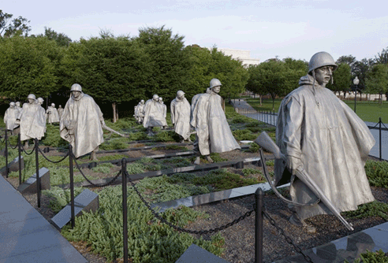
The 19 stainless steel statues were sculpted by Frank Gaylord of Barre, Vermont, and cast by Tallix Foundries of Beacon, New York. They are approximately seven feet tall and represent an ethnic cross-section of America. The advance party has 14 Army, 3 Marine, 1 Navy and 1 Air Force members. The statues stand in patches of juniper bushes and are separated by polished granite strips, which give a semblance of order and symbolize the rice paddies of Korea. The troops wear ponchos [partially] covering their weapons and equipment. The ponchos seem to blow in the cold winds of Korea.

The Mural Wall
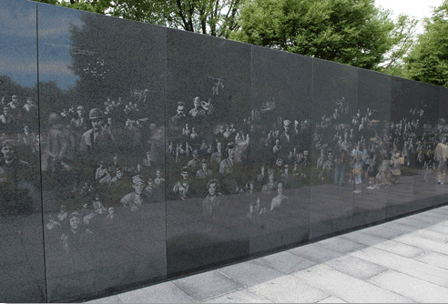
The Mural Wall was designed by Louis Nelson of New York City and fabricated by Cold Spring Granite Company, in Cold Spring, Minnesota. The muralist, sculptor, and architect worked closely to create a two-dimensional work of art adjacent to the three-dimensional statues. The wall consists of 41 panels extending 164 feet. More than 2,400 photographs of the Korean War were obtained from the National Archives. They were enhanced by computer to give a uniform lighting effect and enlarged to the desired size. The mural, representing those forces supporting the foot soldier, depicts Army, Navy, Marine Corps, Air Force and Coast Guard personnel and their equipment. The etchings are arranged to give a wavy appearance in harmony with the layout of the statues. The reflective quality of the Academy Black Granite creates the image of a total of 38 statues, symbolic of the 38th Parallel and the 38 months of the war. When viewed from afar, it also creates the appearance of the mountain ranges of Korea.

The Pool of Remembrance
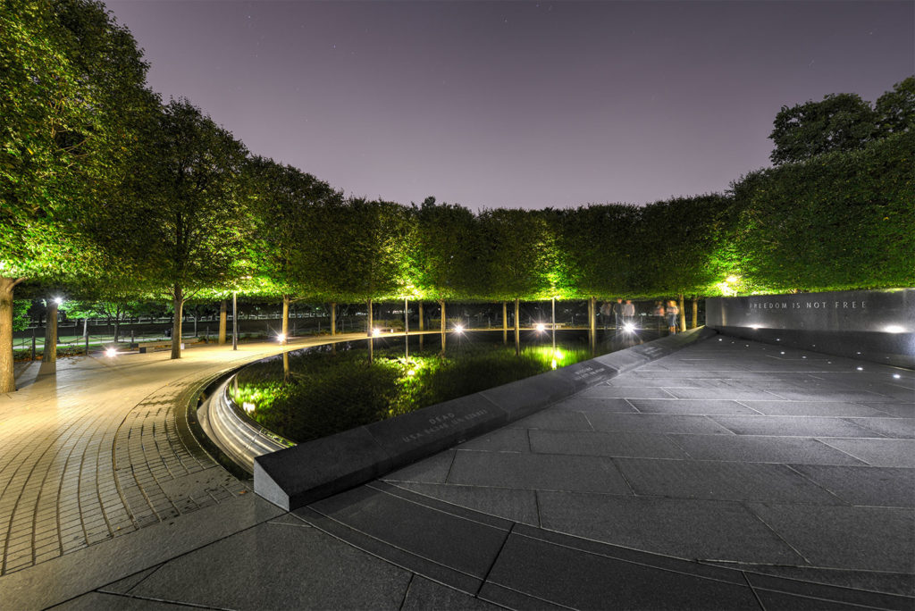
The Memorial has a reflective pool at the far terminus of the memorial site. It encircles the Freedom Is Not Free Wall and Alcove at the base of which are numerically listed the soldiery cost of the war in terms of KIA (Killed in Action), WIA (Wounded in Action), MIA (Missing in Action), and POWs (Prisoners of War). The pool is encircled by a walkway along which benches are located.

The United Nations Wall
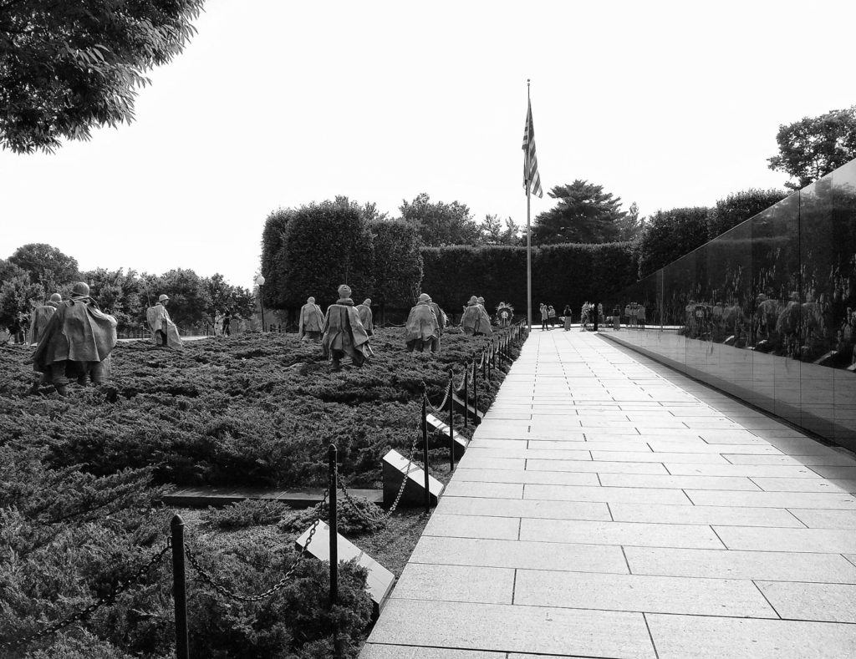
To the left of the Mural Wall is a walkway on which are engraved markers that list the 22 nations that contributed troops to the United Nations’ efforts in the Korean War.

Photos and excerpts used with permission from Korean War Veterans Memorial Foundation, Inc.

Supporting Question 1
Featured Source | Source B: Two memorial songs about Korea: Rosetta Tharpe, “There’s Peace in Korea” (1953), and Don Reno and Red Smiley, “Forgotten Men” (1956)
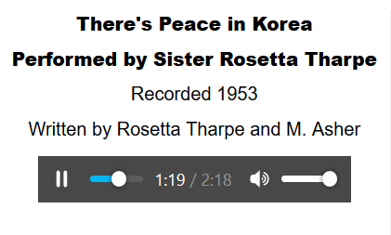

“There's Peace in Korea”
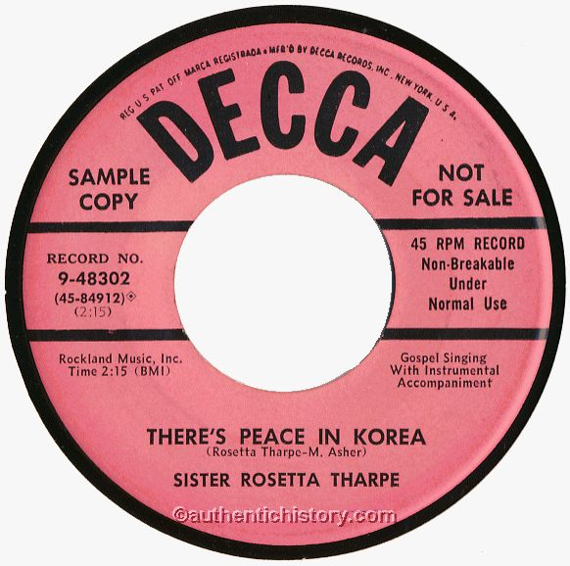
Performed by Sister Rosetta Tharpe
Recorded in 1953
Written by Rosetta Tharpe and M. Asher
I'm so glad at last, there's peace in Korea
Yes, I'm so glad at last, there's peace in Korea
Don't you know, I'm so glad at last, there's peace in Korea
Because President Eisenhower has done just what he said
We're hoping there will be no more misery, and no more sadness
No no no no no no dying, there'll be, in the land
Hope we'll have happiness, and joy, and peace of mind
Because we know God has made this world
And made it for the good and kind
I'm seeing all you mothers, now don't you weep and moan
I know that you are glad because your sons are comin' home
Note to wise, sisters and brothers, you can wipe your cheery eyes
Because, sure as I'm singing, the sun has begun to shine
[repeat first verse twice]

Retrieved from: https://www.historyonthenet.com/authentichistory/1946-1960/2-korea/3-music/19530000_Theres_Peace_In_Korea-Sister_Rosetta_Tharpe.html

https://creativecommons.org/licenses/by/3.0/

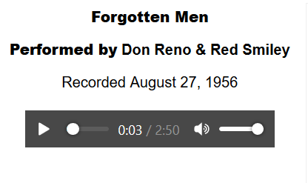

“Forgotten Men”
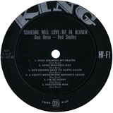
Performed by Don Reno and Red Smiley
Recorded August 27, 1956
Forgotten men who lie asleep across the ocean waves
Who fought and died for the flag that waves across their lonely graves
The flag still waves so proud and free across our land today
Let's not forget the boys who died across the watery spray
Forgotten men who lie asleep across the ocean waves
Who fought and died for the flag that waves across their lonely graves
Her picture hangs upon the wall but their names are not mentioned back home
As the years go by our memories dim, we forget our loved ones are gone
Forgotten men who lie asleep across the ocean waves
Who fought and died for the flag that waves across their lonely graves

Retrieved from: https://www.historyonthenet.com/authentichistory/1946-1960/2-korea/3-music/19560827_Forgotten_Men-Don_Reno-Red_Smiley.html

https://creativecommons.org/licenses/by/3.0/

Supporting Question 1
Featured Source | Source C: Korean War Legacy Project, videotaped oral histories of Korean War veterans Shirley Toepfer and Doris Porpiglia

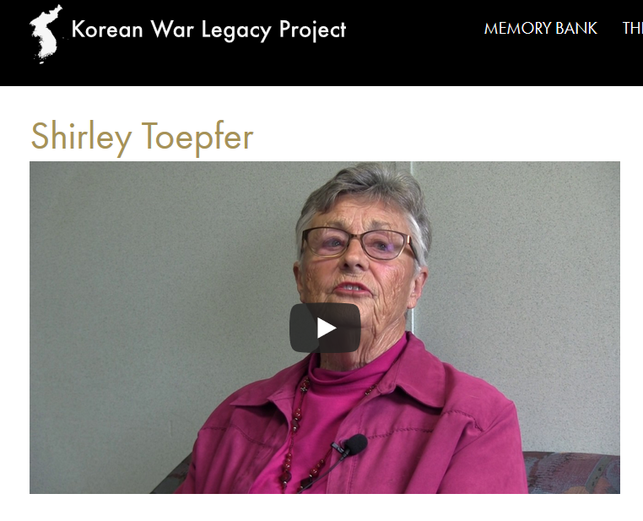

Retrieved from: https://koreanwarlegacy.org/interviews/shirley-toepfer/

Used with permission from the Korean War Legacy Project

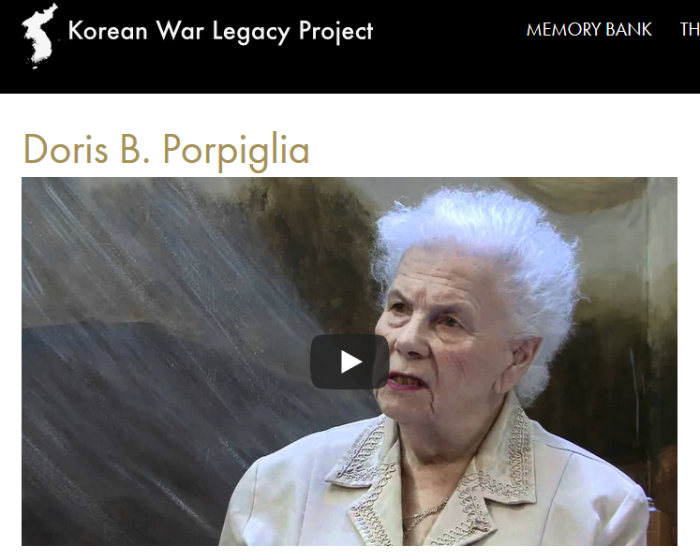

Retrieved from: https://koreanwarlegacy.org/interviews/doris-b-porpiglia/

Used with permission from the Korean War Legacy Project

Supporting Question 2
Featured Source | Source A: Oral History Clip on War’s Impact on Children and photo set

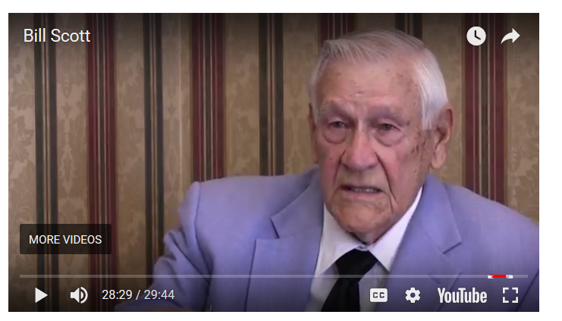

Retrieved from: https://koreanwarlegacy.org

Used with permission from the Korean War Legacy Project

Used with permission from the Korean War Legacy Project

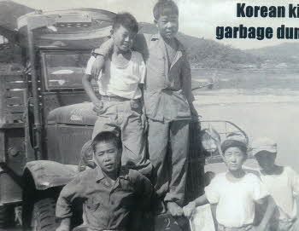
Korean kids at garbage dump truck

Retrieved from: http://www.kwvdm.org/detail_artifact.php?no=34
Image used with permission from the Korean War Legacy Project

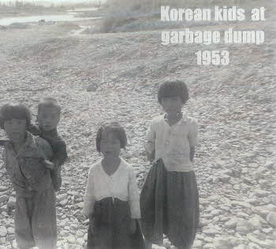
Korean kids at garbage dump, 1953

Retrieved from: http://www.kwvdm.org/detail_artifact.php?no=35

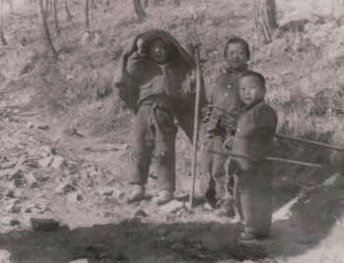
Three Korean boys holding farming tools

Retrieved from: http://www.kwvdm.org/detail_artifact.php?no=59
Image used with permission from the Korean War Legacy Project
Photographs used with permission from the Korean War Legacy Project

Supporting Question 2
Featured Source | Source B: United States Department of Veterans Affairs, “Korean War Exposures” fact sheet defining and discussing the primary, known health hazards of serving in the Korean War, and detailing causes, health implications, symptoms, treatments, and benefits available to veterans.

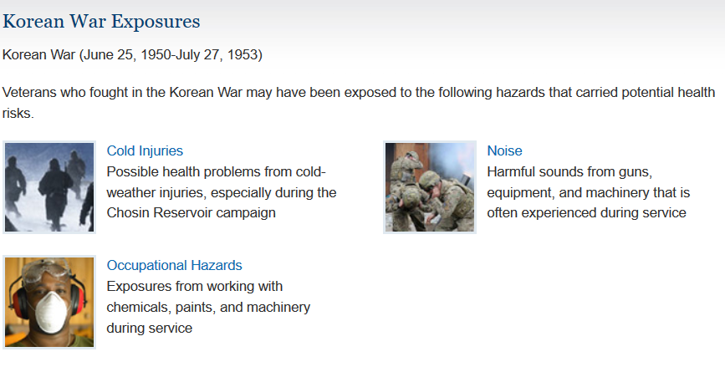

Retrieved from: https://www.publichealth.va.gov/exposures/wars-operations/korean-war.asp

Supporting Question 2
Featured Source | Source C: Lisa Brady, “How Wildlife Is Thriving in the Korean Peninsula’s Demilitarized Zone,” in which the author examines an unintended benefit of establishing a zone without human inhabitants—an accidental sanctuary in which wildlife thrives, Guardian, April 13, 2012
How Wildlife Is Thriving in the Korean Peninsula’s Demilitarized Zone
The forces that lock humans out of the DMZ have allowed other species to thrive. Could a remnant of violent conflict become the symbol of a greener, more peaceful future?

Lisa Brady for China Dialogue, part of the Guardian Environment Network
A thin green ribbon threads its way across the Korean Peninsula. Viewed from space, via composite satellite images, the winding swath clearly demarcates the political boundary between the Republic of Korea (ROK) [South Korea] and the Democratic People's Republic of Korea (DPRK) [North Korea]. Its visual impact is especially strong in the west, where it separates the gray, concrete sprawl of Seoul from the brown, deforested wastes south of Kaesong. In the east, it merges with the greener landscapes of the Taebaek Mountain Range and all but disappears.
From the ground, the narrow verdant band manifests as an impenetrable barrier of overgrown vegetation enclosed by layers of fences topped by menacing concertina wire and dotted with observation posts manned by heavily armed soldiers. That a place so steeped in violence still teems with life seems unimaginable. And yet, the Demilitarized Zone, or DMZ, is home to thousands of species that are extinct or endangered elsewhere on the peninsula. It is the last haven for many of these plants and animals and the center of attention for those intent on preserving Korea's rich ecological heritage.
Once known as the “land of embroidered rivers and mountains,” the Korean Peninsula has experienced almost continual conflict for over 100 years, resulting in a severely degraded natural environment. International competition for control over the peninsula’s resources left Korea in a precarious position at the start of the twentieth century. The Japanese occupation between 1905 and 1945 brought with it radically increased exploitation of mineral and other resources, resulting in massive deforestation, pollution, and general environmental decline.
Since at least the 1940s, deforestation for fuel wood and clearing for agricultural land has caused significant erosion of the area’s mountains and hills and contributed to the siltation of its rivers, streams and lakes. The 1950 to 1953 war raged across the entire peninsula, subjecting it to widespread devastation that destroyed cities, roads, forests and even mountains. And, in the 1960s and 1970s, unchecked industrialization further undermined the peninsula's ecological health, causing air, water, and soil pollution.
The relative health of the DMZ now stands in stark contrast to the failing ecosystems in both North and South Korea.
Created in 1953 during tense armistice negotiations, Korea's DMZ is at once one of the most dangerous places on Earth and one of the safest. For humans, its thousands of landmines and the millions of soldiers arrayed along its edges pose an imminent threat. But the same forces that prevent humans from moving within the nearly 400 square miles of the DMZ encourage other species to thrive. Manchurian or red-crowned cranes and white-naped cranes are among the DMZ’s most famous and visible denizens. Nearly 100 species of fish, perhaps 45 types of amphibians and reptiles, and more than 1,000 different insect species are also supposed to exist in the protected zone.

Scientists estimate that more than 1,600 types of vascular plants and more than 300 species of mushrooms, fungi, and lichen are thriving in the DMZ. Mammals such as the rare Amur goral, Asiatic black bear, musk deer, and spotted seal inhabit the DMZ’s land and marine ecosystems. There are even reports of tigers, believed [to have been] extinct on the peninsula since before Japanese occupation, roaming the DMZ’s mountains.
Much of the biodiversity in the DMZ is speculative, extrapolated from spotty scientific studies conducted in the Civilian Control Zone (CCZ) that forms an additional protective barrier along the DMZ’s southern edge. Approximate though these studies are, the DMZ’s ecological promise is great enough to spur many people to action.
Retrieved from: https://www.theguardian.com/environment/2012/apr/13/wildlife-thriving-korean-demilitarised-zone
https://creativecommons.org/licenses/by/3.0/

Supporting Question 2
Featured Source | Source D: Michael Kilian, article about the racism African American soldiers faced in the Korean War,  “Army Removes Cloud Over Black Korean War Unit,” Chicago Tribune, April 30, 1996

An all-black US Army infantry regiment, disbanded and singled out for cowardice and unreliability in the Korean War, has had its honor restored in an official Army report made public Monday.
Its failures were directly attributable to neglect, inferior white leadership, and institutional racism, according to the study, which is based on 400 interviews and took nine years to complete.

Excerpted from full story: http://articles.chicagotribune.com/1996-04-30/news/9604300190_1_24th-infantry-regiment-white-units-official-army-report

Supporting Question 3
Featured Source | Source A: Professor Thomas Mergel, Department of History, Humboldt University, Berlin, Germany, “Why Study History?” (excerpt, September 2018)

Why study history?

[When asked why anyone should study history,] many would say, “Because we can learn things from history that can help us in the future.” But is that really true? Of course!

History does not simply prepare us for a future that is identical to the past. Instead, it makes us
aware of the fact that we must be open to anything and everything that might await us.

The first reason: Because history has already taught us that nothing stays the same. When studying history, we don’t just discuss how different politics and economics have become. Instead, we look into how, throughout history, bodies, feelings, and social values have varied. Almost everything today that we take for granted—or even consider natural—turns out, upon further inspection, to have developed over the course of time and could, therefore, change again. Thus, the study of history teaches us that all things are historical and, therefore, have the potential of becoming something different overnight.
The second reason: When we study the monks of the Middle Ages, the American settlers of the 18th century, or the Athenians [of ancient eras], we learn how diverse humans and societies can be. What was natural for those people is now foreign to us. Students of history are given an ethnological view of the world, a wide panorama of the potential diversity of people and cultures.
Viewing the world in such a way allows us to put the present day into perspective. It gives us the impression that our current way of life is not so “normal” or “natural.” It encourages us to be open to change. History does not simply prepare us for a future that is identical to the past. Instead, it makes us aware of that fact that we must be open to anything and everything that might await us.

Retrieved from: https://www.geschichte.hu-berlin.de/en/studying-history/why-study-history/why-study-history
Excerpted and used with permission from: Department of History, Humboldt-Universität Zu Berlin

Supporting Question 3
Featured Source | Source B: GoUNESCO, “5 Reasons Why We Should Preserve Heritage Sites” (excerpt), in which some of the reasons to preserve historically significant places are discussed, GoUNESCO website, July 5, 2014

GoUNESCO is a citizen-led, UNESCO-supported umbrella of initiatives that make heritage more engaging.

Why should we preserve heritage sites?
Heritage sites and memorials are symbols of history. They are a representation of the past, and sometimes it becomes hard to understand why, exactly, we need to spend the time, energy, and money to preserve heritage sites. Are they really important in our contemporary world? Apparently, they are!
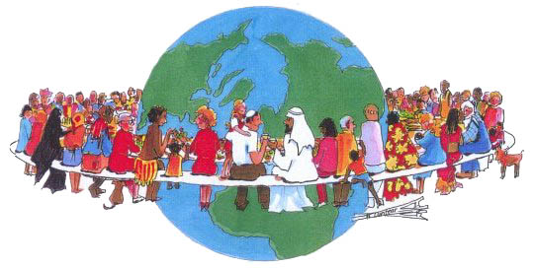
1. The evolution of human consciousness is a continuous process.
History here serves as a laboratory, and the past serves as [contextualization] to understand regional laws and social structures. This understanding helps our progress toward an ideal society.
2. We are not born capable of judging fairly and wisely.
However, learning about various cultures helps us be good global citizens and improve our critical and analytical thinking skills.
3. Every historical site has an important story to tell.
These stories have inspired many people to strengthen their convictions and their commitment to fight injustice and oppression.
4. Heritage sites are our connection to the past.
Heritage sites are living monuments and records of [important] happenings, and this is our real connection to our past.
Retrieved from: https://www.gounesco.com/why-preserve-heritage-sites/
Used with permission from GoUNESCO

