Grades 6-8 Korean War Inquiry

How Can Media Be Used to Influence Others?

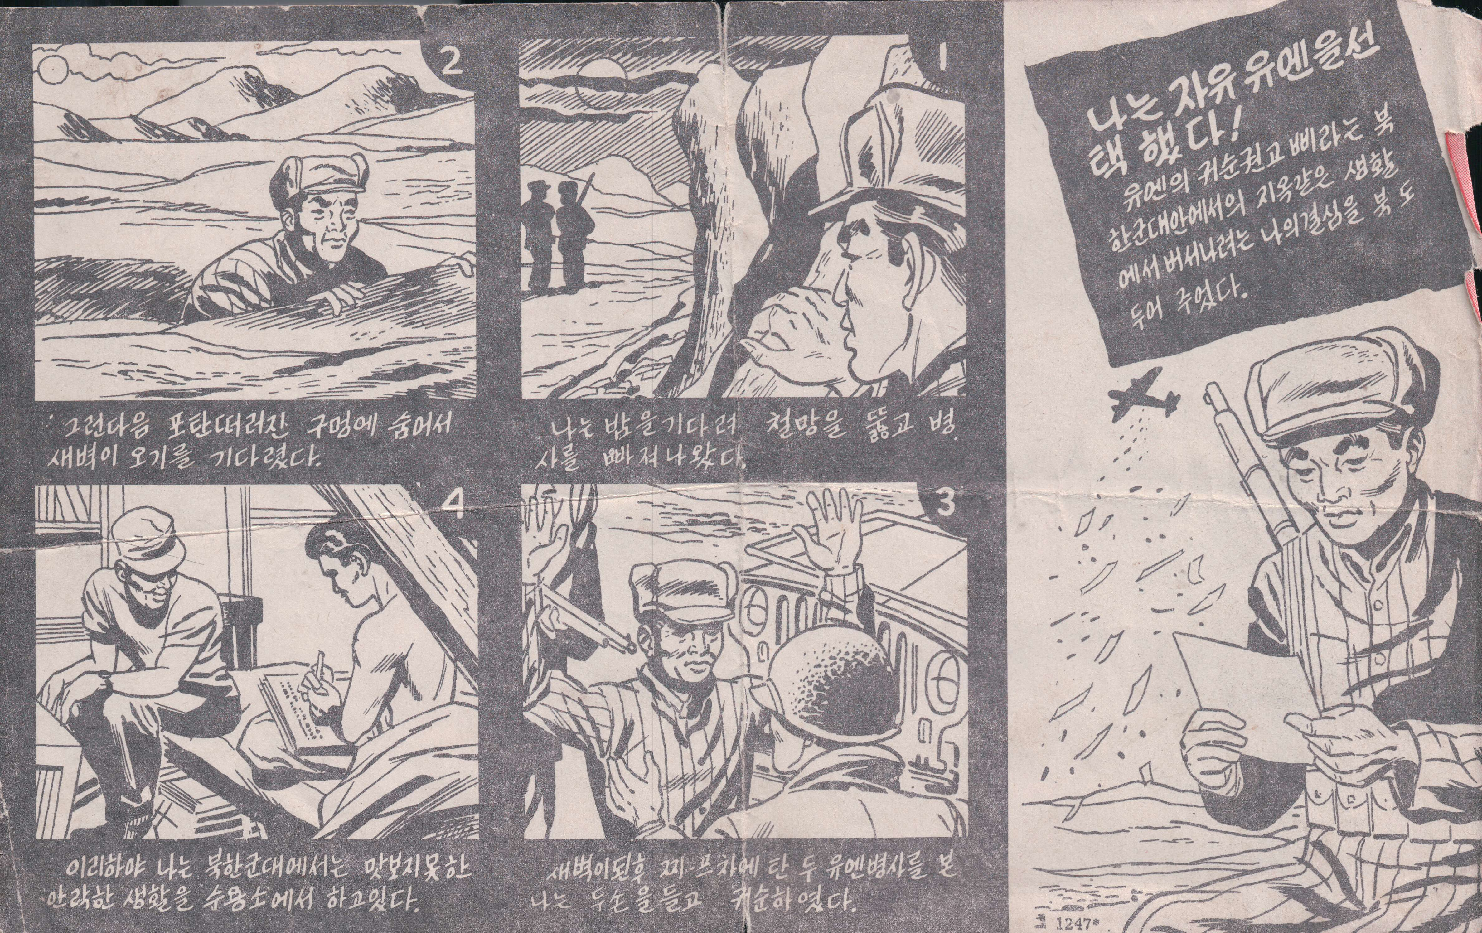
The front of a leaflet spread by airplane encouraging the North Koreans to surrender to the United Nations. Joseph Horton obtained it in December of 1952 while staying in the frontline position.
Image and description credit: Summons to Surrender to UN Front, 1952, Korean War Legacy Project

Used with permission from the Korean War Legacy Project

Supporting Questions
    - How was media used and misused during the Korean War?
    - How is media used and misused in contemporary society, politics, and war?

Grades 6-8 Korean War Inquiry
How Can Media Be Used to Influence Others?
C3 Framework Indicator | D2.His.4.6-8. Analyze multiple factors that influenced the perspectives of people during different historical eras.
Staging the Compelling Question | Explore the uses of media on the battlefield during the Korean War by viewing a US military video.

Supporting Question 1 |  | Supporting Question 2
How was media used and misused during the Korean War? |  | How is media used and misused in contemporary society, politics, and war?
Formative Performance Task |  | Formative Performance Task
Make a T-chart listing uses and misuses of media during the Korean War. |  | Expand on the T-chart by including additional uses and misuses of media in contemporary society, politics, and war.
Featured Sources |  | Featured Sources
Source A: Video clip, interview with Charles Gaush  Source B: Video clip, interview with Norman Renouf  Source C: Media artifacts (leaflets) used on Korean War battlefields |  | Source A: Video clip, How Does Fake News Become News?  Source B: Article (interview transcript) on how social media is reshaping contemporary conflict  Source C: Selected slides from Lee Rainie’s presentation, “The New Age of Politics and Media”

Summative Performance Task | ARGUMENT Construct an argument (e.g., detailed outline, poster, or essay) that responds to the compelling question—“How can media be used to influence others?”—using specific claims and relevant evidence from the sources provided and one other source, while acknowledging competing views.
 | EXTENSION Using the argument as a foundation, design a questionnaire to disseminate to others and use the data collected to predict how the use and misuse of media may influence politics, society, and war in the next decade.
Taking Informed Action | UNDERSTAND Consider how the use and misuse of media may have an impact on ensuring an informed citizenry.  ASSESS Evaluate how the use and misuse of media may threaten democratic ideals.  ACT Working with a partner, create an infographic, a 30-second commercial, or a public service announcement to inform your peers or your community about how to identify and evaluate credible media sources.

Overview

Inquiry Description
This inquiry leads students through an investigation of the uses and misuses of media such as leaflets and radio broadcasts during the Korean War, and the uses and misuses of media in contemporary society, politics, and war. By investigating the compelling question of how media can be used to influence others, students attempt to explore the uses and misuses of media through historical and contemporary lenses. The formative performance tasks build on knowledge and skills developed through the inquiry and help students demonstrate the specific ways media was used and misused during the Korean War and in contemporary society, politics, and war.
This inquiry requires prerequisite knowledge of historical events and ideas. Thus, students should be somewhat familiar with the impact media has on influencing others and the phenomenon of “fake news.”
NOTE: This inquiry is expected to take three 40-minute class periods. The inquiry timeframe could expand if teachers think their students need additional instructional experiences (i.e., supporting questions, formative performance tasks, and featured sources). Teachers are encouraged to adapt the inquiries​ in order to meet the requirements and interests of their particular students. Resources can also be modified as necessary to meet individualized education programs (IEPs) or Section 504 plans for students with disabilities.

Structure of the Inquiry
In addressing the compelling question, “Can media be used to influence others?,” students work through a series of supporting questions, formative performance tasks, and featured sources in order to construct an argument supported by evidence while acknowledging competing perspectives.

Staging the Compelling Question
In staging the compelling question, teachers may prompt students with a clip from a US military primary source video depicting the use of media (e.g. print leaflets, radio broadcasts) during the Korean War.

Supporting Question 1
The first supporting question, “How was media used and misused during the Korean War?,” asks students to view two clips from veterans, and explore primary source artifacts. The formative performance task asks students to demonstrate specific ways in which media was used and misused during the Korean War. Two of the featured sources for this question are video clips from the Korean War Legacy Foundation, and the third source consists of primary source artifacts (leaflets) from the Korean War Legacy Foundation.

Featured Source A is a video clip from a Korean War Legacy Foundation interview with Charles Gaush, in which he discusses the use of media during the Korean War. In Featured Source B, also a video clip from a Korean War Legacy Foundation interview, Norman Renouf discusses media techniques used by the Chinese in the POW camps during the war. Featured Source C is a primary source set of artifacts depicting media leaflets used on the battlefield during the war; these artifacts are part of the Korean War Legacy Foundation archives.

Supporting Question 2
The second supporting question asks, “How is media used and misused in contemporary society, politics, and war?” The formative performance task asks students to demonstrate specific ways media is used and misused in the contemporary context. Augmenting the previous featured sources, those offered here provide students with additional materials that allow them to explore the uses and misuses of contemporary media in society, politics, and war.
Featured Source A is a short video from Teaching Tolerance about how fake news becomes news. Featured Source B is an article/interview transcript from VOX addressing how social media is changing conflict in the contemporary world. Featured Source C is a selection of slides from a 2017 presentation on “The New Age of Politics and Media,” by Lee Rainie, director of internet and technology research at the Pew Research Center.

Summative Performance Task
At this point in the inquiry, students have explored how media was used and misused during the Korean War, and have examined how media is used and misused in contemporary society, politics, and war.
Students should be able to demonstrate the breadth of their understanding and their ability to use evidence from multiple sources to support their claims. In this task, students construct an evidence-based argument using multiple sources to answer the compelling question, “How can media be used to influence others?” Students’ arguments may take a variety of forms, including a detailed outline, poster, or essay.
Students’ arguments will vary, but could include any of the following:
- During times of war, media can be used and misused as a weapon of war against the enemy.
- Media can be used to influence political decisions.
- Media can be used to promote false or fake news.
To extend students’ arguments, teachers may have students design a questionnaire for dissemination to their peers to predict how the use and misuse of media may influence politics and society in the coming decade.
Students have the opportunity to Take Informed Action by drawing on their understandings about how the use and misuse of media may influence politics and society. To understand, students can consider how the use and misuse of media may have an impact on ensuring an informed citizenry. To assess the issue, students will evaluate how the use and misuse of media may threaten democratic ideals. To act, students will create either an infographic, a 30-second commercial, or a public service announcement to inform their peers or others in the community about how to identify and evaluate credible media sources.

Staging the Compelling Question
Featured Source | Source: Periscope Film, The Big Picture Psychological Warfare in the Korean War (35012), archival US military video (from counter 14:00 to 22:43) depicting the use of media during the Korean War; accessible at https://archive.org/details/35012PsychologicalWarfare

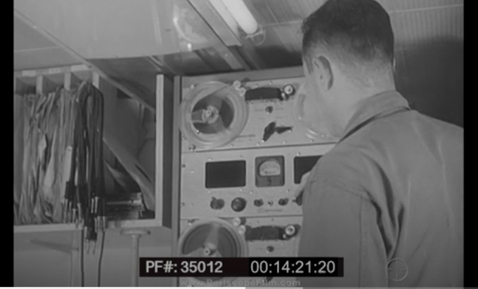
Source: Periscope Film, LLC

Supporting Question 1
Featured Source | Source A: Korean War Legacy Foundation, video clip of interview with Korean War veteran Charles Gaush, in which he discusses the use of media (leaflets) during the Korean War; accessible at https://koreanwarlegacy.org/interviews/charles-gaush/

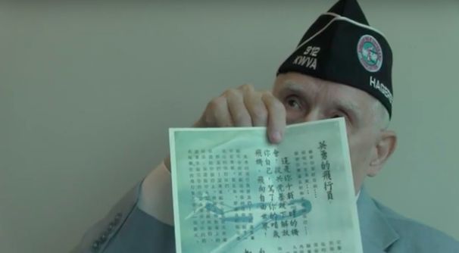
Source: Korean War Legacy Foundation

Used with permission from the Korean War Legacy Project

Supporting Question 1
Featured Source | Source B: Korean War Legacy Foundation, video clip of interview with Korean War veteran Norman Renouf, in which he discusses the media techniques used by the Chinese in the POW camps during the Korean War; accessible at https://koreanwarlegacy.org/interviews/norman-renouf/

Source: Korean War Legacy Foundation

Used with permission from the Korean War Legacy Project

Supporting Question 1
Featured Source | Source C: Korean War Legacy Foundation, primary source set of media artifacts (leaflets) used on the battlefield during the Korean War; images accessible at individual links below

The front of a flyer spread by airplane encouraging the North Koreans to surrender to the United Nations.
http://www.kwvdm.org/detail_artifact.php?no=2161

The back of a flyer spread by airplane encouraging the North Koreans to surrender to the United Nations.
http://www.kwvdm.org/detail_artifact.php?no=2162

The front of a letter written to Koreans interested in becoming a KATUSA and help the 45th division.
http://www.kwvdm.org/detail_artifact.php?no=2163

Safe Conduct Pass
http://www.kwvdm.org/detail_artifact.php?no=4538

Norman Champagne's handwriting on Christmas Propaganda
http://www.kwvdm.org/detail_artifact.php?no=42

A propaganda letter from the Chinese people's volunteer forces
http://www.kwvdm.org/detail_artifact.php?no=1039

Propaganda to North Korean soldiers
http://www.kwvdm.org/detail_artifact.php?no=1035

A propaganda flyer from the Chinese people's volunteer forces
http://www.kwvdm.org/detail_artifact.php?no=1040

Source: Korean War Legacy Foundation

Used with permission from the Korean War Legacy Project

Supporting Question 2
Featured Source | Source A: Teaching Tolerance, video, How Does Fake News Become News?, 2017; accessible at https://www.youtube.com/watch?v=qcRWkkSvfj0
SP
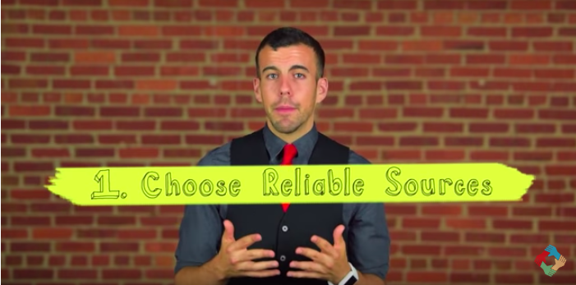
Used with permission from Teaching Tolerance, a project of the Southern Poverty Law Center. www.tolerance.org

Supporting Question 2
Featured Source | Source B: Article/transcript of VOX interview with David Patrikarakos, author of War in 140 Characters (2017); accessible at https://www.vox.com/world/2017/12/8/16690352/social-media-war-facebook-twitter-russia

“Social media has transformed the way that wars are waged, covered, and consumed.”

David Patrikarakos, a London-based author and journalist, begins his book War in 140 Characters with this claim. Though wars are still fought on the battlefield, they are increasingly shaped by competing narratives on social media, he argues.

Excerpted from: https://www.vox.com/world/2017/12/8/16690352/social-media-war-facebook-twitter-russia

Supporting Question 2
Featured Source | Source C: Lee Rainie (director of internet and technology research at Pew Research Center), selected slides from a presentation, “The New Age of Politics and Media,” Flager College, St. Augustine, Florida, February 16, 2017; the full presentation is accessible at http://www.pewinternet.org/2017/02/27/the-new-age-of-politics-and-media/

