K-2 Korea Map Inquiry
What Is the Most Important Information a Map Can Tell Us?

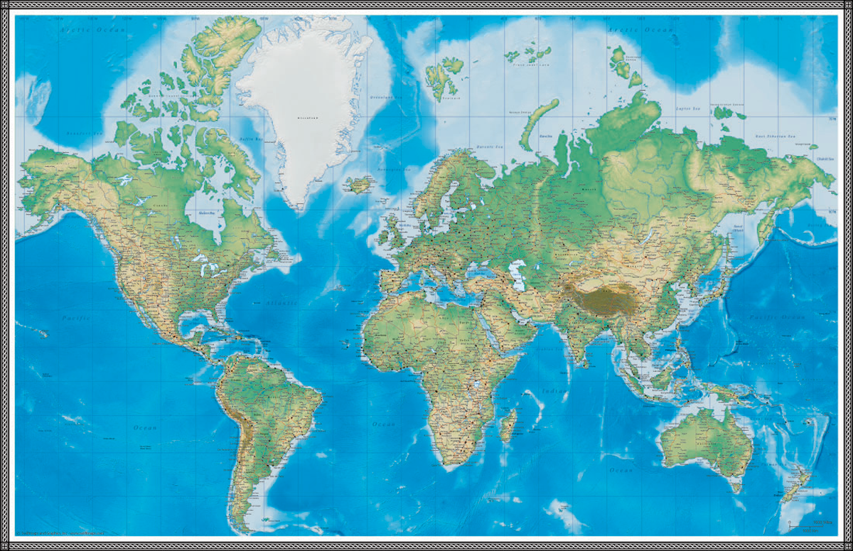
https://www.swiftmaps.com/wp-content/uploads/Swiftmaps-World-Geo-Physical-Full.png

Supporting Questions
    - What are the common characteristics of a map?
    - What can we learn about Korea by studying maps?

K-2 Korea Map Inquiry
What Is the Most Important Information a Map Can Tell Us?
C3 Framework Indicator | D2. Geo.3.K-2. Use maps, globes, and other simple geographic models to identify cultural and environmental characteristics of places.
Staging the Compelling Question | Teachers will show students the National Geographic video clip on how maps are made, and have students find their location and the location of South Korea and/or the Korean Penisula on a map.

Supporting Question 1 |  | Supporting Question 2
What are the common characteristics of a map? |  | What can we learn about Korea by studying maps?
Formative  Performance Task |  | Formative  Performance Task
Create a list of the common characteristics of a map (e.g., title, scale, symbols, cities, rivers). |  | Share observations about the map set with a partner and write down two of these observations.
Featured Sources |  | Featured Sources
Source A: Political map of North America  Source B: “South Up” world map  Source C: Map of Korean Peninsula  Source D: Population density map of South Korea |  | Source A: Gapminder mapping tool: income over time  Source B: Political map of Southeast Asia  Source C: Historical map of Korean Peninsula (1730)  Source D: Map of major Korean rivers (in English and Korean)

Summative Performance Task | ARGUMENT What is the most important thing maps can teach us about Korea? Construct an argument in the form of a poster or drawing that addresses the compelling question.
 | EXTENSION Construct an argument about the most important information maps can tell us about the world, or generalizing the case study of Korea to the broader use of maps.
Taking Informed Action | UNDERSTAND Discuss the idea that maps can be an important part of telling a story about a community.  ASSESS Compare a variety of local/community maps drawn at different scales or focusing on different features, and determine the advantages of some maps over others.  ACT Create a map of your community including the most important information you would want someone to know about your place.

Overview

Inquiry Description
This inquiry leads students through an investigation of maps, the common characteristics of maps, and the stories maps can tell about a place. By investigating the compelling question, “What is the most important information a map can tell us?,” students evaluate a set of maps with a focus on the Korean Peninsula as a case study. The formative performance tasks build on knowledge and skills through the course of the inquiry, help students deepen their understanding of maps and their value as a tool for understanding the world, and build content knowledge about the Korean Peninsula. Using the map set provided, students create an evidence-based argument about the most important piece of information they learned.
This inquiry is designed to provide students with an introduction to maps as a resource and to the Korean Peninsula. This focused inquiry should not require prerequisite knowledge; however, some of the maps involve concepts that students may need some scaffolding to understand.
NOTE: This inquiry is expected to take one to two 30-minute class periods. The inquiry time frame could expand if teachers think their students need additional instructional experiences (i.e., supporting questions, formative performance tasks, and featured sources). Teachers may want to include other classroom resources in the exploration of maps; these might include globes, community maps, or other locally relevant tools and resources. Teachers are encouraged to adapt the inquiries​ in order to meet the requirements and interests of their particular students. Resources can also be modified as necessary to meet individualized education programs (IEPs) or Section 504 plans for students with disabilities.

Structure of the Inquiry
In addressing the compelling question, “What is the most important information a map can tell us?,” students work through a series of supporting questions, formative performance tasks, and featured sources in order to construct an argument supported by evidence.
The New York State P-12 Common Core Learning Standards for English Language Arts & Literacy offer social studies teachers numerous opportunities to integrate literacy goals and skills into their social studies instruction. The Common Core supports the inquiry process through reading rich informational texts, writing evidence-based arguments, speaking and listening in public venues, and using academic vocabulary to complement the pedagogical directions advocated in the New York State K-12 Social Studies Framework. At the end of this inquiry is an explication of how teachers might integrate literacy skills into the content, instruction, and resource decisions they make. The Common Core connections are listed on the last page of this inquiry.

Staging the Compelling Question
In staging the compelling question, teachers may provide students with one or both of the resources provided. The first featured source is a video clip from National Geographic about historical mapmaking processes. Teachers may want to use this video to highlight some of the most important concepts around the common features of most maps (e.g., key, title, scale, compass rose). The second featured source is a map highlighting North America and East Asia. Because this compelling question includes a case study of Korea, this map has been provided so students can find their location (state, community, or region) and then find Korea. This helps students begin to see these places’ relative locations, which provides a grounding for the rest of the sources and supporting questions.
Supporting Question 1
In answering the first supporting question, “What are the common characteristics of maps?,” students analyze a set of maps and identify the common characteristics they find. These characteristics might include title, compass rose, or other features. The formative performance task asks students to create a list of these characteristics. The featured sources for this question provide a variety of world and regional maps that include a range of information, but support students in identifying common map features. The featured documents include a political map of North America, a “south up” world map, a thematic map of the climate and industry of the Korean Peninsula, and a population-density map. All of these maps include compasses, titles, keys and scales. These maps also work to further student understanding of the Korean Peninsula so they can grapple with the case study of this country toward the central compelling question of this inquiry.
Supporting Question 2
The second supporting question is, “What can we learn about Korea by studying maps?” Students discuss this question with a team and then make a bulleted list of the facts they observe about Korea from the map set. In addition to the resources from the previous supporting question, the featured sources provide students with additional materials that allow them to build an understanding of Korea. It may be appropriate to have students use other classroom resources, such as a globe, atlas, or wall map. Each of these featured sources helps build students’ understanding of Korea so they can evaluate the compelling question using Korea as a case study. The featured sources include a global income map, a Southeast Asia political map, a historical map (1730), and a map of the major rivers of the Korean Peninsula.

Summative Performance Task
At this point in the inquiry, students have examined a variety of maps: global and regional, as well as political, physical, and thematic.
Students should be expected to demonstrate the breadth of their understanding and their ability to use evidence from multiple sources to support their claims. In this task, students construct an evidence-based argument using multiple sources to answer the compelling question, “What is the most important information maps can tell us?” It is important to note that students’ arguments could take a variety of forms, including a drawing or oral presentation, particularly for young students who struggle with writing.
Students’ arguments will likely vary, but could include any of the following:
- The most important thing we can learn from a map is the location of places around the world.
- The most important information is related to the economy or industry of a country.
- The most important thing we can learn is information about the physical geography (rivers, oceans, mountains).
- We can learn about cities and populations by studying maps.
- We can learn something about what life is like for people around the world (language, climate, income, industry) by studying maps.
- We can learn about the history of a community or country by studying maps.
To extend their arguments, teachers may have students construct an argument about the most important information maps can tell us about the world, or generalize from their case study of Korea to the broader use of maps.
Students have the opportunity to Take Informed Action by drawing on their understandings that maps can provide important and interesting information about a place. To understand, students can engage in a teacher-led discussion on the idea that maps can be an important part of telling a community’s story. To assess maps as storytelling tools and resources to communicate key data, students can assess maps of their local communities and consider what story is being told, what data is available, and how maps contribute to our understanding. To act, students can create a map of their community that includes the most important information they want to share about their community.
For further reading on community mapmaking with elementary learners, reference David Sobel’s Mapmaking with Children: Sense of Place Education for the Elementary Years (1998).
Children’s literature that includes themes of community mapmaking might also be helpful to young students as they engage with this question; examples include:

DiSalvo-Ryan, D. (2000). Grandfather’s Corner Store. New York: HarperCollins.

Sweeney, J. (2014). Me on the Map. New York: Knopf Books for Young Readers.

Leedy, L. (2000). Mapping Penny's World. New York: Henry Holt and Company.

Staging the Compelling Question
Featured Source | Source A: National Geographic video  https://news.nationalgeographic.com/2018/01/road-map-vintage-video-1940-mapmakers-cartography/

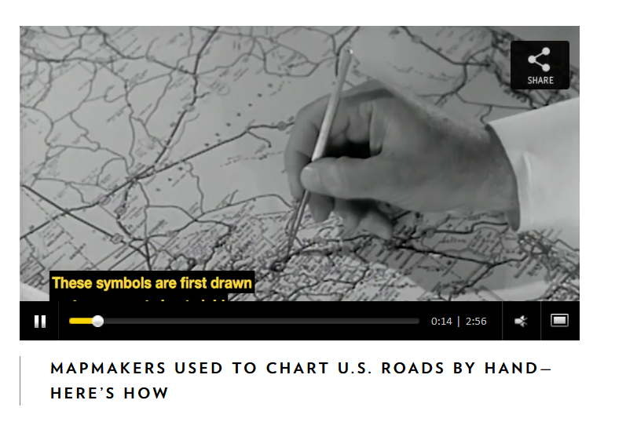

Staging the Compelling Question
Featured Source | Source B: Google map of North America and Asia

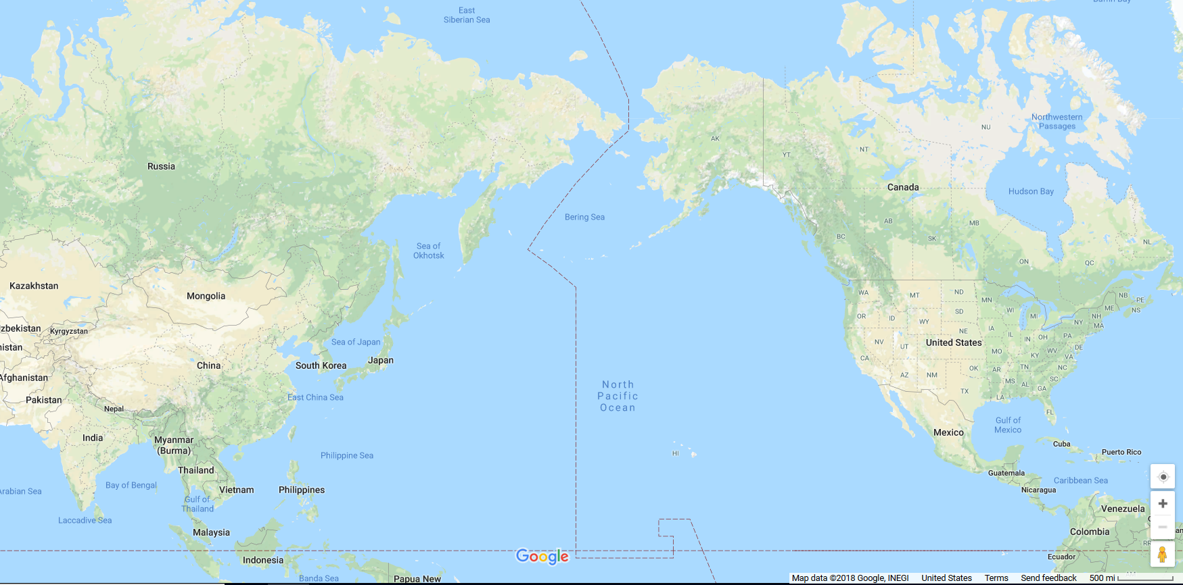

Source: Google Maps

Supporting Question 1
Featured Source | Source A: Political map of North America

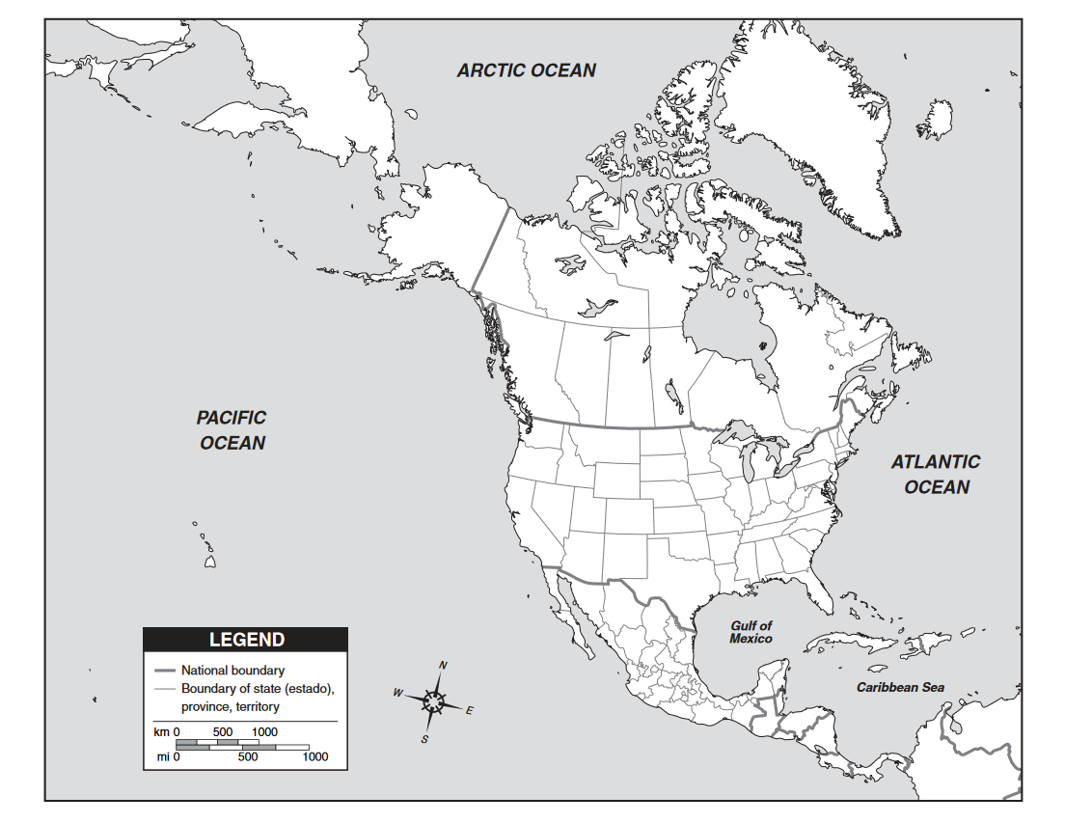

https://www.eduplace.com/ss/maps/pdf/n_america_pol.pdf

Used with permission from Houghton Mifflin Company

Supporting Question 1
Featured Source | Source B: “South up” world map

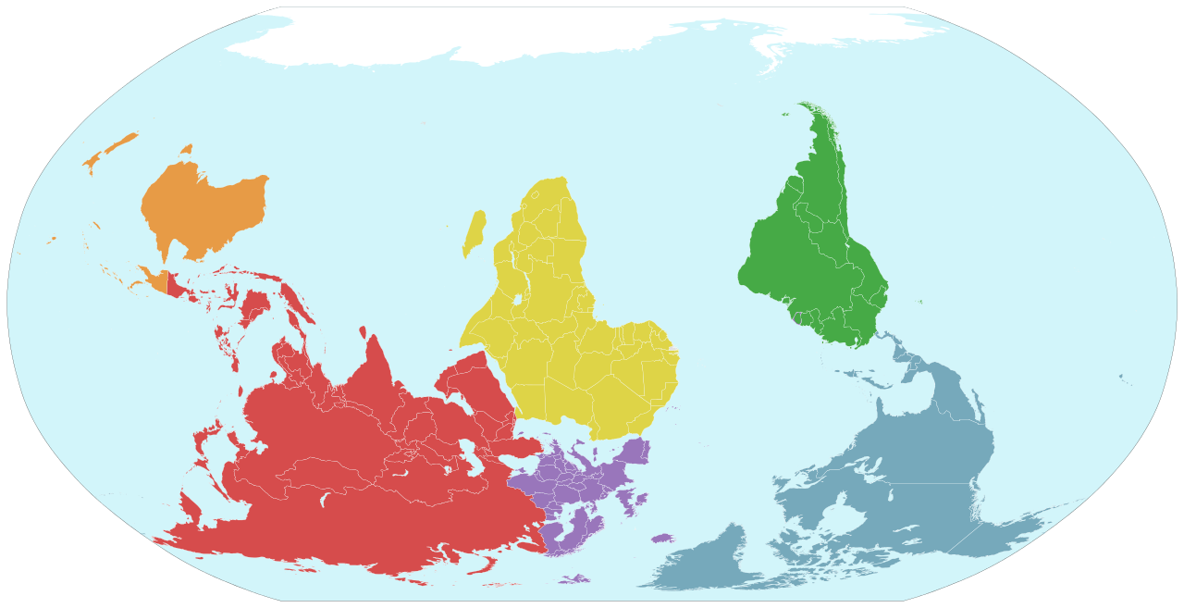

https://commons.wikimedia.org/wiki/File:Seven_continents_world_upside_down.svg

https://creativecommons.org/licenses/by/3.0/

Supporting Question 1
Featured Source | Source C: Map of Korean Peninsula

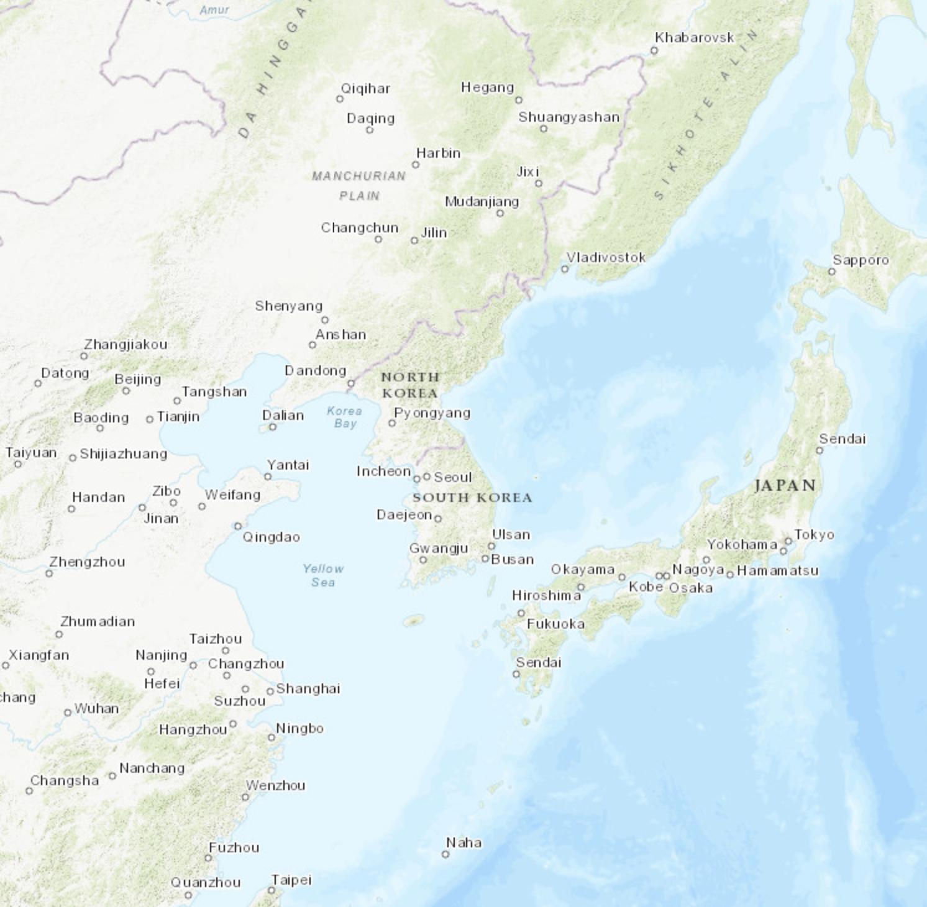

Source: Google Maps

Supporting Question 1
Featured Source | Source D: Population density map of South Korea

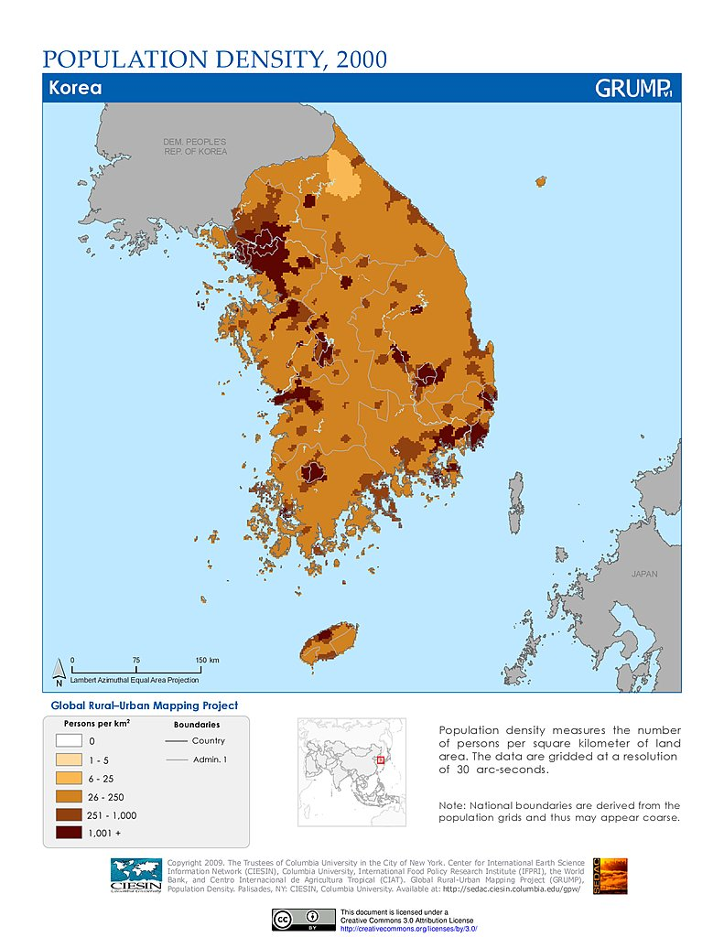

http://sedac.ciesin.columbia.edu/downloads/maps/grump-v1/grump-v1-population-density/kordens.jpg

https://creativecommons.org/licenses/by/3.0/

Supporting Question 2
Featured Source | Source A: Gapminder mapping tool: income over time

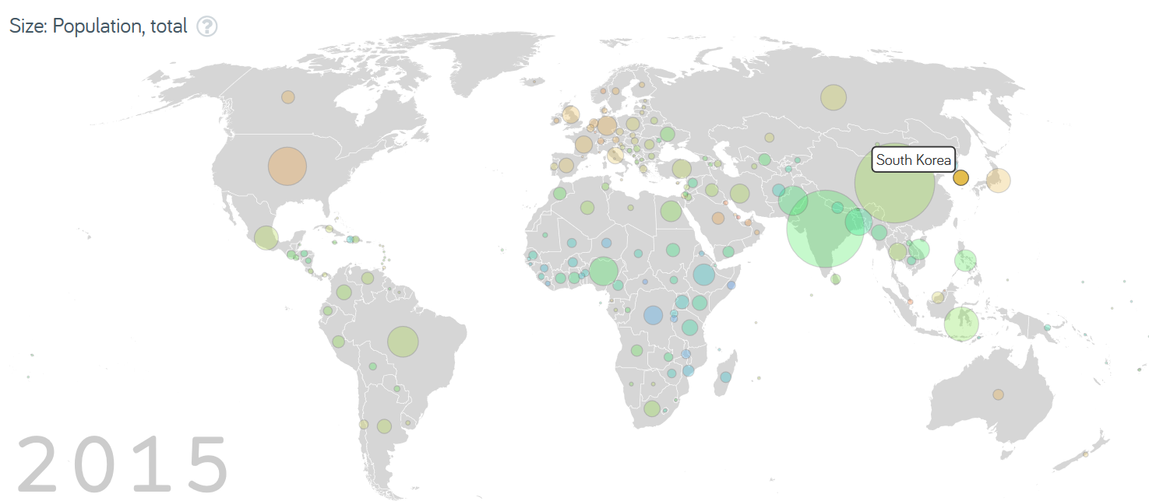

https://www.gapminder.org/

https://creativecommons.org/licenses/by/3.0/

h

ttps://creativecommons.org/licenses/by/3.0/

Supporting Question 2
Featured Source | Source B: Political map of Southeast Asia

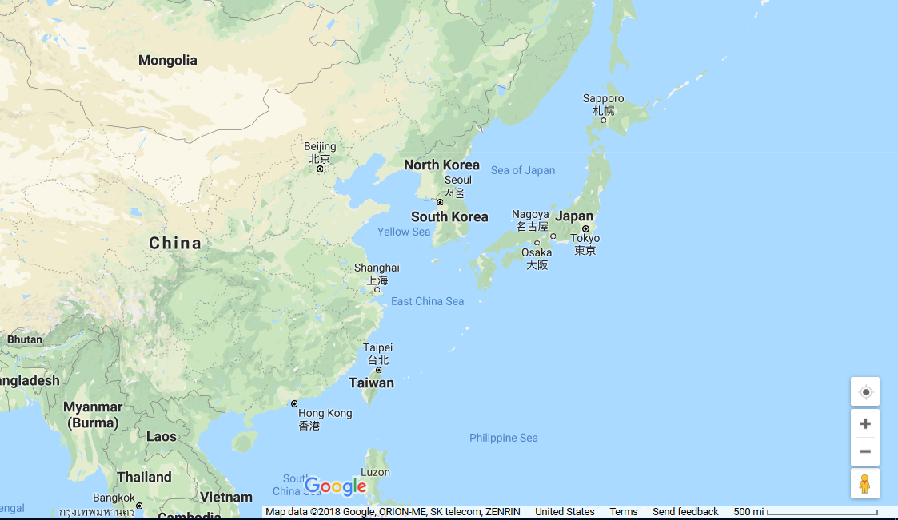

https://www.google.com/maps/place/Korea/

Supporting Question 2
Featured Source | Source C: Historical map of Korean Peninsula (1730)

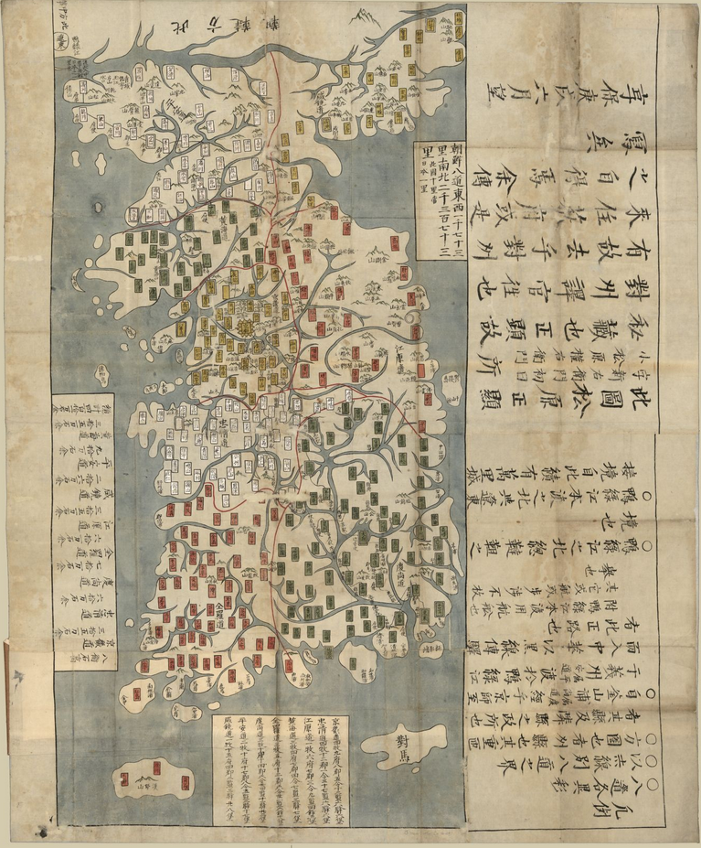

https://www.loc.gov/resource/g7900.ct003255/
Credit: Library of Congress, Geography and Map Division

Supporting Question 2
Featured Source | Source D: Map of major Korean rivers (in English and Korean)

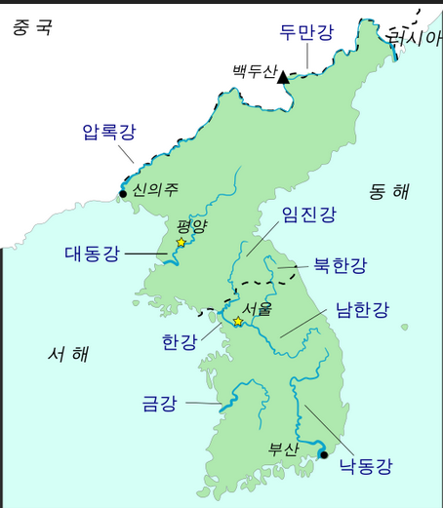
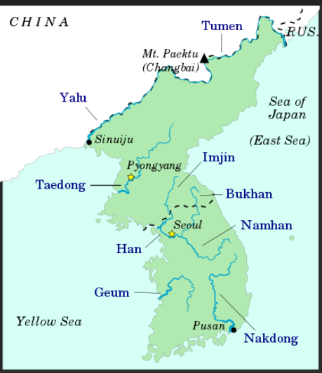
https://upload.wikimedia.org/wikipedia/commons/thumb/5/53/Korea_rivers_%28ko%29.svg/796px-Korea_rivers_%28ko%29.svg.png

https://www.revolvy.com/page/List-of-rivers-of-Korea

https://creativecommons.org/licenses/by/3.0/

