Grades 9-12 Korean War Inquiry
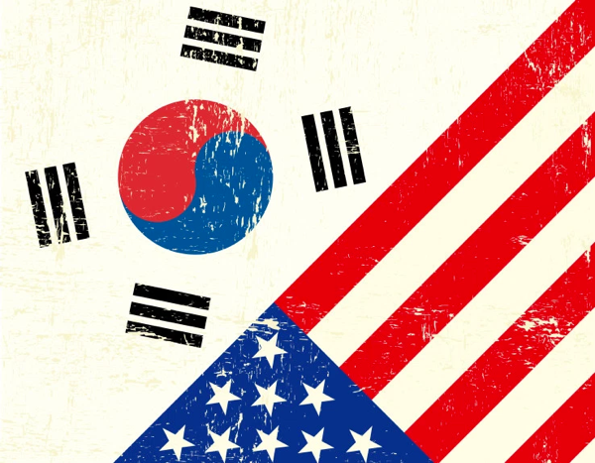
What Has Korea Meant to the United States?

Supporting Questions
    - What did the Republic of Korea mean to the US during the US occupation?
    - How did the relationship between the US and the Republic of Korea change during the Korean conflict?
    - What has the Republic of Korea meant to the US since the Korean conflict?

Grades 9-12 Korean War Inquiry
What Has Korea Meant to the United States?
C3 Framework Indicator | D2.His.1.9-12. Evaluate how historical events and developments were shaped by unique circumstances of time and place as well as broader historical contexts.
Staging the Compelling Question | Watch the documentary from the Korean War Legacy Project and take notes about the types of relationships that it highlights. Use these notes to engage in a whole-class conversation about the personal and political relationships that have been forged between Korea and the US since 1945.

Supporting Question 1 |  | Supporting Question 2 |  | Supporting Question 3
What did the Republic of Korea mean to the US during the US occupation? |  | How did the relationship between the US and the Republic of Korea change during the Korean conflict? |  | What has the Republic of Korea meant to the US since the Korean conflict?
Formative  Performance Task |  | Formative  Performance Task |  | Formative  Performance Task
List two reasons the US occupied Korea, and cite evidence from the sources to support your reasoning. |  | Write one to two paragraphs that answer Supporting Question 2 using evidence from the sources. |  | Construct a claim using evidence to answer Supporting Question 3.
Featured Sources |  | Featured Sources |  | Featured Sources
Source A: Memo from Dean Acheson to Harry S. Truman, September 14, 1945  Source B: War Department Incoming Classified Message, September 18, 1945  Source C: “The Situation in Korea” (excerpt), Office of Reports and Estimates 5, January 3, 1947  Source D: Correspondence from George C. Marshall to Kenneth Royall, June 23, 1948  Source E: “The Position of the United States with Respect to Korea” (excerpt), National Security Council Report 8, March 16, 1949 |  | Source A: "The Truth about Korea," ca. 1950  Source B: US Department of State, Memorandum of Conversation on Korea, June 26, 1950  Source C: Oral history (excerpt) from Richard Hilton, Korean War Legacy Project (KWLP)  Source D: Oral history (excerpt) from Earl A. House, KWLP  Source E: Summary examining the United States’ role in involving the UN in the Korean War, United States Forces Korea (website)  Source F: Note to staff from Dwight D. Eisenhower on US policy towards Korea post-armistice; January, 5, 1954 |  | Source A: “Mutual Defense Treaty Between the United States and the Republic of Korea,” October 1, 1953  Source B: Oral history (excerpt) from George H. Campbell, KWLP  Source C: Oral history (excerpt) from former congressional representative Charles Rangel, KWLP  Source D: “Allies for 67 Years, US and South Korea Split Over North Korea,” New York Times, September 4, 2017

Summative Performance Task | ARGUMENT What has Korea meant to the United States? Construct an argument (e.g., detailed outline, poster, or essay) that discusses the compelling question using specific claims and relevant evidence from historical and contemporary sources while acknowledging competing views.
 | EXTENSION Develop an annotated timeline that charts the relationship between the Republic of Korea and the United States since 1945.
Taking Informed Action | UNDERSTAND Research how many US troops and military bases are on the Korean peninsula today and the current issues that challenge the US-Republic of Korea alliance.  ASSESS Write a list of pros and cons concerning the US military presence in the Republic of Korea, noting whether this ongoing relationship remains worthwhile for both countries.  ACT Create a position statement arguing for or against keeping US troops in the Republic of Korea and post the statement to the Asia Unbound blog, which is part of the Council on Foreign Relations Network.

Overview

Inquiry Description
This inquiry leads students through an investigation into the relationship between the United States and the Republic of Korea. By investigating the compelling question about the what Korea means to the United States, students will have to consider the ways in which government documents and oral histories provide a unique way to understand this strategic relationship and make a claim on the significance of the Korean peninsula to the United States military.

NOTE: This inquiry is expected to take four to seven 55-minute class periods. The inquiry time frame could expand if teachers think their students need additional instructional experiences (i.e., supporting questions, formative tasks, sources). Inquiries are not scripts, and teachers are encouraged to modify and adapt them in order to meet the requirements and interests of their particular students. Resources can also be modified as necessary to meet individualize education plans (IEPs) or Section 504 plans for students with disabilities.

Structure of the Inquiry
In addressing the compelling question, “What has Korea meant to the United States?,” students will work through a series of supporting questions, performance tasks, and sources in order to construct an argument with evidence and counterevidence from a variety of sources.

Staging the Compelling Question

To begin this inquiry, students watch a documentary from the Korean War Legacy Project. The focus of the documentary is a Korean War veteran revisiting Korea with his grandson. As students view the video, they should be prompted to take notes on the types of relationships highlighted in the documentary. After the video, students will use these notes to engage in a whole-class conversation about the personal and political relationships that have been forged between the Republic of Korea and the United States since 1945.

Supporting Question 1

The first supporting question “What did Korea mean to the United States during the US occupation?,” helps students establish a foundational knowledge of the United States’ purpose in Korea after the Japanese had been defeated and WWII ended. The formative performance task calls on students to use primary source documents to list the two main reasons behind the US occupation of Korea, and give evidence to support each reason. The featured sources for this supporting question are a collection of government documents and correspondence from the Truman administration; these are sequenced chronologically. Featured Source A is a 1945 memo from State Department Undersecretary Dean Acheson to President Harry S. Truman. Acheson’s memo details the situation in the Republic of Korea (South Korea) and includes as an attachment a recommended statement for Truman to make based on Acheson’s understanding of the situation. Featured Source B is a then-classified War Department message from 1947 explaining the situation on the Korean peninsula. Featured Source C is a 1947 report on the situation in the Republic of Korea and the development of a self-sufficient government by US occupying forces. Featured Source D is a letter sent in 1948 from the Secretary of State G. C. Marshall to the Secretary of the Army Kenneth Royall. The letter underlies the US decision to begin to pull forces out of Korea. Teachers will want students to dwell in the space this document creates as they work to answer, “How does the fact the US was pulling out troops in 1948 answer what Korea meant to the US?” Featured Source E is a declassified CIA argument from 1949 that highlights the situation in Korea as well as an assessment of the progress that has been made under the watch of the US government.

Supporting Question 2

For the second supporting question “How did the relationship between the US and the Republic of Korea change during the Korean conflict?,” students build on their understanding of Korea’s importance to the United States government by analyzing key government correspondence as well as oral histories from Korean War veterans. Students will work to synthesize the information from the featured sources and write one to two paragraphs that answer this supporting question. Featured Source A is a government paper (circa 1950), “The Truth about Korea,” which is a plea for bipartisan action at the domestic level, and restates the meaning and importance of Korea to the United States on an international level. Featured Source B is a memorandum of conversation between President Truman, State Department officials, and US military leadership detailing a conversation about the “Korean Situation” after the Democratic Peoples’ Republic of Korea (North Korea) invaded the Republic of Korea (South Korea). Featured Sources C and D are oral history excerpts from two veterans who recount what the relationship between the United States and the Republic of Korea meant during the conflict. Featured Source E is a summary of the United Nations Command’s service in the Korean Conflict. Students should be encouraged to think about the role the United States played in getting the United Nations involved, as well as the amount of support the United States gave as a member of the United Nations. Featured Source F is a memorandum from President Eisenhower to staff members detailing the United States’ continued commitment to the Republic of Korea even after the armistice that ended the war was signed.

Supporting Question 3

Having examined the relationship between the Republic of Korea and the United States after WWII as well as during the Korean War, students will now be asked to answer the supporting question, “What has the Republic of Korea meant to the United States since the Korean conflict?” The formative task asks students to answer the supporting question by drawing on the featured sources to build and support a claim. Featured Source A is the mutual defense treaty signed by the United States and the Republic of Korea on October 1, 1953; this formal agreement details the military relationship between the two nations after the Korean War. Featured Sources B and C are excerpts of oral histories from two veterans of the Korean War. In each, the veterans describe the importance of the relationship between the Republic of Korea and the United States. Teachers will want to point out that the veteran in Featured Source C is former congressman Charles Rangel from New York. Featured Source D is a New York Times article describing the strong relationship that has existed between the United Stated and the Republic of Korea for the last 67 years, and how rising tension with North Korea is complicating this longstanding alliance.

Summative Performance Task

In this task, students construct an evidence-based argument using multiple sources to answer the compelling question, “What has Korea meant to the United States?” Students’ arguments could take a variety of forms, including a detailed outline, poster, or essay.
Students’ arguments will vary, but could include any of the following:
- The meaning of the relationship between the United States and Korea has evolved over the last 80 years. Though initially about removing Japanese imperialism and reunifying the country, the relationship changed to be more about limiting the spread of communism, and later to preventing war on the peninsula.
- The relationship between the United States and Korea has been about stabilizing, but not reunifying, the peninsula. Though there were initial efforts to reunify North and South Korea, the relationship has more recently revolved around preventing communism and armed conflict from engulfing the region.
- The relationship between the United States and Korea has been mostly about protecting South Korea from outside influences. The US military’s involvement has centered around eliminating outside threats (e.g., Japanese imperialism and communism) in order to facilitate the establishment of a democratic government and ensuring economic security.
Students could extend the arguments by developing an annotated timeline charting the relationship between the Republic of Korea and the United States since 1945. Teachers will want to make sure that students not only chart the primary source documents that are the basis of this inquiry, but also examine important events that took place during the Korean War. The Korean War Legacy Project website provides valuable additional sources to examine as students develop their annotated timelines.

Students have the opportunity to Take Informed Action by examining what Korea means to the United States today. To understand, students can research how many US military personnel and bases are on the Korean peninsula today and the current issues that challenge the alliance between the two countries. To assess the issue, students could write a list of pros and cons concerning the US military presence in the Republic of Korea, noting whether the ongoing relationship between the United States and the Republic of Korea remains worthwhile for both countries. To act, students could create a position statement arguing for or against keeping US troops in the Republic of Korea, and then post their statements on the Asia Unbound blog maintained by the Council on Foreign Relations that examines the United States’ involvement in Asia.

Staging the Compelling Question
Featured Source | Source: Sultan Sharrief, “The Legacy: A Documentary,” Korean War Legacy Project; full-length, classroom-friendly, 20-minute documentary film accessible at the Korean War Legacy Project website at https://koreanwarlegacy.org

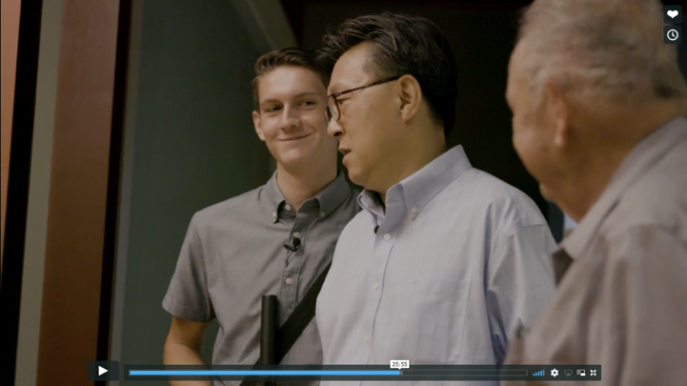

Used with permission from the Korean War Legacy Project

Supporting Question 1
Featured Source | Source A: Memo from Acting Secretary of State Dean Acheson to President Harry S. Truman, with suggested public statement clarifying the United States’ intentions specifically regarding Japanese officials stationed in Korea upon the Armed Forces occupation of the Korean capital, September 14, 1945

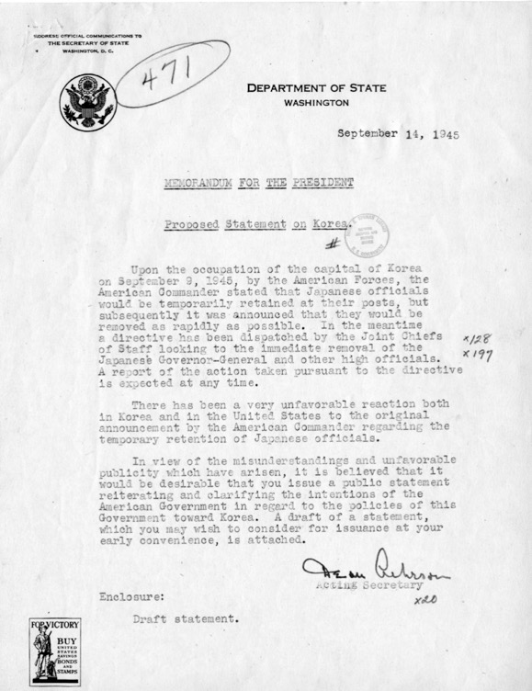

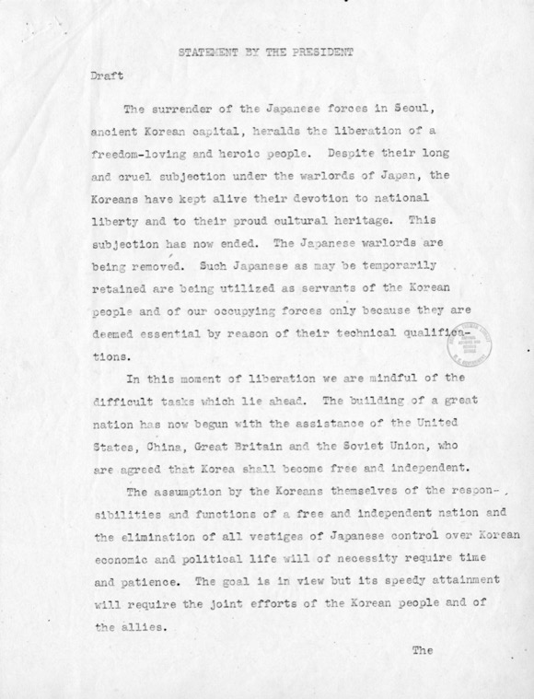

Supporting Question 1
Featured Source | Source B: War Department Incoming Classified Message describing “the general situation” in South Korea as “a powder keg ready to explode,” September 18, 1945

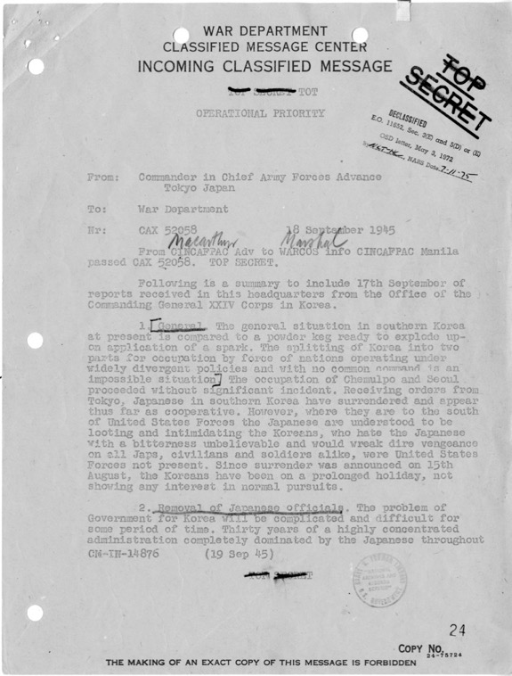

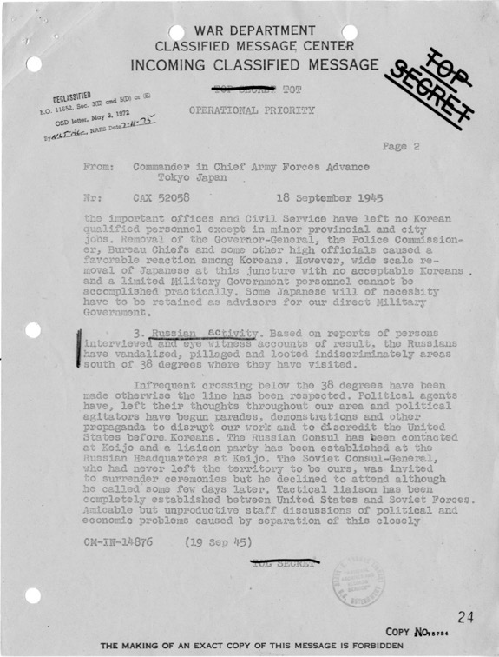
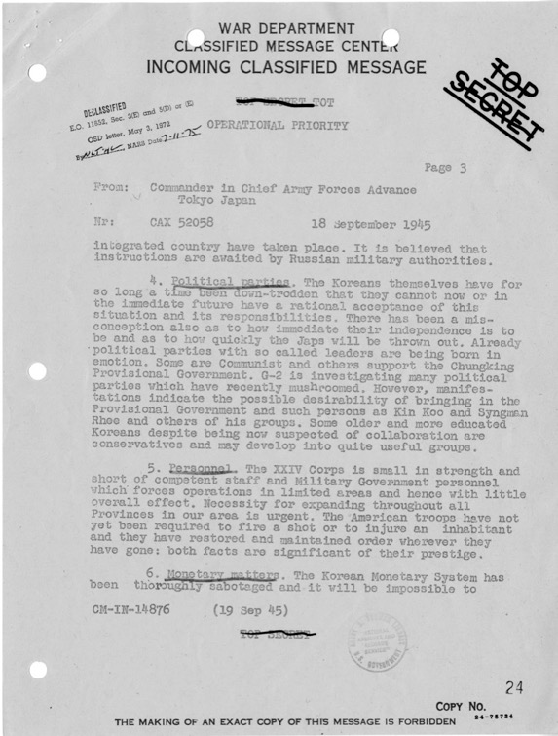
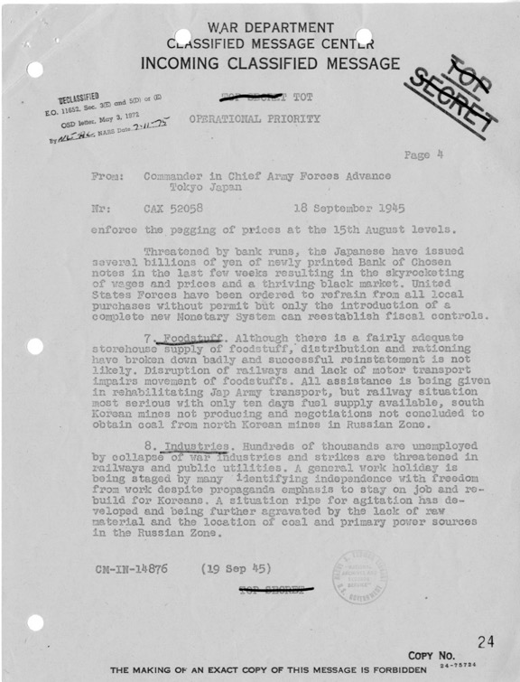
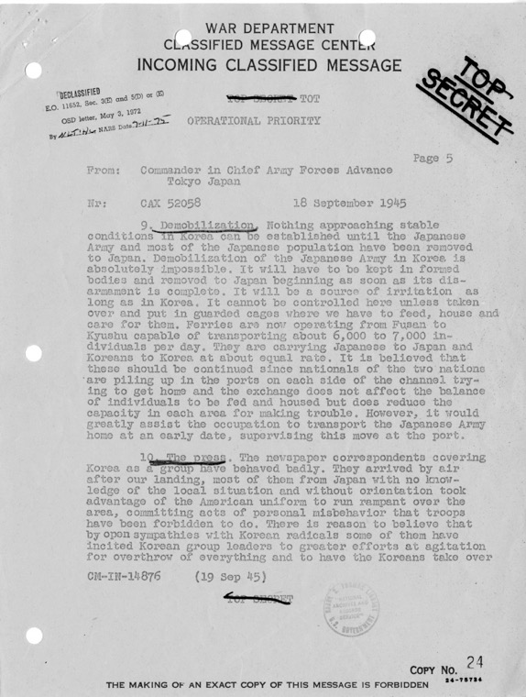
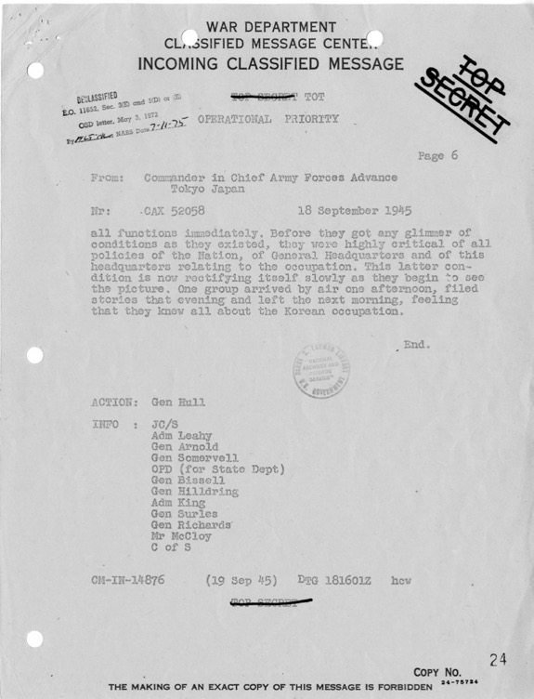

Source: Harry Truman Presidential Library: http://www.trumanlibrary.org/whistlestop/study_collections/koreanwar/index.php

Used with permission from the Harry Truman Presidential Library

Supporting Question 1
Featured Source | Source C: Central Intelligence Group report, “The Situation in Korea” (excerpt), Office of Reports and Estimates 5, January 3, 1947

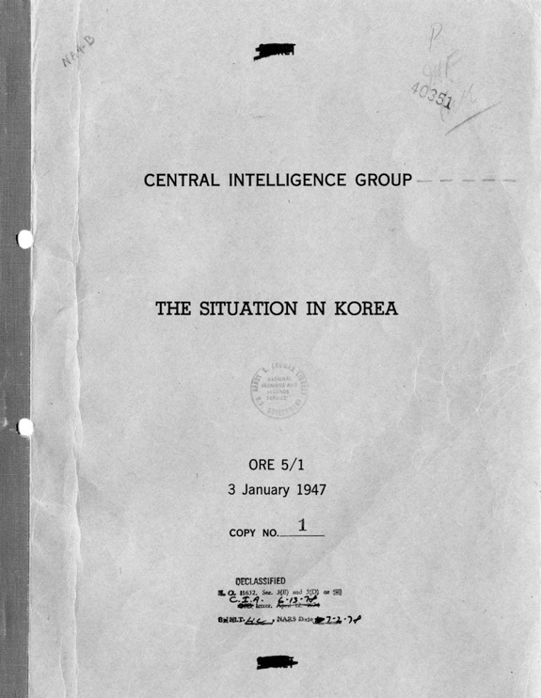

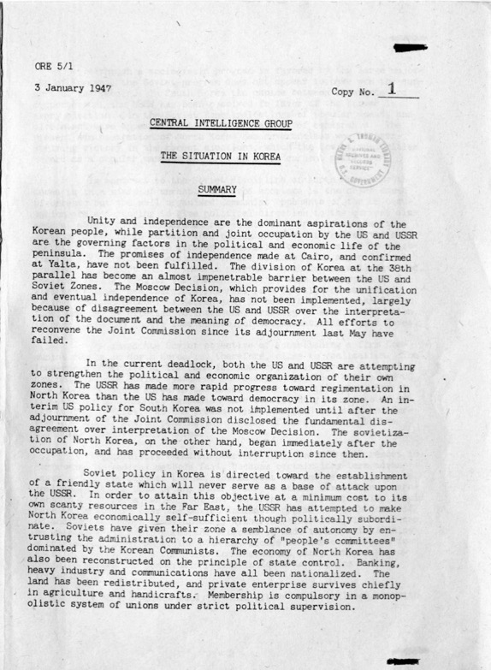

Source: Harry Truman Presidential Library: http://www.trumanlibrary.org/whistlestop/study_collections/koreanwar/index.php

Used with permission from the Harry Truman Presidential Library

Supporting Question 1
Featured Source | Source D: Correspondence from George C. Marshall to Kenneth Royall, following up on “The Position of the United States with Respect to Korea,” June 23, 1948

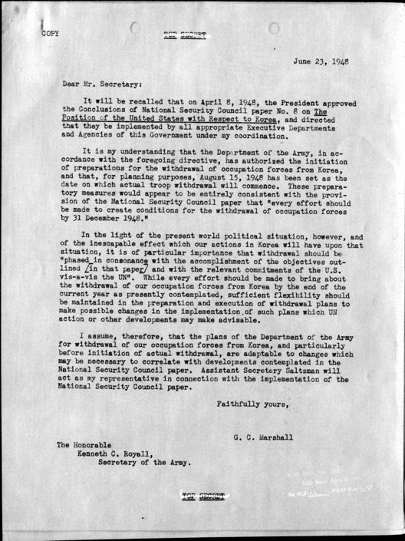

Source: Harry Truman Presidential Library: http://www.trumanlibrary.org/whistlestop/study_collections/koreanwar/index.php

Used with permission from the Harry Truman Presidential Library

Supporting Question 1
Featured Source | Source E: National Security Council report, “The Position of the United States with Respect to Korea” (draft, excerpt), March 16, 1949

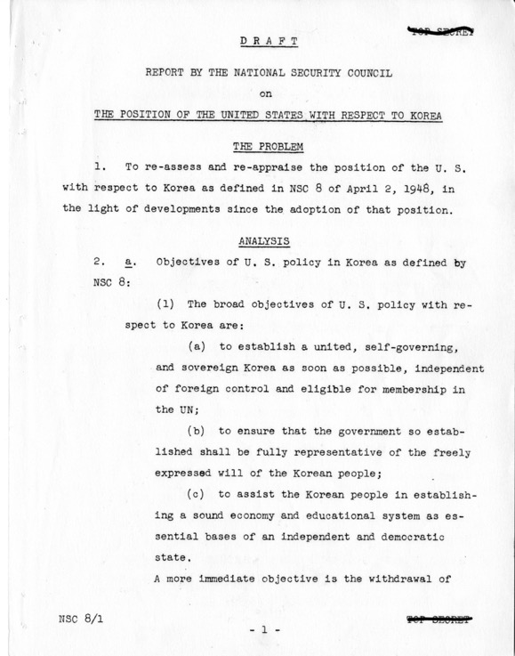

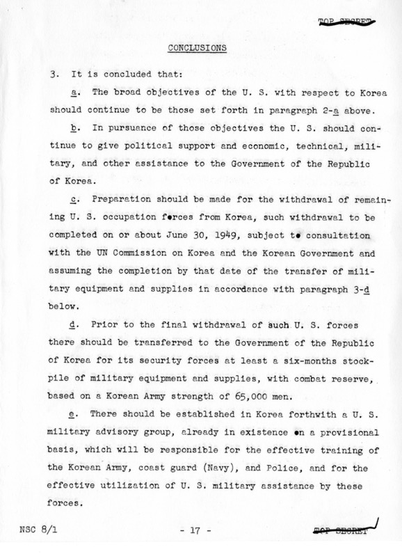
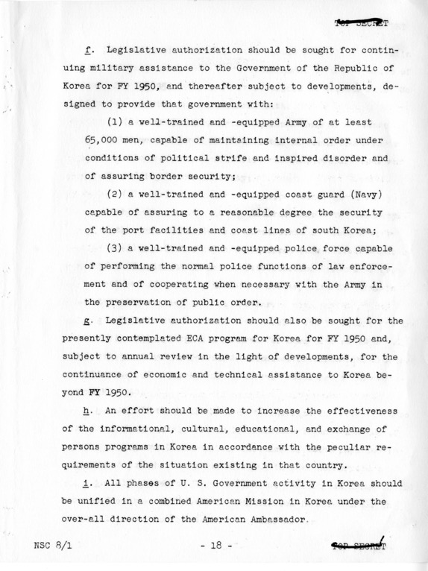
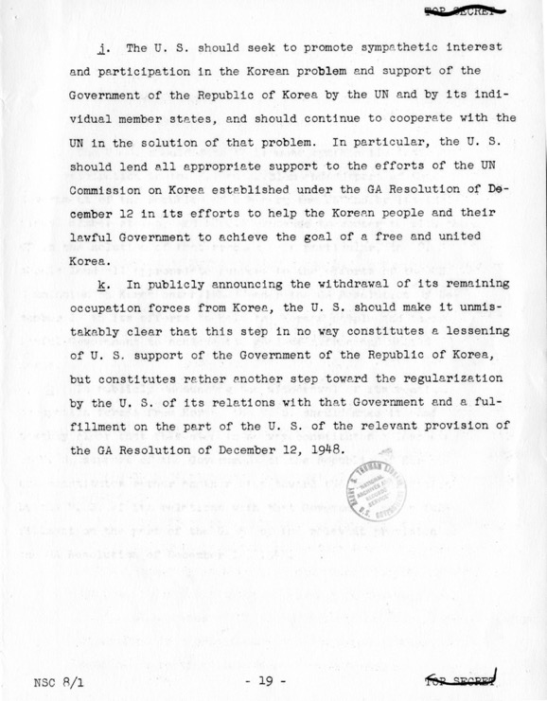

Source: Harry Truman Presidential Library: http://www.trumanlibrary.org/whistlestop/study_collections/koreanwar/index.php

Used with permission from the Harry Truman Presidential Library

Supporting Question 2
Featured Source | Source A: Unknown author, “The Truth about Korea,” ca. 1950

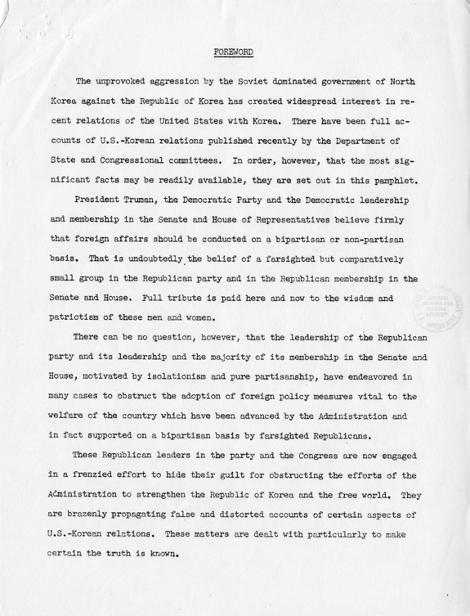

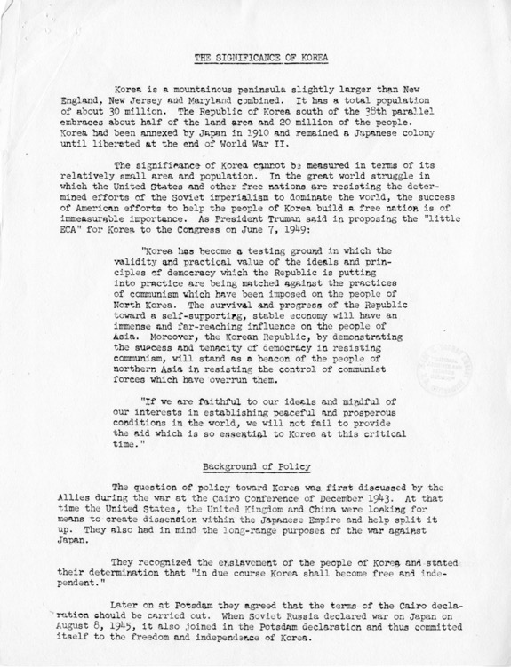
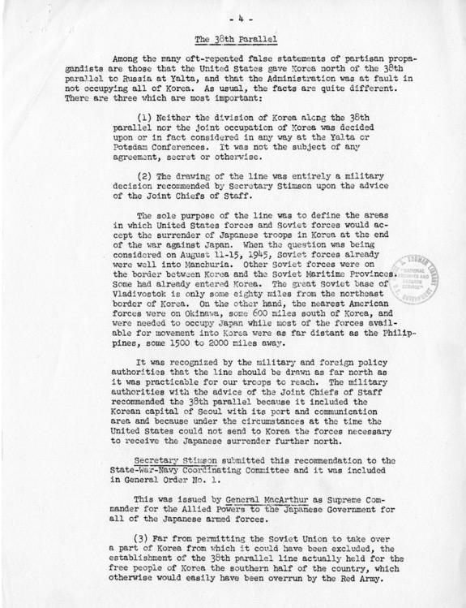

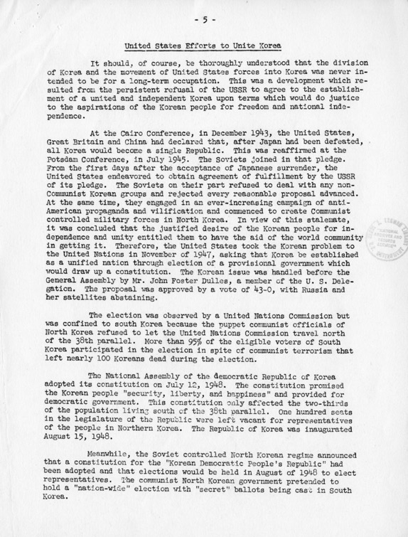
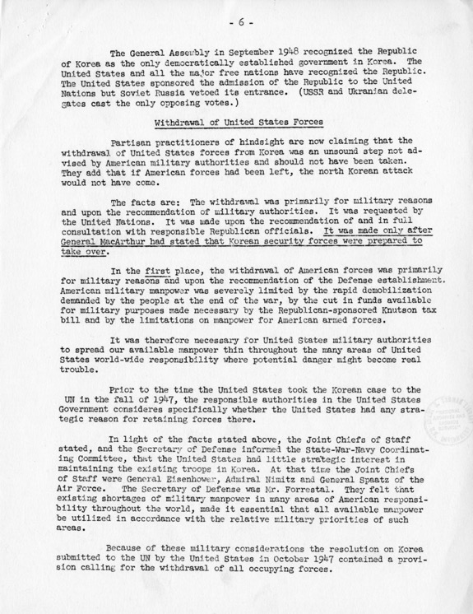

Source: Harry Truman Presidential Library: http://www.trumanlibrary.org/whistlestop/study_collections/koreanwar/index.php

Used with permission from the Harry Truman Presidential Library

Supporting Question 2
Featured Source | Source B: Department of State, Memorandum of Conversation, “Subject: Korean Situation,” June 26, 1950

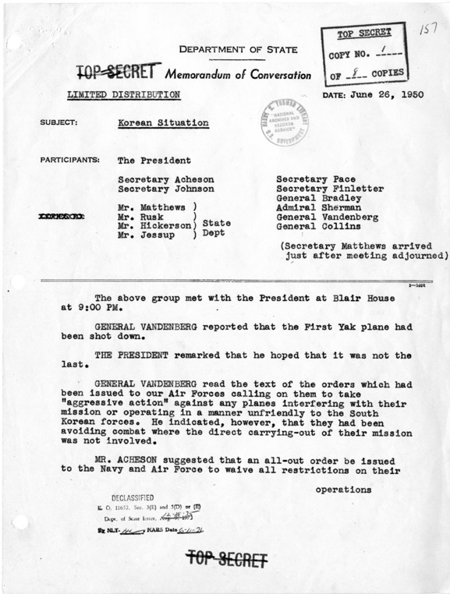
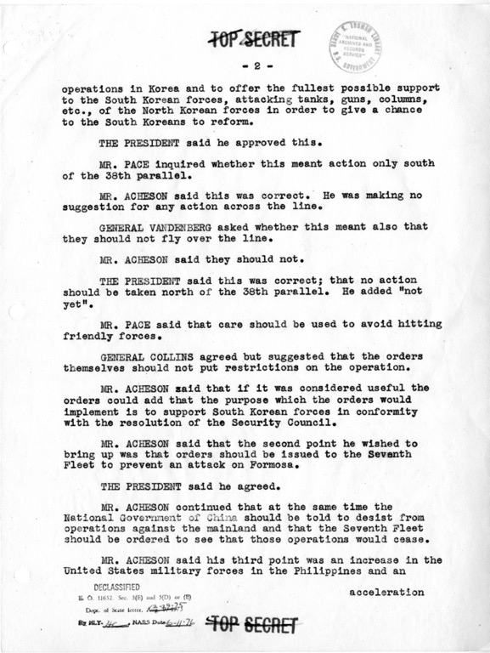
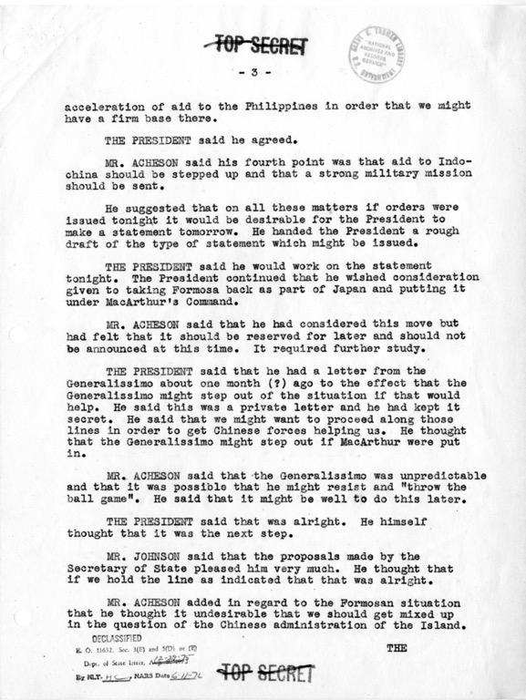
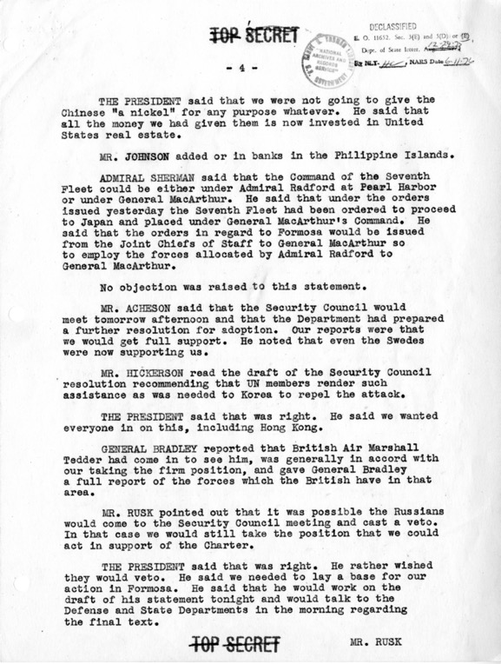
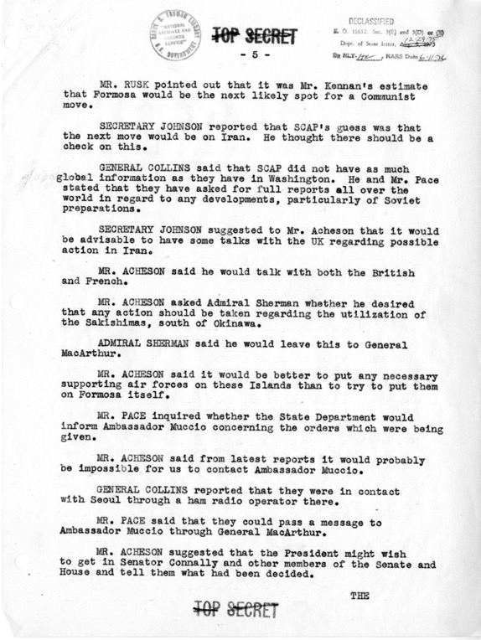
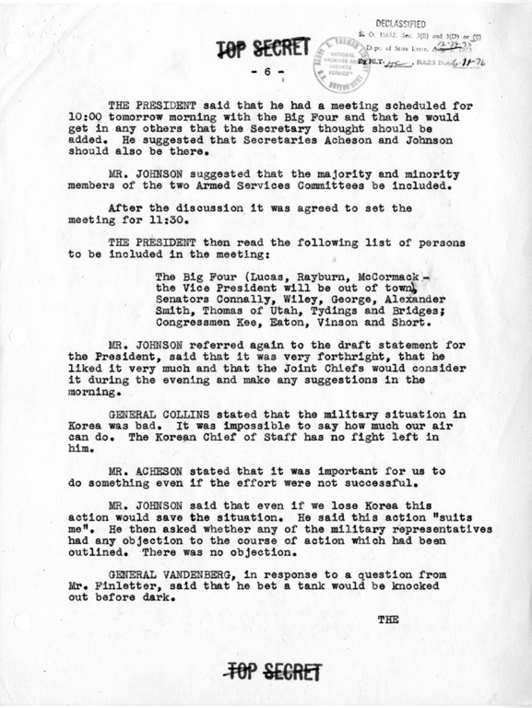
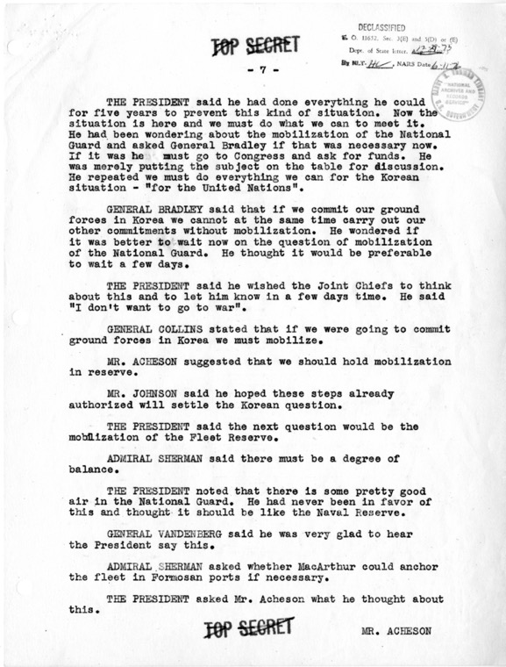
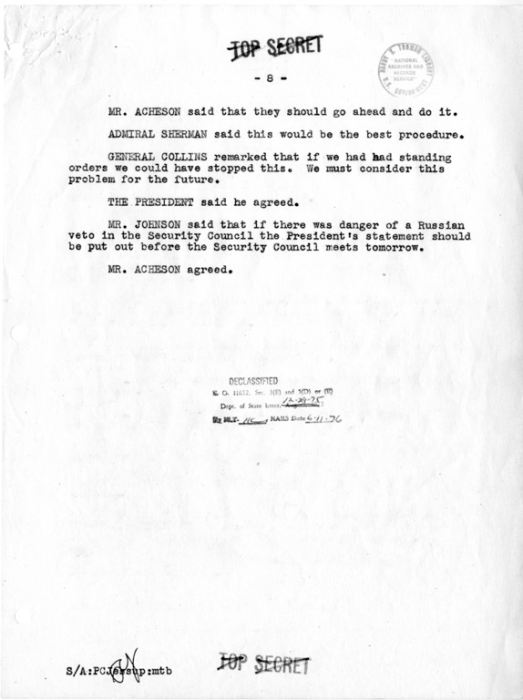

Source: Harry Truman Presidential Library: http://www.trumanlibrary.org/whistlestop/study_collections/koreanwar/index.php

Used with permission from the Harry Truman Presidential Library

Supporting Question 2
Featured Source | Source C: Richard Hilton, oral history, Korean War Legacy Project; accessible at https://koreanwarlegacy.org/interviews/richard-arthur-christopher-rich-hilton/
Richard Arthur Christopher (“Rich”) Hilton was born on May 2, 1933 in Roslyn (Long Island), New York. During the Korean War, Mr. Hilton worked on missile technology due to his proficiency with mathematics. His work with missiles saw him stationed in Albuquerque and White Sands, New Mexico. After his service, Mr. Hilton suffered numerous injuries in a car wreck, which left him blind, without a sense of smell, and lacking many memories of his time in the service. All that said, he is grateful to be alive and proud of his time in the Army.

Used with permission from the Korean War Legacy Project

Supporting Question 2
Featured Source | Source D: Earl A. House, oral history, Korean War Legacy Project; accessible at https://koreanwarlegacy.org/interviews/earl-a-house/

Earl A. House was born in Baltimore, Maryland, on August 30, 1931. After leaving high school early and enlisting in the naval reserves, Mr. House decided to enlist in the Army full time at the beginning of the Korean War. After he completed basic training, Mr. House was sent to Korea. The reality of war quickly subdued his initial excitement for fighting in the war. After receiving a shoulder injury, Mr. House drove a truck and Jeep that transported military personnel. He is proud of his service and sees it as stopping the spread of communism.

Used with permission from the Korean War Legacy Project

Supporting Question 2
Featured Source | Source E: Summary of the United Nations Command in Korea, examining the role of the United States in involving the UN in the Korean War, United States Forces Korea website; accessible at  http://www.usfk.mil/About/United-Nations-Command/

The predawn quiet of a rainy, peaceful Sunday morning, June 25, 1950, was abruptly shattered by the crash of cannons and the snarl of automatic weapons as soldiers of North Korea marched southward. The invading hordes breached the 38th parallel and rolled back the lightly-armed Republic of Korea Army constabulary forces toward their capital of Seoul.
Two days later, the United Nations called on the countries of the world to unite and assist in driving the invader from the ROK. In its resolution, the UN Security Council named the United States as executive agent to implement the resolution and direct UN military operations in Korea.
President Harry S. Truman, armed with the UN resolution and recognizing a threat to the free world, determined the US could no longer remain neutral while communist powers trampled the free nations of the world.
Douglas MacArthur, [General of the Army and Commander-in-Chief of the] Far East Command, was ordered to provide whatever assistance was needed to repel this invasion. General MacArthur committed US air and naval forces and on July 24, in Tokyo, established General Headquarters, United Nations Command.
UNITED NATIONS APPEAL
By then, the UN had issued a further appeal to all member nations to provide what military and other aid they could to assist the ROK Government in repelling the invaders. The first ground troops to enter battle on the side of the ROK were advance elements of the US 21st Infantry Regiment, 24th Infantry Division. Units were airlifted from occupation duties in Japan to form "Task Force Smith." The unit was committed on July 5th a few miles north of Osan.
In the face of overpowering enemy strength, the UNC fought delaying actions as ROK and US units withdrew down the peninsula. Outnumbered and out-gunned, they traded space for time as they waited for the pledged assistance from other countries of the UN.
On August 29, 1950, the British Commonwealth's 27th Brigade arrived at Pusan to join the UNC, which until then included only ROK and US forces. The 27th Brigade moved into the Naktong River line west of Taegu.
Troop units from other countries of the UN followed in rapid succession; Australia, Belgium, Canada, Colombia, Ethiopia, France, Greece, Luxembourg, the Netherlands, New Zealand, the Philippines, Thailand and Turkey. The Union of South Africa provided air units which fought alongside the air forces of other member nations. Denmark, India, Norway, and Sweden provided medical units. Italy provided a hospital, even though it was not a UN member.
KEEP THE FREE WORLD FREE
During the three years of the Korean War, military forces of these nations fought and died together as members of the UNC. They fought for the freedom of the Korean people and to demonstrate UN resolve to stop unprovoked aggression.
Through the freezing winters and the sweltering heat of the Korean summers, men from Britain, Ethiopia, the Republic of Korea, Thailand, Turkey, United States, and other contributing countries demonstrated individual and collective heroism in facing human waves of North Korean and Chinese aggressors. Few battles in the history of modern warfare have wrought the heartbreak and the frustration of this struggle.
Bloody Ridge, Chosin Reservoir, Hamhung, Heartbreak Ridge, Hwachan Reservoir, Iron Triangle, Punch Bowl and Pusan Perimeter—all were mileposts in the seesaw battle for Korea's freedom. The dust of Old Baldy was crimsoned with blood of valiant members of the UNC; the Han and Imjin Rivers ran red with blood of UN fighting men.

On July 27,1953, the shooting ended. An armistice was signed at Panmunjom which provided for the end of the fighting and eventual political settlement of the war. The shooting ended, but the troops remained, each side pulling back 2,000 meters from the last line of military contact to insure peace, to watch the Demilitarized Zone, and to guard against any resumption of hostilities.
THE PRICE OF FREEDOM
In a green field at Tanggok, located near the port of Pusan, stand myriad reminders of the Korean War. Simple white crosses, standing near the sign of the “Crescent and the Star” and the “Star of David” are bleak, symbolic representatives of the 33,629 Americans, numberless Koreans, 717 Turkish soldiers, and 1,109 soldiers of the United Kingdom who gave their lives during the struggle. Also sharing this place of honor are the symbols for the dead of the 12 other nations whose fighting men died to keep Korea free.
With the coming of the armistice, UNC members turned their attention to the tremendous task of assisting in rebuilding a war-torn economy. Assisting the people of the ROK in restoring and reconstructing a nation almost completely devastated by a war that leveled cities and destroyed farmlands was a gigantic project that was years in the accomplishment.

TROOP STRENGTHS
Peak strength for the UNC was 932,964 on July 27, 1953 —the day the Armistice Agreement was signed:
- Republic of Korea: 590,911
- Colombia: 1,068
- United States: 302,483
- Belgium: 900
- United Kingdom: 14,198
- South Africa: 826
- Canada: 6,146
- The Netherlands: 819
- Turkey: 5,453
- Luxembourg: 44
- Australia: 2,282
- Philippines: 1,496
- New Zealand: 1,385
- Thailand: 1,204
- Ethiopia: 1,271
- Greece: 1,263
- France: 1,119

Supporting Question 2
Featured Source | Source F: Dwight D. Eisenhower note to staff on US policy towards Korea after the armistice, January 5, 1954

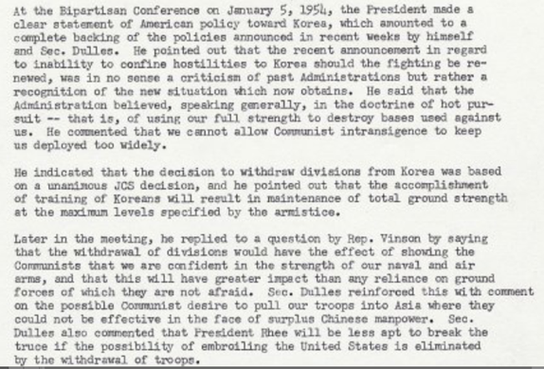
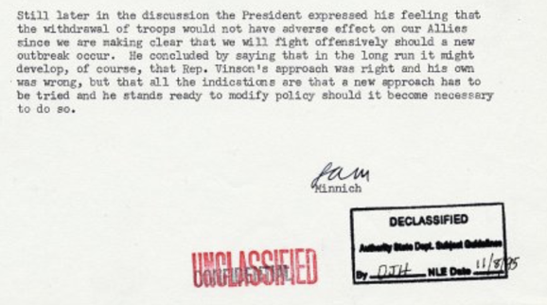

Source: http://eisenhower.archives.gov

Supporting Question 3
Featured Source | Source A: Mutual Defense Treaty Between the United States and the Republic of Korea, October 1, 1953; accessible at http://www.usfk.mil/Portals/105/Documents/SOFA/H_Mutual%20Defense%20Treaty_1953.pdf
Mutual Defense Treaty Between the United States and the Republic of Korea
October 1, 1953
The Parties to this Treaty,
Reaffirming their desire to live in peace with all peoples and an governments, and desiring to strengthen the fabric of peace in the Pacific area, desiring to declare publicly and formally their common determination to defend themselves against external armed attack so that no potential aggressor could be under the illusion that either of them stands alone in the Pacific area, desiring further to strengthen their efforts for collective defense for the preservation of peace and security pending the development of a more comprehensive and effective system of regional security in the Pacific area, have agreed as follows:
ARTICLE I
The Parties undertake to settle any international disputes in which they may be involved by peaceful means in such a manner that international peace and security and justice are not endangered and to refrain in their international relations from the threat or use of force in any manner inconsistent with the Purposes of the United Nations, or obligations assumed by any Party toward the United Nations.
ARTICLE II
The Parties will consult together whenever, in the opinion of either of them, the political independence or security of either of the Parties is threatened by external armed attack. Separately and jointly, by self help and mutual aid, the Parties will maintain and develop appropriate means to deter armed attack and will take suitable measures in consultation and agreement to implement this Treaty and to further its purposes.
ARTICLE III
Each Party recognizes that an armed attack in the Pacific area on either of the Parties in territories now under their respective administrative control, or hereafter recognized by one of the Parties as lawfully brought under the administrative control of the other, would be dangerous to its own peace and safety and declares that it would act to meet the common danger in accordance with its constitutional processes.
ARTICLE IV
The Republic of Korea grants, and the United States of America accepts, the right to dispose United States land, air and sea forces in and about the territory of the Republic of Korea as determined by mutual agreement.
ARTICLE V
This Treaty shall be ratified by the United States of America and the Republic of Korea in accordance with their respective constitutional processes and will come into force when instruments of ratification thereof have been exchanged by them at Washington.
ARTICLE VI
This Treaty shall remain in force indefinitely. Either Party may terminate it one year after notice has been given to the other Party.
IN WITNESS WHEREOF the undersigned Plenipotentiaries have signed this Treaty.
DONE in duplicate at Washington, in the English and Korean languages, this first day of October 1953.

UNDERSTANDING OF THE UNITED STATES
[The United States Senate gave its advice and consent to the ratification of the treaty subject to the following understanding:]
It is the understanding of the United States that neither party is obligated, under Article III of the above Treaty, to come to the aid of the other except in case of an external armed attack against such party; nor shall anything in the present Treaty be construed as requiring the United States to give assistance to Korea except in the event of an armed attack against territory which has been recognized by the United States as lawfully brought under the administrative control of the Republic of Korea.
[The United States communicated the text of the understanding to the Republic of Korea in a note of January 28, 1954, acknowledged by the Republic of Korea in a note of February 1, 1954. The text of the understanding was included in the President's proclamation of November 17, 1954.]
(1) TIAS 3097, 5 UST 23602376. Ratification advised by the Senate Jan. 26, 1954, and ratified by the President Feb. 5, 1954, subject to an understanding; entered into force Nov. 17, 1954.
(2) Ratifications were exchanged Nov. 17, 1954. (3) TIAS 3097.

Source: American Foreign Policy 1950-1955, Basic Documents Volumes I and II, Department of State Publication 6446, General Foreign Policy Series 117, Washington, DC: US Government Printing Office, 1957

Supporting Question 3
Featured Source | Source B: George H. Campbell, oral history, Korean War Legacy Project; accessible at https://koreanwarlegacy.org/interviews/george-h-campbell/

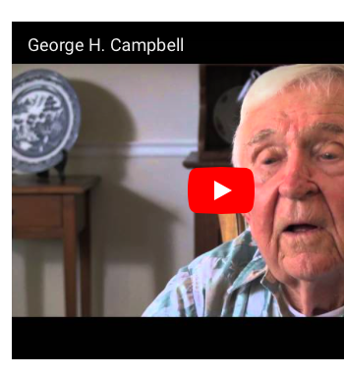
George H. Campbell enlisted in the Army in 1951 in hopes that he would have more say in his military career than he would have if he had been drafted. After attending the University of Florida for two years, Campbell used medical training he received to become a medical airman in the US Army. Although he was not stationed in Korea during the war, Mr. Campbell became a medical equipment inspector and lived in Korea (Busan) with his family for three years in the early 1970s. He is proud of his service, and looks back at his work as [providing a form of] support to the Republic of Korea.

Source: http://www.kwvdm.org

Used with permission from the Korean War Legacy Project

Supporting Question 3
Featured Source | Source C: Charles Rangel, oral history, Korean War Legacy Project; accessible at https://koreanwarlegacy.org/interviews/congressman-charles-rangel/

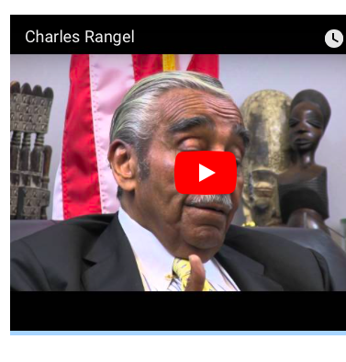
Charles Rangel was born June 11, 1930 in Harlem, New York. At the age of 17, he enlisted in the military as a way to help support his family. During the Korean War, Mr. Rangel served in the 2nd Infantry Division. He was awarded the Bronze Star and Purple Heart for leading a group of men out of a Chinese encirclement at Kunu Ri. He has famously noted that being injured that day was the worst day of his life, and that he has “never had a bad day since.” Rangel is best known for his post-military career as a US Congressional Representative for the state of New York (1971-2017).

Source: http://www.kwvdm.org

Used with permission from the Korean War Legacy Project

Supporting Question 3
Featured Source | Source D: Choe Sang-Hun, “Allies for 67 Years, US and South Korea Split Over North Korea,” New York Times, September 4, 2017 (excerpt); accessible at https://www.nytimes.com/2017/09/04/world/asia/north-korea-nuclear-south-us-alliance.html

“‘South Korea is finding, as I have told them, that their talk of appeasement with North Korea will not work, they only understand one thing!’ Mr. Trump said on Twitter. The tone of Mr. Trump’s statements stunned officials here [in Seoul, South Korea] and underscored what unlikely partners he and Mr. Moon are, at a time when their countries’ 67-year-old military alliance faces an ever-more-dangerous regime in Pyongyang. Mr. Moon, who was elected in May promising to seek dialogue with North Korea, fired back at Mr. Trump, insisting that the crisis be resolved peacefully.”

Excerpted from https://www.nytimes.com/2017/09/04/world/asia/north-korea-nuclear-south-us-alliance.html

