Grades 9-12 Korean War Inquiry
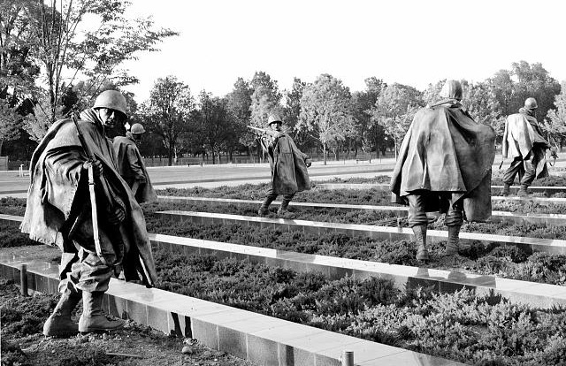
Why Was the Korean War “Forgotten”?

Photograph in the Carol M. Highsmith Archive, Library of Congress, Prints & Photographs Division.

Supporting Questions
    - How did the Korean conflict become a “war”?
    - What domestic concerns distracted Americans from the war?
    - Did the soldiers forget?
    - How has US history forgotten the Korean War?

Grades 9-12 Korean War Inquiry
Why Was the Korean War “Forgotten”?
C3 Framework Indicator | D2.His.5.9-12. Analyze how historical contexts shaped and continued to shape people’s perspectives.
Staging the Compelling Question | In October 1951, US News & World Report referred to the Korean War as the “Forgotten War.” Using the image bank of Korean War monuments and the original article, discuss the factors that influence whether or not a historical event is considered memorable.

Supporting Question 1 |  | Supporting Question 2 |  | Supporting Question 3 |  | Supporting Question 4
How did the Korean conflict become a “war”? |  | What domestic concerns distracted Americans from the war? |  | Did the soldiers forget? |  | How has US history forgotten the Korean War?
Formative Performance Task |  | Formative Performance Task |  | Formative Performance Task |  | Formative Performance Task
Create an annotated timeline of the major events that led to the Korean War. |  | Write a paragraph that describes the domestic concerns that distracted Americans from the Korean conflict. |  | Write a claim supported by evidence about why soldiers believe the war was “forgotten.” |  | Write an evidence-based claim or series of claims about how the Korean War has or has not been forgotten in US history.
Featured Sources |  | Featured Sources |  | Featured Sources |  | Featured Sources
Source A: Korean War Legacy Project’s Memory Bank timeline materials  Source B: Excerpt from Truman radio speech supporting UN action in Korea, September 1, 1950  Source C: Excerpts from Selling the Korean War, Steven Casey  Source D: “Milestones Along the Road to Mobilization,” Pathfinder News Magazine, January 10, 1951  Source E: Excerpt from Truman’s presidential news conference about Korea, July 13, 1950 |  | Sources from SQ 1  Source A: Excerpts from In the Shadow of the Greatest Generation, Melinda L. Pash  Source B: Excerpts from “Truman’s Other War,” Paul G. Pierpaoli, Jr. |  | Sources from SQs 1 and 2  Source A: Transcript of oral history interview, John Singhose  Source B: Transcript of oral history interview, James Warren  Source C: Transcript of oral history interview, Kelley Everett |  | Students’ US History textbooks

Summative Performance Task | ARGUMENT Why was the Korean War “forgotten”? Construct an argument (e.g., detailed outline, poster, or essay) that discusses the compelling question using specific claims and relevant evidence from historical sources while acknowledging competing views.
 | EXTENSION Using claims from Supporting Question 4, propose a textbook revision reflecting research within the inquiry and soldiers’ perceptions of the war.
Taking Informed Action | UNDERSTAND Explore the Korean War Digital History Project’s (KWDHP) Interview Initiative and identify local veteran groups or other community members who are Korean War veterans.  ASSESS Determine the ways in which students can contribute to KWDHP’s initiative.  ACT Create an oral history project to contribute to the KWDH archives.

Overview

Inquiry Description
This inquiry leads students through an investigation of how the Korean War came to be known as the “forgotten war.” By investigating the compelling question, “Why was the Korean War ‘forgotten’?,” students investigate how a major global event could seem to have been forgotten by the American public and, subsequently, in history. The inquiry has students consider the progression of the “conflict” to a “war,” actions of those in power during Harry S. Truman’s US presidency, the views of veterans and those on the home front, and the portrayal of Korea in US history textbooks. This leads students to questions of how the Korean War differed from previous and subsequent military engagements in terms of the remote threat it posed to the American people and an underlying Cold War sentiment that evolved from anti-communism to containment. Teachers should also help students understand how the process of “forgetting” the Korean War reflects geopolitical events as well as domestic concerns.
The formative performance tasks build on knowledge and skills through the course of the inquiry and help students recognize different perspectives in order to better understand the impacts of the Korean War on the home front. Students create an evidence-based argument about how the war was “forgotten,” considering the ways in which daily life was affected, the concerns of the US population at the time, and returning veterans’ experiences.
This inquiry highlights the following C3 Dimension 2 Indicator:
D2.His.5.9-12. Analyze how historical contexts shaped and continue to shape people’s perspectives.
It is important to note that this inquiry will require prerequisite knowledge of historical events and ideas. Thus, teachers will want to ensure their students are aware of the total war mobilization that occurred during World War II, the ways in which World War II mobilized the public by conceptualizing it as a war of fascism versus freedom, and the Cold War tensions that emerged in the post-war period.

NOTE: This inquiry is expected to take four to seven 50-minute class periods. The inquiry time frame could expand if teachers think their students need additional instructional experiences (i.e., supporting questions, formative performance tasks, and featured sources). Inquiries are not scripts, so teachers are encouraged to modify and adapt them​ in order to meet the needs and interests of their particular students. Resources can also be modified as necessary to meet individualized education programs (IEPs) or Section 504 plans for students with disabilities.

Structure of the Inquiry
In addressing the compelling question “Why was the Korean War ‘forgotten’?,” students work through a series of supporting questions, formative performance tasks, and featured sources in order to construct an argument supported by evidence while acknowledging competing perspectives.

Staging the Compelling Question
The compelling question could be staged by introducing students to the Korean War being labeled as a “forgotten war” by US News & World Report in October 1951, as well as by guided viewing of the image bank of Korean War monuments that use the word “forgotten.” Students can discuss the political, social, and/or cultural factors that influence the extent to which a historical event becomes more or less memorable, as well as considering the populations most likely to remember it. The discussion should include consideration of historical events that have occurred in the students’ lives that are memorable to them and what factors have caused them to be so. Additionally, students can discuss current events and the extent to which they believe these events will or will not be memorable. This staging could lead into a discussion of students’ current knowledge of the Korean War.
Supporting Question 1
The first supporting question, “How did the Korean conflict become a ‘war’?,” asks students to consider the progression of the Korean conflict to a war, and how this compared to mobilization during World War II. This formative performance task asks students to create an annotated timeline of the major events that led to the Korean War. Teachers should consider how mobilization affects public perception, including how it may foster public support for the war effort. Featured Source A is the Korean War Legacy’s Memory Bank timeline materials of US involvement in Korea. Featured Source B is a radio address by US President Harry S. Truman calling on the American people to support a resolution by the United Nations to retaliate against the North Korean forces in order to remove them from Seoul; this source provides students with information on how the United States worked with supranational forces to mobilize for war. In Featured Source C, Selling the Korean War, author Steven Casey describes the actions of the Truman administration to minimize public fears to prevent the all-out war culture that existed in World War II. Featured Source D is a newspaper article from the period, which presents milestone events in the mobilization of the home front for the Korean War as well as changes to domestic life. Featured Source E is a transcript of President Truman’s press conference on the Korean “emergency.”
Supporting Question 2
The second supporting question is “What domestic concerns distracted Americans from the war?” To answer this question, students consider the most important domestic American issues during the Korean War era. The formative performance task has students write a summary that describes domestic concerns that distracted Americans from the war. Building on Supporting Question 1, students should consider the extent to which mobilization for the war did or did not make Korea a societal focus in light of these distractions. In the case of the Korean War, there lacked a clear concept of what threat a civil war in Korea posed to the United States. This contrasted sharply with World War II, which had a more clearly defined enemy (i.e., fascism, militarism). In addition to the resources from the previous supporting question, the two featured sources here provide students with additional materials that allow them to consider why the Korean War was just another news story, rather than the most pressing national concern. Featured Source A is an excerpt from Melinda Pash’s In the Shadow of the Greatest Generation. Pash describes the very different home front mentalities during World War II and the Korean War, including the impact of the 1950s consumer culture. Featured Source B for this question is excerpts from Truman's Other War: The Battle for the American Homefront, 1950-1953, by Paul G. Pierpaoli. Pierpaoli presents the United States as being in a new “Cold War climate” in which the Korean War played a part, but was not the centerpiece; he also argues that the Korean War became a part of the larger, permanent mobilization of the Cold War, thereby lessening its individual significance to many Americans. Additionally, teachers may supplement this question with sources related to other domestic issues (e.g., McCarthyism and consumer culture).
Supporting Question 3
The third supporting question, “Did the soldiers forget?,” asks students to consider the ways soldiers reflect on their wartime experiences. Students will write a claim supported by evidence about why soldiers believe the war was “forgotten.” In addition to the previous featured sources, the sources for this task will show the perspectives of three Korean War veterans. These are interview transcripts from the Korean War Digital History Project (KWDHP). Though three interview transcripts are included here, teachers are encouraged to have students explore other interviews to add to this supporting question.
Supporting Question 4
In the fourth supporting question, “How has US history forgotten the Korean War?,” students will evaluate their US History textbooks to consider the extent to which they discuss Korea or whether it is eclipsed by coverage of other topics (e.g., World War II, the larger Cold War, the Vietnam War, and/or other topics from Supporting Question 2). The formative performance task asks students to write an evidence-based claim or series of claims about how the Korean War has or has not been forgotten in US history. For this task, students should use their own textbooks, but teachers may wish to supplement this with other available texts to provide a more inclusive assessment.
Summative Performance Task
At this point in the inquiry, students have examined the ways in which the United States mobilized for the Korean War, the extent to which this had an impact on the home front, how veterans view the war, and US History textbook depictions. Students should be expected to demonstrate the breadth of their understanding and their ability to use evidence from multiple sources to support their claims. In this task, students construct an evidence-based argument using multiple sources to answer the compelling question “Why was the Korean War ‘forgotten’?” It is important to note that students’ arguments could take a variety of forms, including a detailed outline, poster, or essay.
Students’ arguments will vary, but could include any of the following:
- The Korean War was “forgotten” because it started as a police action and slowly progressed to a conflict.
- The Korean War was “forgotten” because Americans were focused on other domestic issues facing the country (e.g., consumerism and the economy).
- The Korean War was “forgotten” because veterans came home to a different social climate than soldiers returning from World War II, leaving many to remain relatively silent about their wartime experiences.
- The Korean War was “forgotten” because it is often eclipsed in textbooks by World War II, the Vietnam War, the larger Cold War, and other domestic concerns.

Students could extend these arguments by using their claims from Supporting Question 4 to propose a textbook revision. This should reflect their research within the inquiry and soldiers’ perceptions of the war.
Students have the opportunity to Take Informed Action by drawing on their understandings of the value in different mediums to preserve historical events, particularly oral histories. To understand, students can explore the Korean War Digital History Project’s Interview Initiative and identify local veteran groups or other community members that are Korean War veterans. To assess the issue, students determine the ways in which they can contribute to the initiative. To act, students contribute to the oral history project for the KWDHP archives.

Staging the Compelling Question
Featured Source | Unknown author, newspaper article, “Korea: The ‘Forgotten’ War,” US News & World Report, October 5, 1951, p. 21 (excerpt)

Far off in Korea, 2,200 American men were killed or badly shot up last week in a war that seemed all but forgotten at home. War that was supposed to end in a deal with Communists instead is growing in intensity.

Ground battles, for the area involved, are as intense as those of any war. Air battles, against fliers of unknown nationality, are approaching in size some of those of World War II. Casualties have increased from an annual rate of 50,000 to more than 100,000. That’s the equivalent of 1 boy in every 10 coming of military age now.

At home, meanwhile, the big headlines concern a growing shortage of beef, graft scandals in the government, strikes as usual, prospects of a new-car scarcity.

Korea, half forgotten, is receding in the minds of many to the status of an experimental war, one being fought back and forth for the purpose of testing men, weapons, materials and methods, on a continuing basis.

Staging the Compelling Question
Featured Source | Image bank: Korean War memorials

Fayetteville, North Carolina
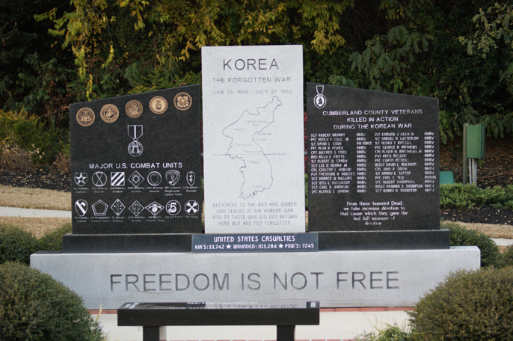
Image: Cumberland County Korean War Memorial, Fayetteville, NC, courtesy of Daniel N. Jourdan
Accessed from https://cdn.lib.unc.edu/commemorative-landscapes/media/monument/475_full.jpg

Auburn, New York
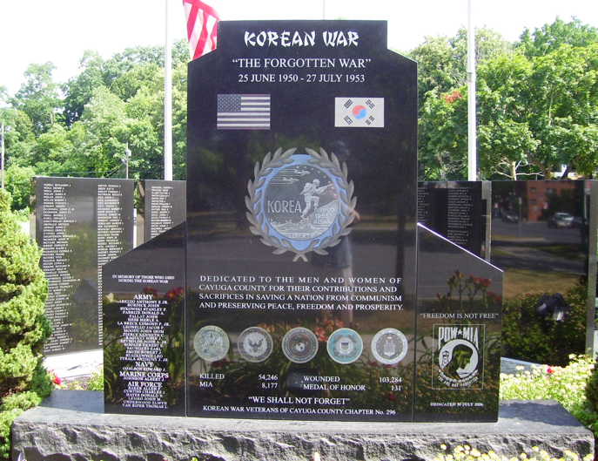
Image: Wikimedia Commons, Beyond My Ken
Accessed from https://commons.wikimedia.org/wiki/File:Korean_War_memorial_Auburn.jpg

Greenville, South Carolina
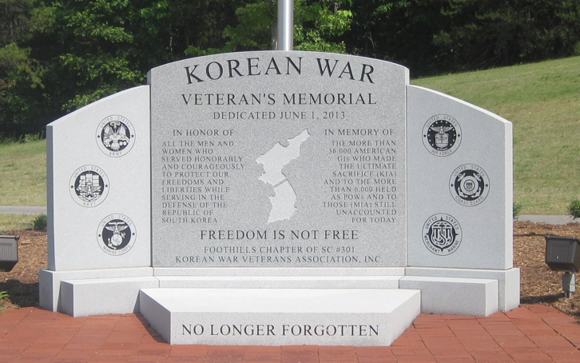
Image: Korean War Veterans Association Inc., Foothills Chapter of SC #301
Accessed from http://www.koreanvets301.com/

Olympia, Washington
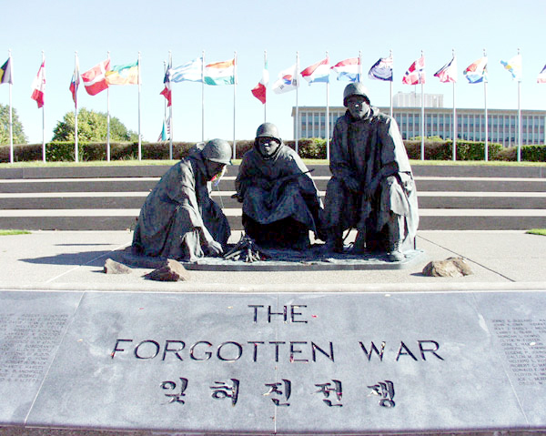
Image: Washington State Department Enterprise Services
Accessed from http://www.des.wa.gov/sites/default/files/public/images/Facilities/MemorialsArtwork/KoreanWar02.jpg

Supporting Question 1
Featured Source | Source A: Korean War Legacy, “Memory Bank,” timeline.

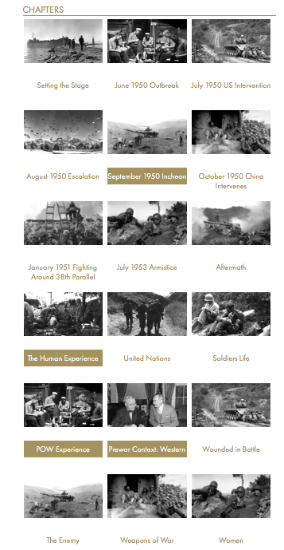
Accessed from http://koreanwarlegacy.org/chapters/
Used with permission from the Korean War Legacy Project

Supporting Question 1
Featured Source | Source B: Harry S. Truman, transcript from radio speech about the support for UN action in Korea, September 1, 1950

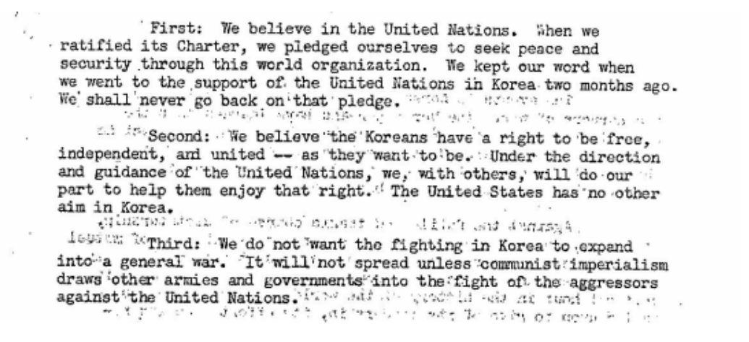

Accessed from https://www.trumanlibrary.org/
Used with permission from the Truman Library

Supporting Question 1
Featured Source | Source C: Steven Casey, book, Selling the Korean War: Propaganda, Politics, and Public Opinion in the United States, 1950-1953, 2008 (excerpts)

Fearful that this new Cold War crisis might escalate into a far bigger conflict with the Soviet Union, the president and his senior advisers sought to keep the home front cool. They made few public statements. And what they did say was carefully restrained. (p. 19)

“Don't make it alarmist” became something of a motif for [President Truman’s] early information campaign. As one shrewd observer [US News & World Report] noted at the time, “the real idea was to fix in the public eye a picture of the government in a calm mood… to keep Korea in its place: a pint-sized incident, not a full-scale war. […] Official Washington was doing everything it could to keep a firm line against the communists, and keep the home front cool at the same time.” (p. 20)

But all of a sudden, one question [at a press conference, June 29, 1950] brought a typically quick-fire response. “Mr. President, everybody is asking in this country, “Are we, or are we not, at war?” “We are not at war,” Truman emphatically declared, a statement he allowed reporters to quote directly. Anxious to get something more substantial, another journalist then prompted Truman with a trick that periodically worked at his press conferences: he put words into the president's mouth. Would it be correct “to call this a police action under the UN?,” he inquired. “Yes,” Truman replied, “that is exactly what it amounts to.” (p. 28)

As news of battlefield defeats hit home, the administration tried to channel the public debate on how America ought to mobilize in this new, more dangerous phase of the Cold War. The instinct of Truman and his senior advisers was to remain cautious: they were still keen to stop the domestic mood from overheating, lest this result in overpowering demands to escalate the Cold War, perhaps even by launching a preventive strike against the Soviet Union. (p. 67)

Until now, domestic pressures had also seemed to stand in the way of a large defense buildup. Before Korea, Congress had clearly been in a stingy mood, and it had escaped no one's notice back in January when Truman's State of the Union address had been noisily interrupted from both sides of the aisle as soon as he proposed that “federal expenditures be held to the lowest levels.” Nor, more generally, did the mass of Americans seem willing to embrace the sacrifices necessary for a sustained mobilization. During the spring, even champions of NSC-68 [a critical, top-secret memorandum about national security, written by the US government in 1950] had been pessimistic about the prospect of persuading a majority of the public to support their rearmament ideas, convinced that the popular mood was basically volatile, with many Americans all too willing to lapse periodically into a state of apathy and complacency. “I fear that the US public would rapidly tire of such an effort,” Edward Barrett [Assistant Secretary of State for Public Affairs] had gloomily noted in April. (p. 68)

The president's call [Fireside Chat, July 19, 1950] for limited economic controls was also far less radical than some officials seemed to want. (p. 70)

[Truman] doubtless recalled the deep hostility toward wage and price regulation during World War II, when the Office of Price Administration had become “a target for all the frustrations and disappointments of people unaccustomed to regimentation and control,” not to mention the 1946 midterm elections, when Republicans had successfully campaigned on a platform to swiftly terminate wartime controls. Unwilling to return to such an unpopular path in the current limited emergency, Truman concurred with his political and economic advisers, like Averell Harriman and Leon Keyserling, who “were profoundly convinced that the country and Congress were not yet ready for an all-out mobilization bill.” Consequently, all that appeared in the administration's defense production measure were powers to allow the president to allocate resources and facilities for the buildup, to control consumer credit and commodity speculation, and to provide loans to small businesses to help them participate in the production of military hardware.” That the administration's mobilization plan was distinctly limited would naturally become a focal point for all the public explanations during the coming weeks. The president would not ask for sweeping powers “until he thinks they are essential and that Congress would grant them,” Dr. John Steelman, assistant to the president, told one Time reporter in a background briefing. “That wouldn't be until we are in a real emergency and I wouldn't say that we are in such an emergency now.” “We are not, at this time, calling for an all-out mobilization,” Symington explained. (p. 70)

Inside the White House, meanwhile, Truman remained anxious to avoid any action that might engender or exacerbate a “war psychosis” among the American public. (p. 72)

[Assistant Secretary of State for Public Affairs] Barrett stressed that: “the mobilization for which he [the president] is asking is for the purpose of replacing the wastage in Korea and generally improving the defense of the United States. It does not constitute full war mobilization. He therefore feels that in the passage cited it would be desirable not to relate the measures now being taken to the expectation of general war.” (p. 72)

Supporting Question 1
Featured Source | Source D: “Milestones Along the Road to Mobilization,” Pathfinder News Magazine, January 10, 1951

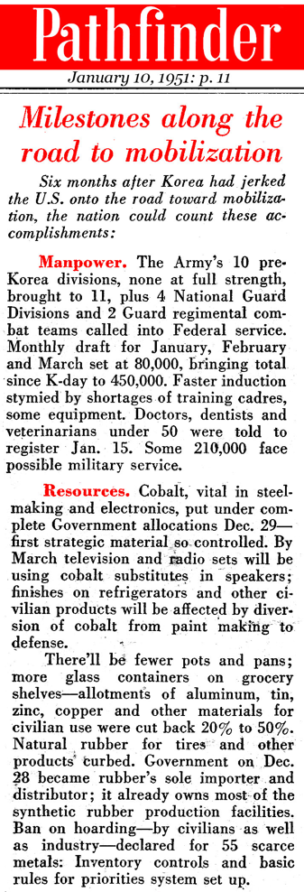
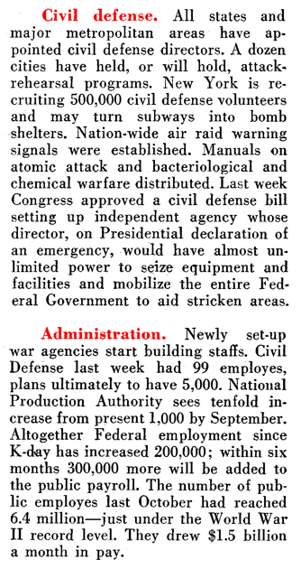
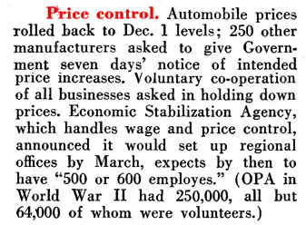

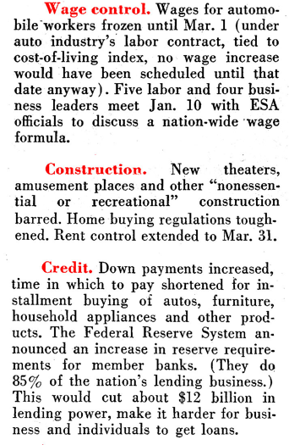

Accessed from: http://www.oldmagazinearticles.com/article-summary/korean-war-mobilization#.WC9NQuErI1g

Article provided courtesy of OldMagazineArticles.com

Supporting Question 1
Featured Source | Source E: Harry S. Truman, Presidential News Conference (excerpt), his 231st, in which the president addresses a standing-room-only crowd to answer questions about the Korean “emergency,” Indian Treaty Room (Room 474) in the Executive Office Building, Washington, DC, July 13, 1950
THE PRESIDENT. I have no particular announcements to make, but I will try to answer questions so far as I can.
Q. Mr. President, is there anything you could tell us about plans for any partial industrial mobilization—
Voices: Can't hear—can't hear.
THE PRESIDENT. He wanted to know if there were any plans about industrial mobilization. All the things that relate to the emergency are under consideration, and at the proper time the necessary steps will be taken if they are necessary. I want to say directly that they are under consideration.
Q. Well, specifically, Mr. President, Senator Thomas yesterday said that he expects that there will be a request for a billion additional [dollars] for military expenditures in a week or so—?
THE PRESIDENT. Since the figures have not been assembled and presented to the President of the United States, we can't give any definite figure.
Q. Mr. President, may I just give you one more [question]?
THE PRESIDENT. Sure, fire away.
Q. May we expect, though, that there will be a request for additional military expenditures in the next week or so?
THE PRESIDENT. It is under consideration.
Q. Mr. President, sir, do you still call this a “police action”?
THE PRESIDENT. Yes, it is still a police action.
Q. Mr. President, are we prepared to resist aggression everywhere in the world, as in Korea?
THE PRESIDENT. We will have to meet the situations as they develop. I can't answer that question.
[ … ]
THE PRESIDENT. Did you have a question?
Q. Yes, sir, thank you. Can you say anything about mobilization plans, sir, not industrial/manpower?
THE PRESIDENT. All those things are under consideration, and I can't make any statements on them at the present time. You will be kept informed of all the procedures as they come about.
Q. Mr. President, are you planning any report to Congress, or to the people, on the Korean situation?
THE PRESIDENT. That is under consideration, too. No decision has been reached.
Q. Mr. President, would you give us an evaluation now of the fighting so far in Korea, from your point of view?
THE PRESIDENT. No. I am not in charge of the military in Korea, and the report is made every day by General MacArthur, and he is the one to evaluate the situation. I rely on his evaluation.
Q. Well, Mr. President, can you comment in general on the outlook in Korea? Last week you said you were hopeful—
THE PRESIDENT. I feel the same way. My position has not changed on that at all.
Q. Are you anything more than hopeful, sir? What I mean is—
THE PRESIDENT. What do you mean by that?
Q. It does require clarification. We all get queries from our home offices—
THE PRESIDENT. Sure.
Q. —on the communiqués. What reassurance can we give the American people that we are not getting the tar licked out of us?
THE PRESIDENT. We are going to—
Q. Can't hear, sir.
THE PRESIDENT. Let me tell you something—
Q. We can't hear.
THE PRESIDENT. He wanted to know what assurance we could give the American people that we aren't getting the tar licked out of us. It has never happened to us. It won't happen this time.
Q. In that connection, Mr. President, do you feel certain that we will be able to retain a foothold in Korea?
THE PRESIDENT. We will be able to retain a foothold in Korea as far north as the 38th parallel.
Q. Mr. President, does that mean that we don't intend to carry our police action north of the 38th parallel?
THE PRESIDENT. I will make that decision when it becomes necessary to do it.
Q. Thank you.
Q. Mr. President, any news on the Mexican loan?
THE PRESIDENT. No. There is one thing I would like very much to impress on you, if you will bear with me about a minute. There is no prospect of any food shortage in this country at any time. We have in prospect one of the largest corn crops we have ever had, and had a billion bushels carried over. We have a normal cotton crop in prospect, and there are 3 million bales in storage in the hands of the Commodity Credit Corporation. We expect as large a wheat crop as we had last year, and anticipate as large a one next year, and there are some 700 million bushels of wheat in the carryover. So there is nothing to worry about, so far as food and things of that sort are concerned. I wish you would make that perfectly plain to your subscribers.
Q. Mr. President, we talked to [Secretary of Agriculture Charles F.] Brannan this morning about that, and he said it would be a reasonable deduction that rising prices would be due to profiteering. Do you agree with that?

THE PRESIDENT. I do. The statement I just made you would show that that is true. I discussed the matter with Secretary Brannan this morning, too. [Laughter]
Q. He denied it.
Q. Would you like to comment on the hoarding, Mr. President?
THE PRESIDENT. I beg your pardon?
Q. There are reports of hoarding of food and various other commodities. Would you like to make a statement?
THE PRESIDENT. I think it is very foolish to start anything of that kind now. There is no necessity for it whatever, as I am trying to make perfectly plain to you.
Q. Mr. President, would your remarks apply also to consumer goods, like automobiles and other—
THE PRESIDENT. I can't comment on any of those things, because I am only talking of the things that I know definitely about.
Q. Mr. President, there is a report from Geneva from the International Red Cross, I think, that they have sent a man to North Korea to see that they recognize the rules of warfare—?
THE PRESIDENT. I haven't had any such report, but I am sure that General [George C.] Marshall [president of the International Red Cross] will see that that is done.
Q. Thank you, sir.
Q. Mr. President, you were asked earlier about consideration of either going before the Congress or the people on the Korean situation. Did you mean that to say that you were considering both, or one or the other?
THE PRESIDENT. Yes, both.
Q. Thank you, sir.
THE PRESIDENT. I am considering everything in connection with this situation which I think will be helpful in keeping the American people and the Congress informed on what goes on.
Q. Mr. President, are we doing anything to urge the participation of ground troops of other nations in—
THE PRESIDENT. That question was answered by Secretary Acheson yesterday. If you will read his report at the press conference, you will get your answer.
Q. Mr. President, do you plan to ask for an increase in taxes?
THE PRESIDENT. I have no tax plans. The statement of the Secretary of Agriculture covered all that I can say about the matter at this time.
Q. Treasury, Mr. President.
THE PRESIDENT. I mean Secretary of the Treasury, yes. I was thinking about Brannan.
Q. Can you say anything about contingent reports that you might call up reserve officers and specialists, or mobilize the National Guard ?

THE PRESIDENT. All those things are under consideration. If it is necessary, announcements will be made in plenty of time so that you will all know about it.
Q. Mr. President, on the basis of what you said about food a minute ago, you mean that there is no contemplation of rationing being necessary in food?
THE PRESIDENT. Not at all.
Q. Mr. President, in view of the present situation, is there anything to speed up the machinery of the North Atlantic Pact being urged also on the other partners?
THE PRESIDENT. That is a matter on which I can't comment at this time.

Provided courtesy of The American Presidency Project. John Woolley and Gerhard Peters. University of California, Santa Barbara.

Accessed from https://www.trumanlibrary.org/publicpapers/index.php?pid=820&st=&st1

Used with permission from the Truman Library

Supporting Question 2
Featured Source | Source A: Melinda L. Pash, book, In the Shadow of the Greatest Generation: The Americans Who Fought the Korean War, 2012 (excerpts)

Unlike their older brothers and cousins who served in World War II and returned to ticker-tape parades and welcoming bands, Korean War veterans returned quickly to a country that in their absence scarcely missed them. Though Americans initially rallied to the war drum when President Harry S. Truman called on the nation to defend South Korea from communist aggression, the lack of meaningful home-front participation in the form of rationing or other personal sacrifice soon made Korea only a minor distraction for the American public. As soldiers still green to battle clung to the Pusan Perimeter, as marines fought their way out of Chosin Reservoir with frozen feet and staggering casualties, and as GIs tried to hold the line in a bloody stalemate half a world away, Americans at home went on with their business as usual, concentrating on making the most of the prosperous post-World War II economy. Fearing wartime shortages, they snapped up furniture and televisions, refrigerators and cars. In Fords and Lincolns and Chevrolets, the war drove right out of the minds of many Americans and into the middle and back pages of newspapers. Returning veterans could only wonder at the world that seemingly had forgotten them, surprised that “there was no evidence that the civilian population of the USA even knew (or cared) that those of us getting off the ship had seen desperate combat” [quoting Robert Henderson, Korean War Veteran Survey, 9, Center for the Study of the Korean War, Graceland University, Independence, Missouri]. (p. 1)

Perhaps understandably, average Americans found themselves too busy to pay attention to the conflict raging thousands of miles away in Korea or to the soldiers trickling home, but movie makers, novelists, and even historians proved no better at acknowledging the sacrifices made by those American servicemen and women. Throughout the war and in the years following, Hollywood produced a number of war movies, but most of them looked back to the “good war,” World War II, for inspiration. (p. 2)

Ten- and eleven-year-old kids when the Japanese bombed Pearl Harbor, [the Korean War generation] saw Americans join together to back the war effort, even if that meant making grave sacrifices. Sixteen million American men stepped into military uniforms ready to do their duty and lay down their lives in defense of the country and the values for which it stood. Those on the home front did their part, too. Whole towns turned out to say goodbye to their native sons being shipped off to war. Ordinary Americans, even young ones, grew Victory Gardens, saved scrap metal and paper, bought war stamps and war bonds, harvested milkweed pod for parachute making, and patriotically rallied behind their government. […] When asked to conserve [for World War II], Americans accepted severe rationing of gasoline, meat, butter, sugar, and flour, and they continued to support the war. For hundreds of thousands of kids, the message must have been clear; in a time of war American citizens rally together, sharing the sacrifices and keeping the trust with those whom they called to serve. (p. 10)

As the [Korean] war dragged on, however, public interest and support waned. […] The buying frenzy that had characterized 1950, when people still worried that war would directly affect their ability to purchase sugar, shortening, or televisions, had drawn to a close, leaving Americans free to concentrate on things other than the war effort. Headlines concerning strikes, domestic events, and even UFOs, rather than war news, monopolized the front pages of most newspapers. (p. 30)

Aside from a lack of political recognition, the troops in Korea had other reasons to feel like the home front had abandoned and forgotten them. Every day Americans laid down their lives in service to country on the Korean Peninsula, but back in the States people seemed completely disinterested in the war. Front-page headlines advertised “a growing shortage of beef, graft scandals in the Government, strikes as usual, [and] prospects of a new-car scarcity.” The war just did not seem all that newsworthy after the early months and especially once it stalemated. As editorial cartoonist Bill Mauldin noted of the Korean War infantryman, “He fights a battle in which his best friends get killed and if an account of the action gets printed at all in his home town paper, it appears on page 17 under a Lux ad.” And, more than not paying attention to the war, people on the home front actually compromised the ability of men and women to carry out their duties in Korea—at least from the perspective of those in the war zone. Strikes and the attention paid them not only distracted Americans but deprived men in the field of the supplies they needed. Shortages at home meant the rationing of things like ammunition and equipment in the war zone. Of one strike a frustrated GI in theater wrote, “We felt it very definitely in the shortage of supplies and especially of equipment for several days. It woke me up to how closely connected all the fronts we battle on are. You begin to wonder if the old country realizes there’s a war going on over here.” Similarly, returning from Korea, another serviceman asserted, “Strikes at home make the GI feel … that people are so preoccupied with their own self-interests that they seem to have forgotten that we are fighting a war. The shortages due to the shipping strike in New York last autumn could be felt in Korea within two weeks.” (pp. 125-126)

Supporting Question 2
Featured Source | Source B: Paul G. Pierpaoli, Jr., magazine article, “Truman’s Other War: The Battle for the American Homefront, 1950-53,” OAH Magazine of History 14(3), pp. 15-19, 2000 (excerpt)

Prior to 25 June 1950, President Harry S. Truman had no notion of fighting a major land war in Asia or, for that matter, engaging the nation in a vast and exorbitant Cold War rearmament program. In his January 1949 inaugural address, the president—always a rather staunch fiscal conservative—had promised to balance the budget, decrease the national debt, keep inflation at bay, and implement his Fair Deal program, an ambitious social welfare plan that sought to address an array of problems from public housing and health care to civil rights.

To accomplish this, Truman cast his lot with those who sought to keep national security and defense spending to a bare minimum. He also sought to provide America’s allies with protection from the perceived Russian threat by using the strength of the US economy as a bulwark against Communism. Thus, initiatives such as the Marshall Plan, the International Monetary Fund, and the General Agreement on Tariffs and Trade (GATT) would emphasize economic—rather than military--containment of the Soviet Union.

Supporting Question 3
Featured Source | Source A: John Singhose, transcript of oral interview for Korean War Digital History Project (excerpt)

Interviewer: When you left Korea, what did you think about the future of Korea? Did you have any idea how Korea would develop? Did you have any thought about it?
John Singhose: No, I had no idea what it was going to be like. It’s unbelievable really. I’ve seen a lot of pictures, I’ve talked to a lot of these folks that have been over there and visited, but I know one thing, that the Korean people were very industrious, good, honest, hard workers.
Interviewer: How did you know?
JS: They worked with us. We had workers with us, too.
Interviewer: There were workers other than Kimbu Kan and Kim J. Ku?
JS: Oh, gosh yes—we had like two dozen workers there; [they were] very dependable.
Interviewer: What were you thinking about you being there? I mean, you didn’t know where Korea was—not much, right?
JS: No.
Interviewer: And, when you left Korea, you didn’t think about the future of Korea? You didn’t have any idea? Now, you’re back in your home and looking at all of those things happening in Korea, what do you think about the whole thing?
JS: I think it’s a great thing they’ve done. They’re a great industrial power, and I’ve talked with a lot of folks from Korea since then, and I’m really impressed with them. I’m impressed with the country. I’m impressed with the people.
Interviewer: Why do you think we were able to pull this off?
JS: Well, I know they had help from the United States and Great Britain, and other countries there. We had people from Turkey there, Ethiopia, Canada. The Canadians were very helpful, also, working with the Koreans.
Interviewer: But despite such a clearly successful outcome out of the Korean War, why do you think the Korean War has been regarded as forgotten?
JS: Well, a lot of people seem to have forgotten it, but a lot of us haven’t forgotten it.
Interviewer: Why [not]?
JS: Well, when I’m visiting with Ray, a lot of times we would discuss what we did over there.
Interviewer: What did you do there?
JS: I was a construction foreman, but I ran a bulldozer for a good part of the time. I did demolition work, too.
Interviewer: Now looking back all those years, what do you think you did for Korea?
JS: We trained a lot of their people, for one thing. I had always hoped to make contact with this Kim J. Ku and I had his address there [in Korea] and one of the fellows from the Korean Embassy was going to see if he could look him up, but I never heard anything back.
Interviewer: What was the most difficult thing? Was there something you really hated while you were in Korea?
JS: The extreme weather, probably, but we had clothing and whatever. We were good. The weather was probably the worst, but we worked with other units, the Marine Corps and the Turkish people. I didn’t work with the Ethiopians, but Ray did. I thought it was kind of good. I worked with Canadians, too. It was good to work with those other people—a good learning experience.
Interviewer: What do you want to say to the Korean people now? Is there any message that you want to convey?
JS: I would like to congratulate them on the great job they did rebuilding the country, [and] the road networks they put in. The roads we put in were more or less just trails. But I think they have done a great job there. I would be the first to tell them that. I told a lot of the folks from the Korean Embassy that; we met with from time to time.
Interviewer: So you don’t regret your service there?
JS: Oh no, not at all. I learned a lot.

Used with permission from the Korean War Legacy Project

Supporting Question 3
Featured Source | Source B: James Warren, transcript of oral interview for Korean War Digital History Project (excerpt)
Interviewer: What were some of the most difficult, dangerous, rewarding, and happiest memories that you recall from your stay?
James Warren: Meeting my wife was probably the best—you know, meeting a lot of good people, meeting my best friend. Being able to experience [Korea]. I had been to Japan with the military and I was in Korea, and I found Korea to be better than Japan in the people sense. The Korean people seemed to be more friendly than the Japanese people. You can talk to them more, and the Japanese were stuck up compared to the Korean people. Stuff like that. It was easy to talk to them, [they were] easy to get along with and always helpful and friendly, and I enjoyed that. One of the things I did as a photographer [happened when] we had a Change of Command ceremony, the commander of the Second Infantry Division at the time was General Jeffrey Smith, and he was getting ready to be reassigned back to the States. They had assigned a new general coming from the States to take over the Second Infantry Division, so what they wanted me to do as a photographer was to go to every camp in the Second Infantry Division and photograph something significant to that camp. For example, if I went to this camp over here and it was primarily composed of infantry people, then I would take some [pictures of] things that would symbolize infantry. If I went to another camp filled with artillery soldiers, then I would take pictures that pertained to field artillery. And I did that for all the Second Infantry Divisions and going up to the DMV and photographing things. The purpose of that was to brief the new general once he arrived in Korea by debriefing—showing him different places that were going to be under his command.
Interviewer: What was the impact of you being stationed in Korea, and did it impact your life at all after you returned home—besides the fact that you met your wife?
JW: That was probably the biggest impact of all.
Interviewer: Is there anything that you learned or that you took with you from Korea, or from [the experience of] being surrounded by the Korean people?
JW: I’m sure I probably was impacted in more ways than I could think of at the time, but what I really appreciate about the Korean people even today is their closeness and their values—like, all Koreans are friends to each other, that I have experienced, and we need to have more of that in all people. Especially in my race of people, we need to have more of that family [or] friend feel, like in relationships. So I learned that from meeting people and working with Korean people while I was stationed in Korea.
Interviewer: Have you been back to Korea?
JW: I was stationed there twice, and have not been back. My wife went back many times, but I did not go with her or anything like that and she communicated with family by telephone. I met some of the family while I was stationed there, but I haven’t been back. That was probably one of the things that we were going to look at doing if [my wife] got better, health-wise.
Interviewer: In 2013 we witnessed the sixtieth anniversary of the armistice, which was signed by China, North Korea, and the UN on July 7, 1953. There is no war in modern history that has lasted sixty years after an official cease fire. What do you think we have to do to put a closure on it?
JW: You know, I don’t know. To close it you have to put the country back together and not have a North and South—just [a unified] Korea. I don’t know how you could achieve that. North Korea is not going to say, “Here you go!,” and they are not going to negotiate, so I don’t know. I don’t know what you could do. I wish I could answer that question.
Interviewer: Would you support some kind of movement to petition for the end of war officially? Or maybe replace the armistice with a peace treaty?
JW: That is a hard one. Because, if you have North and South agreeing to things— “you do your thing, and I’ll do my thing”—that probably would work out, but you cannot trust North Korea. My understanding is the North wants to be unified so if South Korea was satisfied and said, “Just give me a peace treaty; we will let them [in North Korea] live their life and we [in South Korea] will live our life,” the North would not go forward with that. They would all be instigating doing things. So I would say, “So, let the armistice continue until such time as the country can be unified,” and in the end you will have peace.

Interviewer: Do you think it is important for younger generations to understand what the Korean War was, and that it is still going on today, unofficially?
JW: Yes. This is my understanding of the Korean War Veterans Association’s mission. The Korean War is called the “Forgotten War.” It is the mission of the Korean War Veterans Association to not let the people forget that. Many people died and sacrificed, so you just can’t forget that. The Korean [War] soldiers are dying out now, so when they’re gone, the memory of what they did will be gone. So what they [at the KWVA] have done is incorporate people like me who served in Korea but who didn’t serve in the Korean War so we can keep their story alive, so that it won’t be forgotten. They do things to try to keep in the public eye so that it is not a forgotten war, and should never be a forgotten war. They do things like a program called Tell America, where they go into schools and they tell [students] about the Korean War and the things they did in the Korean War. The have received a lot of great response from that. So they must, it’s historical and all history must be repeated, so people won’t forget it and repeat it.
Interviewer: Why do you think the Korean War is known as the Forgotten War?
JW: I really don’t know. First of all, we came out of WWII and people were tired and war weary, and not too long after that we entered the Korean War, and because it wasn’t so much a “win” situation but [instead a division of the country into] North and South, it’s easy to be placed under WWI and WWII. The main reason it’s forgotten is that they never really called it a war. It was kind of like a police action. We use “police action” and stuff, and if you view the phrase over time and say it’s a police action and it’s actually not a war, well, people are going to remember a war but not a police action. And people forget that when they talk about war sometimes, so that’s why I think it’s forgotten. But by being in the association, I know those guys who were in the air doing things, on the ship doing things, and on the ground doing things, and I’ve heard their stories. I mean, it’s a story worth retelling.
Interviewer: Earlier, you mentioned something about the legacy of Korean War veterans. What do you think that legacy is?
JW: That the people who fought and died, and the people who sacrificed, would not be forgotten. I think that’s the legacy.
Interviewer: [Why] do you think the Korean War Veterans digital memorial that we are doing here, interviewing veterans, is important?
JW: It’s very important because it serves to remind us of the war that we don’t want to be forgotten. It is a tribute to those who made the ultimate sacrifice. And to those who fought and lived, it’s a tribute to those who supported that. It is not always the guy on the ground or the guy flying in the air, it’s all the support for the guys who are doing it. It is a tribute to all of those who had anything to do with the Korean War. Let me just say this about the [South] Korean people: they are truly thankful for what the Korean War veterans did to make their country a free country and the way it is. They express it all the time. They express it here in church, because they honor those veterans here every year. We have been to activities in Dallas [Texas] where they reiterated how much they appreciate what the Korean War veterans have done for their country, what it is today and stuff. When you hear those people say that, you know they are saying it from the heart.
Interviewer: Is there anything else that you would like to share, maybe memories or messages or something to do with your occupation that you would like to have preserved?
JW: The most important is when I re-enlisted in the military, I was a young man who had no idea what he wanted to do with himself. I was contemplating whether or not I should go to college, or should I just get myself a regular job. I had no way, and my friends suggested the military. So I enlisted in the military just to find myself. After being in the military, that might be what you want to do, or get an education, but it instills patriotism in you. The fact that you want to serve your country and the result of that willingness is that you may end up in a war or you may end up dead. I would like to think I am a true patriot because of the time I spent in the military. You don’t have to be in the military to be a patriot, but it made my patriotism greater. All the other veterans should be thanking us.

Used with permission from the Korean War Legacy Project

Supporting Question 3
Featured Source | Source C: Kelley Everett, transcript of oral interview for Korean War Digital History Project (excerpt)

Interviewer: So, you had no prior knowledge, really, of what had happened between 1950 and 1953 [in Korea]?
Kelley Everett: I knew that there was a war, but… go ahead.
Interviewer: When or how did you learn more about the Korean War?
KE: Mainly through history, TV—things of that nature.
Interviewer: Did they teach you about it in school, when you were growing up and before your enlistment? Were they teaching it in schools yet?
KE: Well, they weren’t teaching it, they were more teaching World War I and World War II back then. The Korean War was a recent event, it happened in the ‘50s and I was in school. I think I was in like the first grade in the ‘50s.
Interviewer: Do you have any messages for younger generations? Do you feel it’s important for younger generations to know the sacrifices and contributions made in Korea [during the war]?
KE: I think that there were sacrifices of many soldiers who are traumatized and still suffering today from that war, and from all the other wars before [the Korean War].
Interviewer: Do you think it’s important and necessary for us to preserve the interviews of these veterans and their legacy?
KE: Very important. Yes, I do.
Interviewer: And why do you think, in your opinion, the Korean War is known as the forgotten war?
KE: Well, it was after the big one: World War II, and a lot of soldiers that came out of Korea never got the benefits or the just treatment that they should’ve gotten from being what they called at that time “battle shocked” or “battle fatigued.” I think the military environment is a great environment, a great experience, and I would think that every American should […] experience it. But it is a traumatic experience when you have to go places and experience different cultures.
Interviewer: Is there anything else, any other stories or memories, messages that you had during your stay or anything else you would like to share to preserve your legacy?
KE: I think Korea is a great place. I don’t regret one moment of my time in Korea. I gained a lot of insight that I would never have received had I not experienced that.

Used with permission from the Korean War Legacy Project

