Grades 9-12 Korean Conglomerates Inquiry
Are Conglomerates Good for the Economy?

Image used with permission from Getty Images: Tokism/Busan at night/Getty Images

Supporting Questions
    - What is a chaebol?
    - What are the benefits and drawbacks of chaebols?

Grades 9-12 Korean Conglomerates Inquiry

Are Conglomerates Good for the Economy?
C3 Standards for Social Studies | D2.Eco.15.9-12. Explain how current globalization trends and policies affect economic growth, labor markets, rights of citizens, the environment, and resource and income distribution in different nations.
Staging the Compelling Question | Examine a set of economic datagraphics and create a claim about the the economic health of the Republic of Korea.

Supporting Question 1 | Supporting Question 2
What is a chaebol? | What are the benefits and drawbacks of chaebols?
Formative Performance Task | Formative Performance Task
Write a definition of a chaebol and describe its significance to the Korean economy. | Create a graphic organizer showing evidence of the benefits and drawbacks of the chaebol system.
Featured Sources | Featured Sources
Source A: Article, “Money, Power, Family: Inside South Korea’s Chaebol” (excerpt), New York Times, February 17, 2017  Source B: Bar graph, economic weight of chaebol as a percentage of South Korean economy, using data from the Korea Fair Trade Commission | Source A: Video, “How Samsung Dominates South Korea’s Economy,” CNN, February 17, 2017  Source B: Timeline, “South Korea’s Conglomerates,” Sage Business Researcher, August 21, 2017  Source C: Article, “The Death of Daewoo,” The Economist, August 19, 1999  Source D: Article, “South Korea’s Moon Vows to Rev Up Jobs and Rein in ‘Chaebol,’” Nikkei Asian Reivew, May 18, 2017  Source E: Documentary film, “The Legacy,” Korean War Legacy Project, 2018

Summative Performance Task | ARGUMENT Are conglomerates good for the economy? Use evidence to construct a claim and a counterclaim that address the compelling question.
 | EXTENSION Use gapminder.org to research the impact of South Korea’s economic boom on its society, health, environment, education, and infrastructure in order to revise or strengthen your argument.

Overview

Inquiry Description
The compelling question for this inquiry calls on students to consider whether conglomerates are good for the economy. Specifically, this focused inquiry is a case study of South Korean conglomerations, known as chaebols. After the Korean War, large sums of money were given to a handful of corporations (Samsung, Lotte, Hyundai, Daewoo, etc.) in order to spur economic growth in the South. The chaebols, including Samsung, Hyundai, and Daewoo, would play an important role in spurring economic growth by focusing on the export of cheap electroinc goods. At the same time, these chaebols were protected by the government because of the belief that they were “too big to fail.” Currently, corrupt business practices by chaebol leaders have led some Koreans to question whether or not chaebols should be dismantled. In this focused inquiry, students will work with a variety of sources in order to answer whether or not such conglomerates or chaebols are good for the economy. Although the focus of this inquiry is on Korean conglomerates, this examination has students wrestle with the idea of how countries should develop economically.

NOTE: This inquiry is expected to take four to seven 55-minute class periods. The inquiry time frame could expand if teachers think their students need additional instructional experiences (i.e., supporting questions, formative tasks, sources). Inquiries are not scripts, and teachers are encouraged to modify and adapt them in order to meet the requirements and interests of their particular students. Resources can also be modified as necessary to meet individualize education plans (IEPs) or Section 504 plans for students with disabilities.

Structure of the Inquiry
In addressing the compelling question, “Are conglomerates good for the economy?,” students will work through two supporting questions, formative performance tasks, and a number of sources in order to construct a claim and counterclaim supported by evidence.

Staging the Compelling Question

The inquiry begins with students examining four documents highlighting the economic situation in the Republic of Korea. The first document is a line graph illustrating World Bank data on how the Republic of Korea’s Gross Domestic Product (GDP) has changed since 1960. Teachers will want students to be able to recognize that generally GDP has greatly increased, but students should also consider possible causes of dips in progress along the way.

The second document is a list of countries ranked by GDP. Teachers will want to point out the Republic of Korea’s position on the list, noting also those nations ranking higher and lower than South Korea.

The third source is a table of income inequality (Gini coefficient) and poverty (relative poverty) for select countries. Teachers will want to ensure students understand both measures. The Gini coefficient measures the economic equality within a country: a score of “0” means a country has perfect economic equality; a score of “1” means the country has perfect economic inequality—meaning one person has all the wealth. Relative poverty measures the percentage of people whose income is less than half of the national median income.

The final source is a bar graph illustrating how much of the wealth in South Korea is controlled by the top 10 percent of the population, and how that compares with other countries in the region.

From these documents, students should be able to discuss whether or not they believe the economy of the Republic of Korea to be economically healthy.

Supporting Question 1

The first supporting question, “What is a chaebol?,” is a foundational question when examining the South Korean economy. The formative performance task asks students to write a definition of a chaebol and describe its significance to the South Korean economy using the sources provided. Featured Source A is an excerpt from the New York Times article, “Money, Power, Family: Inside South Korea’s Chaebol.” This article defines the term chaebol and details how the conglomerates have become integrated into the political side of South Korea. Featured Source B is a bar graph showing the economic weight of chaebols in South Korea’s economy. Teachers may want to draw parallels between conglomerates in the United States and chaebols in South Korea.

Supporting Question 2

The second supporting question, “What are the benefits and drawbacks of chaebols?,” helps students synthesize both sides of the chaebol debate. The formative performace task calls on students to create a graphic organizer in which they record evidence highlighting either the benefits of or the drawbacks to the chaebols to the overall economy. Featured Source A is a short CNN video, “How Samsung Dominates South Korea’s Economy.” It provides a brief look at the divsersity of products and interests that are housed under the Samsung name. Featured Source B is a timeline tracing South Korea’s economic rise with the rise of the chaebols and democracy. The timeline comes from the article “South Korea’s Conglomerates,” from Sage Business Researcher. While Featured Sources A through C define chaebols and put them in context in South Korea’s modern history, Featured Source D looks at what happens when a chaebol fails. This article from the Economist, “The Death of Daewoo,” examines not only why the chaebol failed, but also the real and imagined impact of its failure on the Korean economy. Teachers will want students to think about whether or not these chaebols are really “too big to fail.” Featured Source E is an article from the Nikkei Asian Review, “South Korea’s Moon Vows to Rev Up Jobs and Rein in ‘Chaebol’.” The article examines how South Korea’s new president, Moon Jae-in, will attempt to limit the power of the chaebol and instead focus on small and medium size businesses for capital investment. Featured Source F is a clip from “The Legacy,” a documentary from the Korean War Legacy Project. Minutes 23:05 to 25:55 of the video feature Dr. Jongwoo Han explaining the rise of the South Korean economy after the Korean War.

Summative Performance Task

In this task, students construct an evidence-based argument responding to the prompt, “Are conglomerates good for the economy?” Teachers will want to have students refer back to the graphic organizer they filled out in the inquiry as a way to focus their responses. In this focused inquiry, students are asked to develop a claim and counterclaim with evidence from the sources they examined during the inquiry. Students’ arguments will vary, but could include any of the following:
- Conglomerates are good for the economy. Using the Republic of Korea as an example, conglomerates known as chaebols helped bring about the “economic miracle” in the Republic of Korea and continue to be a large contributor to the economic health of the country.
- Conglomerates are not good for the economy. Using the Republic of Korea as an example, conglomerates known as chaebols have been propped up as “too big to fail” and have been found to foster widespread, corrupt business practices and eliminate the growth of smaller companies.
- Conglomerates are both good and bad for the economy. Using the Republic of Korea as an example, conglomerates known as chaebols helped to spur the “economic miracle” in the Republic of Korea, but have also fostered corrupt business practices and halted innovation by smaller companies.
Students could extend these arguments by researching the impact of chaebols on the global economy in order to more clearly articulate, revise, or strengthen their arguments.

Staging the Compelling Question
Featured Source | Line graph, South Korea’s Gross Domestic Product (GDP) per capita, 1960 to present, according to World Bank data, excerpted from Kim Jaewon, “South Korea’s Moon Vows to Rev Up Jobs and Rein in ‘Chaebol,’” Nikkei Asian Review, May 18, 2017

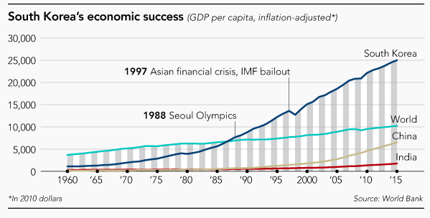

Source: https://asia.nikkei.com/magazine/20170518/On-the-Cover/South-Korea-s-Moon-vows-to-rev-up-jobs-and-rein-in-chaebol?page=2

https://creativecommons.org/licenses/by/4.0/

Staging the Compelling Question
Featured Source | Chart, rankings of countries by Gross Domestic Product, 2016, World Bank

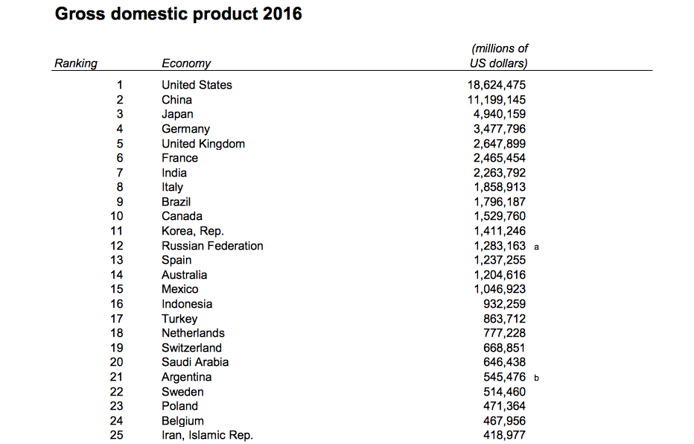

Source: http://databank.worldbank.org/data/download/GDP.pdf

https://creativecommons.org/licenses/by/4.0/

Staging the Compelling Question
Featured Source | Chart, income distribution and relative poverty, Organisation for Economic Co-operation and Development (OECD), 2015

Income Distribution and Poverty

Country | Gini Coefficient | Relative Poverty, %, 2015
Republic of Korea | 0.295 | 13.8
USA | 0.39 | 16.8
Canada | 0.313 | 12.6
Japan | 0.33 | 16.1
Italy | 0.326 | 13.7
France | 0.297 | 8.2
Mexico | 0.459 | 10.4

Source: OECD

Data found: http://www.oecd.org/social/inequality.htm

Staging the Compelling Question
Featured Source | Bar graph illustrating the percentage of total income earned by the wealthiest 10% of the total population, by country; excerpted graphic from Kim Kyung-rok “Income Inequality in South Korea the Most Severe in Asia,” Hankyoreh, March 17, 2016; accessible at http://english.hani.co.kr/arti/english_edition/e_national/735462.html

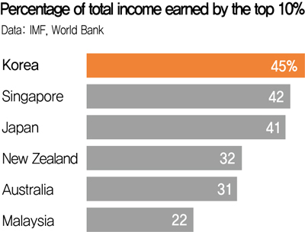

Supporting Question 1
Featured Source | Source A: Carlos Tejada, article describing the founding and power of chaebol, “Money, Power, Family: Inside South Korea’s Chaebol,” New York Times, Carlos Tejada, February 17, 2017 (excerpt); accessible at https://www.nytimes.com/2017/02/17/business/south-korea-chaebol-samsung.html
What are chaebol?
The word [chaebol] comes from the combination of the characters for “rich” and “clan.” It applies to large groups of interconnected companies that are usually dominated by a wealthy family. South Korea has several, but the best known outside the country are Hyundai, LG and Samsung. Others include Hanjin, Kumho, Lotte and SK Group.
Chaebol are generally conglomerates of affiliated companies. LG, for example, makes smartphones, televisions, electronic components, chemicals and fertilizer.

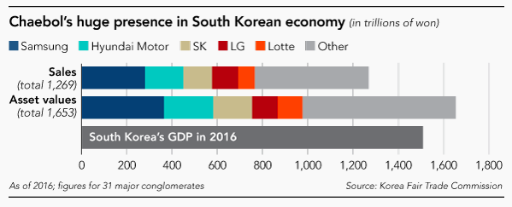

Supporting Question 1
Featured Source B | Bar graph showing the significant economic presence of chaebol in the South Korean economy, using data from the Korea Fair Trade Commission, excerpted from Kim Jaewon, “South Korea’s Moon Vows to Rev Up Jobs and Rein in ‘Chaebol,’” Nikkei Asian Review, May 18, 2017

Supporting Question 2
Featured Source | Source A: Video about the numerous, diverse products Samsung produces, “How Samsung Dominates South Korea’s Economy,” 2017; accessible at http://money.cnn.com/2017/02/17/technology/samsung-south-korea-daily-life/index.html

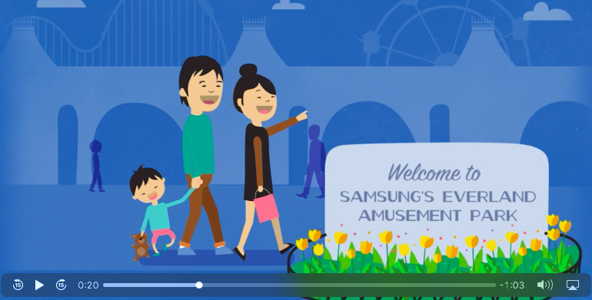

Supporting Question 2
Featured Source | Source C: Rachel Premack, timeline detailing Chaebols and the South Korean economy, “South Korea’s Conglomerates,” Sage Business Researcher, August 21, 2017

1910–1987 | From colonialism to development.
1910 | Neighboring Japan annexes the Korean Peninsula.
1945 | Japan surrenders in World War II and its colonial rule in Korea ends. The Soviet Union and United States split the country in two, with the Soviet Union dominating the northern half and the United States the southern. They determine that the two Koreas should be reunited after four years and enjoy independent rule.
1950–1953 | The Korean War begins when the North invades the South, then concludes in a stalemate, with no peace treaty signed. The estimates of total casualties, including military and civilians, range from 1.2 million to 5 million. South Korean President Syngman Rhee rules autocratically for the rest of the 1950s as the economy struggles. In the North, Communist strongman Kim Il-sung creates a Stalinist state.
1963 | After seizing power in a military coup two years earlier, Park Chung-hee is elected president. During his 18-year rule, South Korea’s economy is revolutionized at a deep cost to human rights.
1972 | Under Park Chung-hee’s direction, a young company, POSCO, opens its first modern steel plant. Skepticism abounds that South Korea should develop domestic heavy industries. POSCO is now the fifth-largest steel producer in the world.
1981 | South Korea receives its last significant aid package from Japan, just under $800 million in 2010 US dollars. Six years later, it begins granting development assistance to others.
1987 | Ending decades of military dictatorships and crushed democracy movements, a democratic government is established in South Korea. The constitution, still in force today, provides for a free press, direct election of presidents and, among other rights, habeas corpus.
1997–present | Crises and corruption charges amid global dominance.
1997 | South Korea is among the hardest hit by the Asian financial crisis. Its national debt-to-GDP ratio nearly doubles, its currency tumbles in value and its stock markets experience record drops.
1998 | Some chaebols and several affiliated firms go under as a result of the financial crisis. Daewoo, once a major force in buses, cars, shipbuilding, electronics and hotels, declares bankruptcy and splits into three smaller firms. Samsung Motors sells 80 percent of its stock to French automaker Renault.
1999–2000 | Gross domestic product grows by 11.3 percent in 1999 and another 8.9 percent in 2000, marking a return to a flourishing economy.
2010 | South Korea joins the Organisation for Economic Co-operation and Development’s Development Assistance Committee, a consortium of the world’s biggest aid donors. South Korea is the first country to go from being a recipient of committee aid to a donating member.
2012 | South Korea becomes the first newly industrialized country to join the “20–50 club” – countries with a population of more than 50 million that have a per capita income of more than $20,000. The other six are the United States, Germany, France, the United Kingdom, Italy and Japan.
2016 | Approval ratings for President Park Geun-hye, who is Park Chung-hee’s daughter, fall to 4 percent in late November. Details concerning allegations of influence peddling involving Park and confidante Choi Soon-sil emerge, prompting hundreds of thousands of Koreans to turn out for weekly protests demanding the imprisonment of Park, Choi and several chaebol leaders.
2017 | Lee Jae-yong, the de facto head of Samsung Group and third-wealthiest person in Korea, is arrested in February. Samsung allegedly paid $36 million in bribes in 2015 to fraudulent charities operated by Choi. Park is arrested a month later. Moon Jae-in is elected president in May, the first liberal to win a presidential election in South Korea since 2002.

Source: http://businessresearcher.sagepub.com/sbr-1863-103804-2830718/20170821/south-koreas-conglomerates

Supporting Question 2
Featured Source | Source C: Staff writers, “The Death of Daewoo,” detailing the failure of one chaebol, The Economist, August 19, 1999 (excerpt); accessible at http://www.economist.com/node/233562

Daewoo's financial trouble came to a head only last month, but its failure was a long time coming. Last year, when the economic crisis forced most of the chaebol to cut back, Daewoo brazenly added 14 new firms to its existing 275 subsidiaries—and this in a year where the group lost a combined 550 billion won ($458m) on sales of 62 trillion won ($51 billion). At the end of 1997, South Korea's four biggest chaebol averaged debt of nearly five times their equity.

Supporting Question 2
Featured Source | Source E: Kim Jaewon, “South Korea’s Moon Vows to Rev Up Jobs and Rein in ‘Chaebol,’” detailing how the current South Korean President may want to limit the power of chaebol, Nikkei Asian Review, May 18, 2017 (excerpt); full article accessible at https://asia.nikkei.com/magazine/20170518/On-the-Cover/South-Korea-s-Moon-vows-to-rev-up-jobs-and-rein-in-chaebol?page=2

He [Moon] singled out the four biggest conglomerates—Samsung, Hyundai Motor, SK and LG—as needing to be reined in, noting they account for about half of all assets held by the country's top 30 conglomerates.

Moon said the Lee family that owns Samsung, the country's largest conglomerate, has run the group like “an emperor,” controlling all aspects of the business despite having only a limited stake, while taking no responsibility for its failures. He said the family’s totalitarian style of leadership needs to make way for a democratic management run by professionals.

Supporting Question 2
Featured Source | Source E: Sultan Sharrief, “The Legacy: A Documentary,” Korean War Legacy Project; full-length, classroom-friendly, 20-minute documentary film accessible at the Korean War Legacy Project website at https://koreanwarlegacy.org

Used with permission from the Korean War Legacy Project

