Grades 6-8 Korean War Inquiry

How Does War Affect Children?

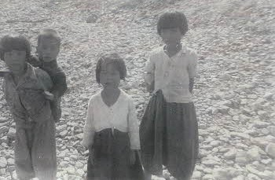

Image credit: Korean Kids at Garbage Dump, 1953, Korean War Legacy Project

Used with permission from the Korean War Legacy Project

Supporting Questions

    - What were the experiences of Korean children during the Korean War?
    - What were the experiences of Korean children during the Korean War from the perspective of US soldiers?
    - What are the human costs of displacement and war?

Grades 6-8 Korean War Inquiry
How Does War Affect Children?
C3 Framework Indicator | D2.Civ.14.6-8. Compare historical and contemporary means of changing societies and promoting the common good.
Staging the Compelling Question | Discuss the affects of war on children by viewing the clip from the Korean War Legacy Foundation where Veteran George Drake describes the evacuation of 950 Korean Orphans prior to the Chinese occupation of Seoul.

Supporting Question 1 |  | Supporting Question 2 |  | Supporting Question 3
What were the experiences of Korean children during the Korean War? |  | What were the experiences of Korean children during the Korean War from the perspective of US soldiers? |  | What are the human costs of displacement and war?
Formative Performance Task |  | Formative Performance Task |  | Formative Performance Task
Construct the story of a child depicted in the photographs during the Korean War. |  | Write a paragraph about the experiences of Korean children during the war from the perspective of American soldiers. |  | Create four historical questions about the human costs of displacement and war to prepare for a guided Socratic Seminar.
Featured Source |  | Featured Sources |  | Featured Sources
Source A: Photographs of children during the Korean War |  | Source A: Video clip, interview with Charles Buckley  Source B: Video clip, interview with Everett Kelley  Source C: Video clip, interview with Andrew Lanza |  | Source A: Video clip, Syrian children describing experiences with war and conflict  Source B: Video clip, effects of war on children in South Sudan  Source C: Information from the UN Refugee Agency on the effects of war and global displacement due to war and conflict

Summative Performance Task | ARGUMENT How does war affect children? Construct an argument (e.g., detailed outline, poster, or essay) that discusses the compelling question using specific claims and relevant evidence from the sources provided and one other source, while acknowledging competing views.
 | EXTENSION Discuss a current refugee/orphan crisis in the context of the summative argument.
Taking Informed Action | UNDERSTAND Examine the plight of contemporary refugees and orphans of war, and the effects of their displacement.  ASSESS Consider what the United Nations, individuals, and non-governmental organizations can do to promote the common good of contemporary refugees and orphans of war.  ACT Working with a partner, create a short story or picture book portraying how war affects children. Students will share their books with refugees or orphans of war in their schools and community.

Overview

Inquiry Description
This inquiry leads students through an investigation of the consequences faced by children of war, including hunger, displacement, trauma, and the loss of family and stability. By investigating the compelling question “How does war affect children?” students attempt to contextualize the consequences of war on children. The formative performance tasks help students build knowledge and skills through the course of the inquiry as they examine the experiences of Korean children during the war, the role members of the armed forces played in helping these children, and the human costs of displacement and war. Students create an evidence-based argument about Korean children’s war-time experiences and members of the armed forces’ role in helping the children and then write historical questions about the human costs of displacement and war to prepare for a guided Socratic Seminar.
This inquiry requires prerequisite knowledge of historical events and ideas. Thus, students should be somewhat familiar with ongoing contemporary refugee crises, but the sources provided should suffice as a decent introduction to these crises, if necessary.
NOTE: This inquiry is expected to take four 40-minute class periods. The inquiry timeframe could expand if teachers think their students need additional instructional experiences (i.e., supporting questions, formative performance tasks, and featured sources). Teachers are encouraged to adapt the inquiries​ in order to meet the requirements and interests of their particular students. Resources can also be modified as necessary to meet individualized education programs (IEPs) or Section 504 plans for students with disabilities.

Structure of the Inquiry
In addressing the compelling question “How does war affect children?” students work through a series of supporting questions, formative performance tasks, and featured sources in order to construct an argument supported by evidence while acknowledging competing perspectives.

Staging the Compelling Question
In staging the compelling question, “How does war affect children?” teachers may prompt students with the video clip from the Korean War Legacy Foundation in which Korean War veteran George Drake describes the evacuation of 950 Korean orphans prior to the Chinese occupation of Seoul.

Supporting Question 1
The first supporting question—“What were the experiences of Korean children during the Korean War?—encourages students to examine the consequences of war on Korean children using photographs from the period. The formative performance task asks students to construct the story of a child depicted in the photographs during the Korean War.
The featured source for this question is a collection of photographs depicting children during the Korean War.
Supporting Question 2
The second supporting question—“What were the experiences of Korean children during the Korean War from the perspective of US soldiers?”—has students expand on their examination of the consequences of war on Korean children. The formative performance task asks students to discuss with a partner and write a paragraph about the experiences of Korean children during the war from the perspective of American soldiers serving in the Korean War.
In addition to the resources from the previous supporting question, the featured sources provide students with additional materials that allow them to gain an understanding of how American soldiers viewed experiences of Korean children during the war. All three featured sources for this question are video clips with veterans of the Korean War from the Korean War Legacy Project. Featured Source A is a clip from an interview with Charles Buckley in which he talks about the suffering of Korean children during the war as well as the ways soldiers tried to help Korean children. Featured Source B is a clip from an interview in which Everett Kelley describes how he tried to help Korean children during the war. Featured Source C is a clip from an interview in which Andrew Lanza discusses the effects of war on Korean children.

Supporting Question 3
For the third supporting question—“What are the human costs of displacement and war?”—students write four historical questions about the human costs of displacement and war to prepare for a guided Socratic Seminar. The questions should reflect a range of thinking about, and engagement with, the topic.
In addition to the resources from the previous supporting questions, the featured sources here provide students with materials that allow them to learn more about other conflicts that have had an impact on children. Featured Source A is a video clip of Syrian children describing their experiences with war and conflict. Featured Source B is a video clip on the effects of war on children in South Sudan. Featured Source C includes information from the UN Refugee Agency on the effects of war and global displacement due to war and conflict.

Summative Performance Task
At this point in the inquiry, students have contextualized the experiences of war on children, and have examined the human costs of war and displacement.
Students should be able to demonstrate the breadth of their understanding and their ability to use evidence from multiple sources to support their claims. In this task, students construct an evidence-based argument using multiple sources to answer the compelling question, “How does war affect children?” Students’ arguments will take a variety of forms, including a detailed outline, poster, or essay.
Students’ arguments will vary, but could include any of the following:
- War affects children by making them homeless.
- War affects children because they won’t have food or clean water.
- War affects children by making them afraid.
To help students extend their arguments, teachers may have students read aloud with a partner a children’s story or picture book exploring the contemporary refugee/orphan crisis, and thoughtfully analyze the book in a whole-group discussion.
Students have the opportunity to Take Informed Action by analyzing the effects of war on children. To understand, students can draw on their understandings of the plight of contemporary refugees, orphans of war, and the effects of their displacement. To assess the issue, students should consider what the United Nations, individuals, and/or non-governmental organizations can do to promote the common good of contemporary refugees and orphans of war. To act, students might create a short story or picture book portraying how war affects children, and share these with refugees or orphans of war in their schools or communities.

Staging the Compelling Question
Featured Source | Korean War veteran George Drake, clip from videotaped interview describing the evacuation of 950 Korean Orphans prior to the Chinese occupation of Seoul, South Korea, accessible at https://koreanwarlegacy.org/interviews/george-drake/

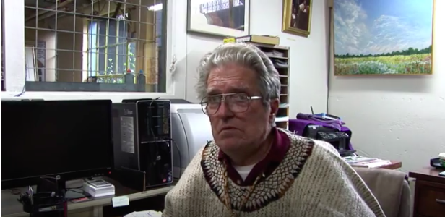
Used with permission from the Korean War Legacy Project

Supporting Question 1
Featured Source | Source A: Image bank, children of the Korean War, the Korean War Legacy Foundation, images accessible at individual links below

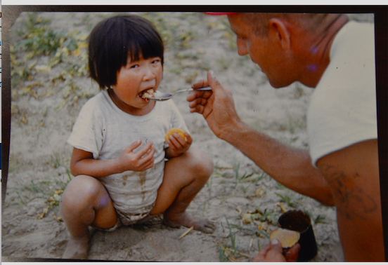
http://www.kwvdm.org/detail_artifact.php?no=5099

A picture of a child (“Boy-san”- Dennis Smith) carrying his younger brother (“Baby-san”-Dennis Smith) on his back.
http://www.kwvdm.org/detail_artifact.php?no=3937

Al Cooper holds a homeless Korean boy he and his company had unofficially adopted
http://www.kwvdm.org/detail_artifact.php?no=4058

Korean kids in fromt of wire entanglement, some laundry haning on wire entanglement
http://www.kwvdm.org/detail_artifact.php?no=87

Martin Rothenberg and Korean girl
http://www.kwvdm.org/detail_artifact.php?no=477

A Korean child
http://www.kwvdm.org/detail_artifact.php?no=1241

Korean children
http://www.kwvdm.org/detail_artifact.php?no=1248

Steven Montalbano feeding an orphan
http://www.kwvdm.org/detail_artifact.php?no=2237

Used with permission from the Korean War Legacy Project

Supporting Question 2
Featured Source | Source A: Charles Buckley (Korean War veteran), video clip from interview discussing the suffering of Korean children during the war and the ways Buckley and other soldiers tried to help them, Korean War Legacy Foundation, accessible at https://koreanwarlegacy.org/interviews/charles-buckley/

Source: Korean War Legacy Foundation

Used with permission from the Korean War Legacy Project

Supporting Question 2
Featured Source | Source B: Everett Kelley (Korean War veteran), video clip from interview discussing how Kelley and others helped Korean children during the war, Korean War Legacy Foundation, accessible at https://koreanwarlegacy.org/interviews/everett-kelley/#clip-life-impact

Source: Korean War Legacy Foundation

Used with permission from the Korean War Legacy Project

Supporting Question 2
Featured Source | Source C: Andrew Lanza (Korean War veteran), video clip from interview discussing the effects of war on Korean children during the war, Korean War Legacy Foundation, accessible at https://koreanwarlegacy.org/interviews/andrew-lanza/

Source: Korean War Legacy Foundation

Used with permission from the Korean War Legacy Project

Supporting Question 3
Featured Source | Source A: Video clip of Syrian children describing their experiences with war and conflict, BBC News, accessible at https://www.youtube.com/watch?v=2iz2tNiRpeY

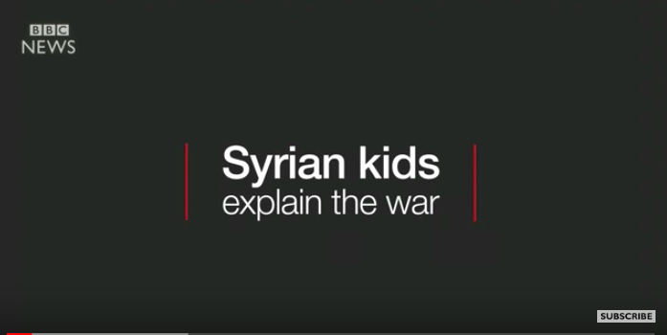

Source: BBC News

Supporting Question 3
Featured Source | Source B: Video clip on effects of war on children in South Sudan, Aljazeera News, accessible at https://www.aljazeera.com/news/2018/02/south-sudan-war-deprives-children-education-180202120925076.html

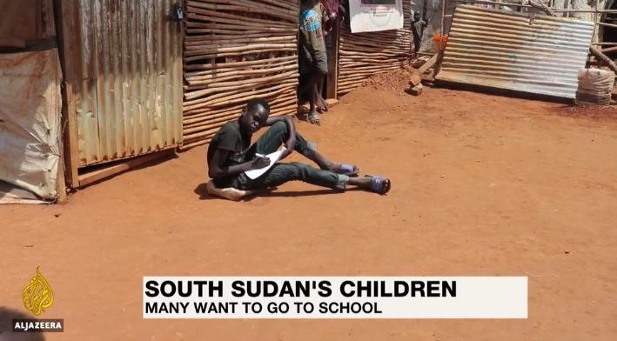

South Sudan has the world's highest proportion of young children not receiving an education. The civil war has seen thousands of people killed and millions displaced. It’s also had a major impact on education, with 1.8 million, or 70 percent of school-age children not getting any education. The United Nations says years of war makes it difficult for kids to get to school, even in areas not directly affected by fighting.
Source: Aljazeera News
Excerpted from: https://www.aljazeera.com/news/2018/02/south-sudan-war-deprives-children-education-180202120925076.html

Supporting Question 3
Featured Source | Source C: United Nations High Commissioner for Refugees (the UN Refugee Agency), “Forced Displacement above 68m in 2017, New Global Deal on Refugees Critical,” article on the effects of war and global displacement due to war and conflict, June 19, 2018, accessible at  http://www.unhcr.org/en-us/news/press/2018/6/5b27c2434/forced-displacement-above-68m-2017-new-global-deal-refugees-critical.html

Forced Displacement above 68m in 2017, New Global Deal on Refugees Critical
Wars, other violence and persecution drove worldwide forced displacement to a new high in 2017 for the fifth year in a row, led by the crisis in Democratic Republic of the Congo, South Sudan’s war, and the flight into Bangladesh from Myanmar of hundreds of thousands of Rohingya refugees. Overwhelmingly it is developing countries that are most affected.
In its annual Global Trends report, released today, UNHCR, the UN Refugee Agency said 68.5 million people were displaced as of the end of 2017. Among them were 16.2 million people who became displaced during 2017 itself, either for the first time or repeatedly – indicating a huge number of people on the move and equivalent to 44,500 people being displaced each day, or a person becoming displaced every two seconds.
Refugees who have fled their countries to escape conflict and persecution accounted for 25.4 million of the 68.5 million. This is 2.9 million more than in 2016, also the biggest increase UNHCR has seen in a single year. Asylum-seekers, who were still awaiting the outcome of their claims to refugee status as of 31 December 2017, meanwhile rose by around 300,000 to 3.1 million. People displaced inside their own country accounted for 40 million of the total, slightly fewer than the 40.3 million in 2016.
In short, the world had almost as many forcibly displaced people in 2017 as the population of Thailand. Across all countries, one in every 110 persons is someone displaced.
“We are at a watershed, where success in managing forced displacement globally requires a new and far more comprehensive approach so that countries and communities aren’t left dealing with this alone,” said UN High Commissioner for Refugees Filippo Grandi. “But there is reason for some hope. Fourteen countries are already pioneering a new blueprint for responding to refugee situations and in a matter of months a new Global Compact on Refugees will be ready for adoption by the United Nations General Assembly. Today, on the eve of World Refugee Day, my message to member states is please support this. No one becomes a refugee by choice; but the rest of us can have a choice about how we help.”
UNHCR’s Global Trends report is released worldwide each year ahead of World Refugee Day (20th June) and tracks forced displacement based on data gathered by UNHCR, governments, and other partners. It does not examine the global asylum environment, which UNHCR reports on separately and which continued in 2017 to see incidents of forced returns, politicization and scapegoating of refugees, refugees being jailed or denied possibility to work, and several countries objecting even to use of the word “refugee.”
Nonetheless, the Global Trends report offers several insights, including in some instances into perceived versus actual realities of forced displacement and how these can sometimes be at odds.
Among these is the notion that the world’s displaced are mainly in countries of the Global North. The data shows the opposite to be true – with fully 85 per cent of refugees in developing countries, many of which are desperately poor and receive little support to care for these populations. Four out of five refugees remain in countries next door to their own.

Large-scale displacement across borders is also less common than the 68 million global displacement figure suggests. Almost two thirds of those forced to flee are internally displaced people who have not left their own countries. Of the 25.4 million refugees, just over a fifth are Palestinians under the care of UNRWA. Of the remainder, for whom UNHCR is responsible, two thirds come from just five countries: Syria, Afghanistan, South Sudan, Myanmar and Somalia. An end to conflict in any one of these has potential to significantly influence the wider global displacement picture.
Two other insights from Global Trends are that most refugees live in urban areas (58 per cent) not in camps or rural areas; and that the global displaced population is young – 53 per cent are children, including many who are unaccompanied or separated from their families.
As with the number of countries producing large-scale displacement, the number of countries hosting large numbers was also comparatively few: Turkey remained the world’s leading refugee hosting country in terms of absolute numbers with a population of 3.5 million refugees, mainly Syrians. Lebanon meanwhile hosted the largest number of refugees relative to its national population. In all, 63 percent of all refugees under UNHCR’s responsibility were in just 10 countries.
Sadly, solutions for all this remained in short supply. Wars and conflict continued to be the major drivers with little visible progress towards peace. Around five million people were able to return to their homes in 2017 with the vast majority returning from internal displacement, but among these were people returning under duress or to fragile contexts. Due to a drop in the number of resettlement places on offer, the number of resettled refugees was down by over 40 per cent at around 100,000 people.

Used with permission from UNHCR, the UN Refugee Agency

NOTE: Additional UNHCR information about world refugees is accessible at http://www.unhcr.org/globaltrends2016/

