Beyond the Bridge of No Return:
Viewing Guide for Middle Level Social Studies

Image: Korean War veteran, Arden Rowley, and his great grandson, Cayden from the documentary,
Beyond the Bride of No Return

About the Viewing Guide

The following viewing guide is focused on having students respond to the question – “How have relationships impacted South Korea?” In order to answer the question, students will need to consider the important relationships taking place inside the county, on the peninsula, and internationally. The documentary follows the journey of a Korean War veteran, Arden Rowley, as he travels back to Korea for the first time since the war with Cayden, his great grandson. In highlighting the relationship between grandfather and great grandson, the documentary asks viewers to think about the different relationships that have impacted Korea including, cultural, economic, and international relationships. In building their understanding of these relationships, students will pull information from the documentary to develop a claim with evidence.

Image: Korean War veteran, Arden Rowley, and his great grandson, Cayden

Staging the Documentary

Before watching the film, the teacher may want to prepare students by having them think about how different relationships have impacted their lives. For example, the teacher could begin by prompting students with the question, “What people/relationships have had the biggest impact on your life?” Then, students could work in small groups with a think-pair-share exercise in which they present one person/relationship and describe how they impacted their life.
To set up this exercise, the teacher could show clips from the documentary in which Arden and Cayden describe their relationship. An example would be a clip lasting from 34:38-34:50 in which Arden shines light on the way the relationship with his great grandson will allow his story to continue.

After students have had time to reflect on their own relational experiences, they will begin to prepare for thinking about political, cultural, and economic relationships on a national level. To do this, the teacher may want to put students into small groups and brainstorm and discuss different relationships that have impacted the United States. For example, students may want to think about the United States international connection to France during the Revolutionary War, economic connection to Mexico and Canada through the North American Free Trade Agreement –NAFTA, and the cultural connection between different ethnic peoples within the United States.

Using this discussion on relationships, the teacher could introduce students to South Korea, highlighting the relationship that the United States has had over the last century. Teachers may even consider asking students what they already know about Korea.

The images below appear in the documentary and could be a way to anchor the discussion about South Korea.
Images: Busan, South Korea during the Korean War (Top); Busan, South Korea in 2017 (Bottom)
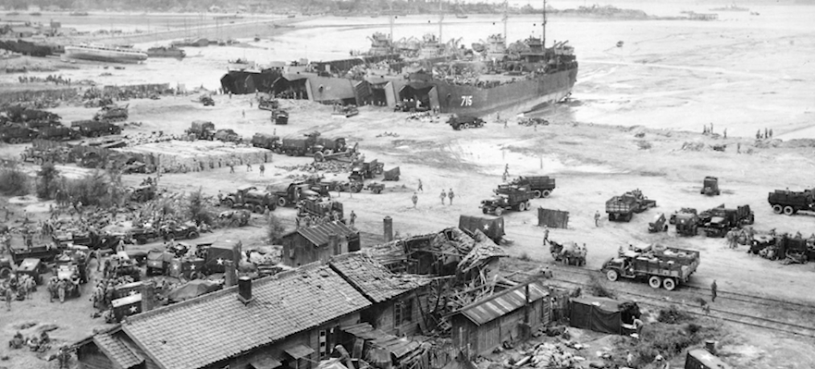

Viewing the Documentary

Once students have thought about different relationships on a personal and national level, the teacher may divide the class into viewing groups of 3-4 students. Using the graphic organizer in Appendix A, each student group will be asked to view the documentary from a relationship perspective and record information that pertains to that theme. For instance, the group who is looking for economic relationships would note clips that relate to the impact of economic relationships on South Korea. An example would be the clip lasting 23:05-23:55 in which the growing economy of Korea is discussed. Students would want to note that international trade allowed for the South Korean economy to grow. Other relationship themes that run through the documentary include international relationships, traditional versus modern relationships, and the relationship between North and South Korea. Depending on the amount of technology present in the classroom, the teacher may want to have each group watch the documentary independently in order to gather information, rather than as a class.

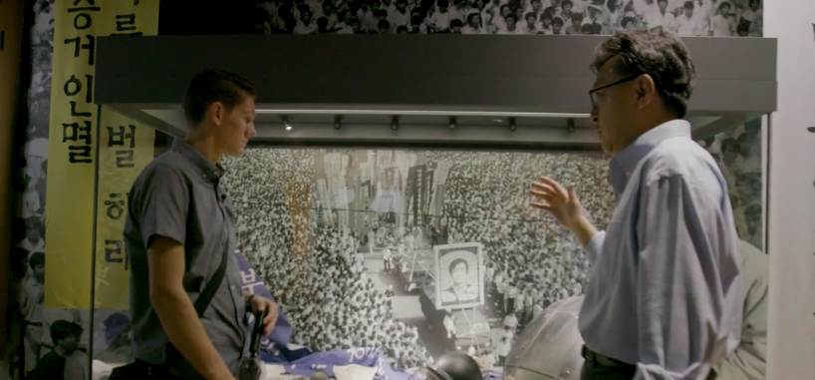
Image: Great grandson, Cayden, getting a lesson in Korean history from Dr. Jongwoo Han

Summative Performance Task – Post Viewing Task

Using data they have collected from the documentary, students work together to make a claim with evidence about how their theme relates to the question, “How have relationships impacted South Korea?” The teacher will then split students into home groups where each relationship theme will have a representative. In other words, each group will have a person who noted economic, North and South, traditional vs. modern, and international relationships related to South Korea.

Working deliberatively, these groups will make a claim that answers the question, “How have relationships impacted South Korea?” Teachers will want to have students refer back to the graphic organizer they filled out during the documentary as a way to focus their responses. In this post-viewing exercise, students are asked to develop a claim and counterclaim with evidence the examined during the inquiry. Students’ arguments likely will vary but could include any of the following:

- The international relationship between South Korea and the United States helped provide service in the form of aid and troops during the Korean War, and has continued to benefit South Koreans through providing military defense services.
- The economic relationship between the Korean businesses and foreign countries allowed for an increase in the size of the economy through the exporting of cars, electronics, and other goods.
- The fractured relationship between North and South Korea has impacted South Korea because the division has separated families for multiple generations, led to an increased military presence at the DMZ, and has led to a volatile climate in which the Korean peninsula is consistently moving between heightened security and easing of tensions.
- The relationship between traditional and modern ideas has created a landscape in which South Korea is both viewed as a country with modern cities that serve as hubs for commerce and art while at the same time honoring tradition and history through the preservation of architecture and statues commemorating important figures.

Students could extent these arguments by using evidence or questions generated during the documentary to research important relationships related to South Korea including the role of the United States, the relationship between government and Chaebols, and, the relationship between North and South Korea.

Appendix A: Graphic Organizer

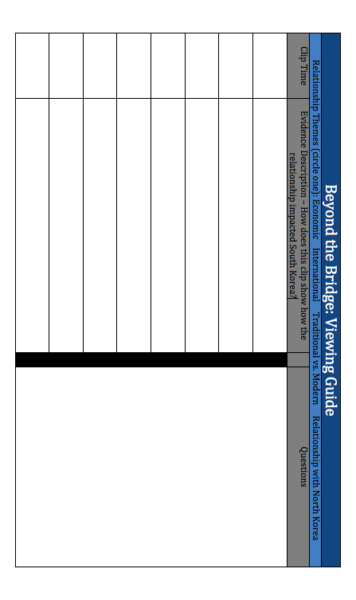

Appendix – B: Inquiry Blueprint

Korean War Legacy: Beyond the Bridge Viewing Guide
How have relationships impacted South Korea?
C3 Framework Standards for Social Studies | D2.Geo.5.9.12 Evaluate how political and economic decisions throughout time have influenced cultural and environmental characteristics of various places and regions.
Staging the Question | Reflect on relationships have impacted students lives, and then identify economic and international relationships that have impacted the United States.

Supporting Question
What does the film, Beyond the Bridge tell us about relationships that have impacted South Korea?

Formative Performance Task
Watch the documentary and fill out a graphic organizer focusing on different relationships highlighted in the documentary (e.g., economic, international, traditional versus modern, and North and South Korea.
Featured Sources
Source A: “Beyond the Bridge,” The Korean War Legacy Project, 2018

Summative Performance Task | ARGUMENT How have relationships impacted South Korea? Construct a claim supported with evidence that addresses the compelling question.

