11th Grade Korean War Inquiry
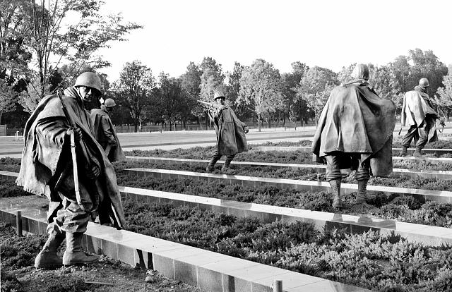
Why was the Korean War “Forgotten”?

Stainless-steel troopers "on patrol" on grounds created to resemble Korea's rice paddies

at the Korean War Veterans Memorial, Washington, D.C.

Photographs in the Carol M. Highsmith Archive, Library of Congress, Prints and Photographs Division.

Supporting Questions
    - How did the Korean conflict become a “war”?
    - What domestic concerns distracted Americans from the war?
    - Did the soldiers forget?
    - How has U.S. history forgotten the Korean War?

Middle/High School Korean War Inquiry
Why was the Korean War “Forgotten”?
C3 Framework Indicator(s) | D2.His.5.9-12. Analyze how historical contexts shaped and continued to shape people’s perspectives.
Staging the Question | In October 1951, U.S. News & World Report refers to Korea as the “Forgotten War.” Using the image bank of Korean War monuments and the original article, discuss the factors that impact an historical event’s legacy as memorable or not.

Supporting Question 1 |  | Supporting Question 2 |  | Supporting Question 3 |  | Supporting Question 4
How did the Korean conflict become a “war”? |  | What domestic concerns distracted Americans from the war? |  | Did the soldiers forget? |  | How has U.S. history forgotten the Korean War?
Formative Performance Task |  | Formative Performance Task |  | Formative Performance Task |  | Formative Performance Task
Create an annotated timeline of the major events that led to the Korean War. |  | Write a paragraph that describes the domestic concerns that distracted Americans from the Korean conflict. |  | Write a claim supported by evidence about why soldiers believe the war was “forgotten.” |  | Write an evidence-based claim or series of claims as to how the Korean War is or is not forgotten in U.S. history.
Featured Sources |  | Featured Sources |  | Featured Sources |  | Featured Sources
Source A: Korean War Legacy Timeline Materials  Source B: Excerpt from Selling the War, Steven Casey  Source C: “Milestones along the road to mobilization,” Pathfinder News Magazine, January 10, 1951  Source D: “U.S. Studying Mobilization on Home Front,” Chicago Tribune, July 14, 1950. |  | Sources from SQs 1  Source A: Excerpt from In the Shadow of the Greatest Generation, Melinda L. Pash  Source B: Excerpt from “Truman’s Other War,” Paul G. Pierpaoli |  | Sources from SQs 1 and 2  Source A: Oral History Interview, Kelley Everett  Source B: Oral History Interview, John Singhose  Source C: Oral History Interview, James Warren |  | Students’ U.S. History textbooks

Summative Performance Task | ARGUMENT Why was the Korean War “Forgotten”? Construct an argument (e.g., detailed outline, poster, essay) that discusses the compelling question using specific claims and relevant evidence from historical sources while acknowledging competing views.
 | EXTENSION Using claims from Supporting Question 4, propose a textbook revision reflecting research within the inquiry and soldiers’ perceptions of the war.
Taking Informed Action | UNDERSTAND Explore the Korean War Digital History Project’s (KWDH) Interview Initiative and identify local veteran groups or other community members that are Korean War veterans.  ASSESS Determine the ways in which students can contribute to the initiative  ACT Create an oral history project to contribute to the KWDH archives.

Overview

Inquiry Description
This inquiry leads students through an investigation of how the Korean War came to be known as the “forgotten war”. By investigating the compelling question, “Why was the Korean War ‘forgotten’?” students investigate how a major global event could be “forgotten” by the American public and, subsequently, in history. The inquiry has students consider the progression of the conflict to a war, actions of those in power during the Truman administration, the views of veterans and those on the home front, and Korea’s portrayal in U.S. history textbooks. This leads students to questions of how the Korean War was different from previous and later military engagements, in terms of: the battlefield, how it affected national culture, specifically, the extent to which it reflected an emerging Cold War mentality, of anti-communism and, eventually, containment. Teachers should also help students understand how the process of “forgetting” the Korean War reflects geopolitical events, as well as domestic concerns.
The formative performance tasks build on knowledge and skills through the course of the inquiry and helps students recognize different perspectives in order to better understand the ways in which the war impacted the home front. Students create an evidence-based argument about how the war was “forgotten,” considering the ways in which it impacted daily life, the concerns of the American population, at the time, and the experiences of returning veterans.
This inquiry highlights the following C3 Dimension 2 Indicator:
D2.His.5.9-12. Analyze how historical contexts shaped and continued to shape people’s perspectives.
It is important to note that this inquiry will require prerequisite knowledge of historical events and ideas. Thus, teachers will want their students to have already studied the total war mobilization that occurred during World War II, the ways in which World War II mobilized the public through conceptualizing it as a war of fascism versus freedom, as well as the Cold War tensions that emerged in the post-war period.
Note: This inquiry is expected to take four to seven 50-minute class periods. The inquiry time frame could expand if teachers think their students need additional instructional experiences (i.e., supporting questions, formative performance tasks, and featured sources). Teachers are encouraged to adapt the inquiries​ in order to meet the needs and interests of their particular students. Resources can also be modified as necessary to meet individualized education programs (IEPs) or Section 504 Plans for students with disabilities.

Structure of the Inquiry
In addressing the compelling question “Why was the Korean War ‘Forgotten’?” students work through a series of supporting questions, formative performance tasks, and featured sources in order to construct an argument supported by evidence while acknowledging competing perspectives.

Staging the Compelling Question
The compelling question could be staged by introducing students to the Korean War being labeled as a “forgotten war” by U.S. News & World Report in October 1951, as well as the image bank of Korean War monuments that use the word “forgotten.” Students can discuss the political, social, and/or cultural factors that impact the extent to which an historical event becomes more or less memorable, as well as considering the populations more likely to remember it. The discussion should include consideration of what historical events that have occurred in the students’ lives are memorable to them and what factors are causing them to be so. Additionally, students can discuss more current events and the extent to which they believe they will/will not be memorable. This staging could lead into a discussion of their current knowledge of the Korean War.
Supporting Question 1
The supporting question –“How did the Korean conflict become a ‘war’?”—asks students to consider the progression of the Korean conflict to a war, with some consideration as to how this compared to mobilization during World War II. This formative performance task asks students to create an annotated timeline of the major events that led to the Korean War. Teachers should consider how mobilization impacts public perception, including how it may foster public support for the war effort. Featured Source A is the Korean War Legacy’s Memory Bank timeline materials of the U.S.’s involvement. In Featured Source B, Selling the Korean War, Steven Casey describes the actions of the Truman administration to minimize public fears so as to prevent an all-out war culture as existed in WWII. Featured Sources C and D are newspapers from the time period, both providing students with information related to the relative mobilization of the home front for the Korean War in terms of soldiers, as well as changes to domestic life.
Supporting Question 2
For the second supporting question—“What domestic concerns distracted Americans from the war?”—students consider the most important domestic issues to Americans during the Korean War period. The formative performance task has students write a summary that describes domestic concerns that distracted Americans from the war. Building on supporting question 1, students should consider the extent to which mobilization for the war made Korea a societal focus or not, in consideration of these distractions. In the case of the Korean War, there was a lack of a clear conceptualization of the threat of a civil war in Korea to the United States. This contrasted WWII, which had a more clearly defined enemy (i.e., fascism, militarism). In addition to the resources from the previous supporting question, the two featured sources provide students with additional materials that allow them to consider why the Korean War was just another news story, rather than the most pressing national concern. Featured Source A is an excerpt from Melinda Pash’s In the Shadow of the Greatest Generation. Pash describes the disparity between the home front mentality of World War II and the Korean War realities, including the impact of the 1950s’ consumer culture. Featured Source B for this question is excerpts from “Truman's Other War: The Battle for the American Homefront, 1950-1953,” by Paul G. Pierpaoli. Pierpaoli presents the United States as being in a new, Cold War climate, where the Korean War played a part, but was not the centerpiece of life. He also argues that the Korean War became a part of the larger, permanent mobilization of the Cold War, thereby lessening its individual significance in the minds of many Americans. Additionally, teachers may supplement this question with sources related to other domestic issues (e.g. McCarthyism, consumer culture).

Supporting Question 3
The third supporting question—“Did the soldiers forget?”—asks students to consider the ways soldiers reflect on their wartime experiences. Students will write a claim supported by evidence about why soldiers believe the war was “forgotten.” In addition to the previous featured sources, the sources for this task will show the perspectives of three Korean War veterans. These are interview transcripts from the Korean War Digital History Project. Though three are included here, teachers are encouraged to have students explore other interviews to add to this supporting question.
Supporting Question 4
In the fourth supporting question—“How has U.S. history forgotten the Korean War?”—students will evaluate their US history textbooks to consider the extent to which they discuss Korea or whether it is eclipsed by coverage of other topics (e.g., World War II, the larger Cold War, the Vietnam War, topics from Supporting Question 2). The formative performance task asks students to write an evidence-based claim or series of claims as to how the Korean War is or is not forgotten in U.S. history. For this task, students should use their own U.S. history textbook, but teachers may wish to supplement this with other available texts to provide a more inclusive assessment.
Summative Performance Task
At this point in the inquiry, students have examined the ways in which the United States mobilized for the Korean War, the extent to which this impacted the home front, how veterans view the war, and U.S. history textbook depictions. Students should be expected to demonstrate the breadth of their understandings and their abilities to use evidence from multiple sources to support their claims. In this task, students construct an evidence-based argument using multiple sources to answer the compelling question “Why was the Korean War ‘Forgotten’?” It is important to note that students’ arguments could take a variety of forms, including a detailed outline, poster, or essay.
Students’ arguments will likely vary, but could include any of the following:
- The Korean War was “forgotten” because it started as a police action and slowly progressed to a conflict.
- The Korean War was “forgotten” because Americans were focused on other issues facing the country (e.g., consumerism, economy)
- The Korean War was “forgotten” because veterans came home to a different climate than after World War II, leaving many to remain relatively silent about their wartime experiences.
- The Korean War was “forgotten” because it is often eclipsed by World War II, the Vietnam War, the larger Cold War, and other domestic concerns in textbooks.
Students could extend these arguments by using their claims from Supporting Question 4 to propose a textbook revision. This should reflect their research within the inquiry and soldiers’ perceptions of the war.
Students have the opportunity to Take Informed Action by drawing on their understandings of the value in different mediums to preserve historical events, particularly oral histories. To understand, students can explore the Korean War Digital History (KWDH) Project’s Interview Initiative and identify local veteran groups or other community members that are Korean War veterans. To assess the issue, students determine the ways in which they can contribute to the initiative. To act, students contribute to the oral history project for the KWDH archives.

Staging the Compelling Question
Featured Source | Source A: “Korea: The ‘Forgotten’ War”, U.S. News & World Report, October 5, 1951, p.21 (Excerpt).

“Far off in Korea, 2,200 American men were killed or badly shot up last week in a war that seemed all but forgotten at home. War that was supposed to end in a deal with Communists instead is growing in intensity.
“Ground battles, for the area involved, are as intense as those of any war. Air battles, against fliers of unknown nationality, are approaching in size some of those of World War II. Casualties have increased from an annual rate of 50,000 to more than 100,000. That’s the equivalent of 1 boy in every 10 coming of military age now.
“At home, meanwhile, the big headlines concern a growing shortage of beef, graft scandals in the Government, strikes as usual, prospects of a new-car scarcity.
“Korea, half forgotten, is receding in the minds of many to the status of an experimental war, one being fought back and forth for the purpose of testing men, weapons, materials and methods, on a continuing basis.”

Staging the Compelling Question
Image Bank | Korean War Memorials

Fayetteville NC
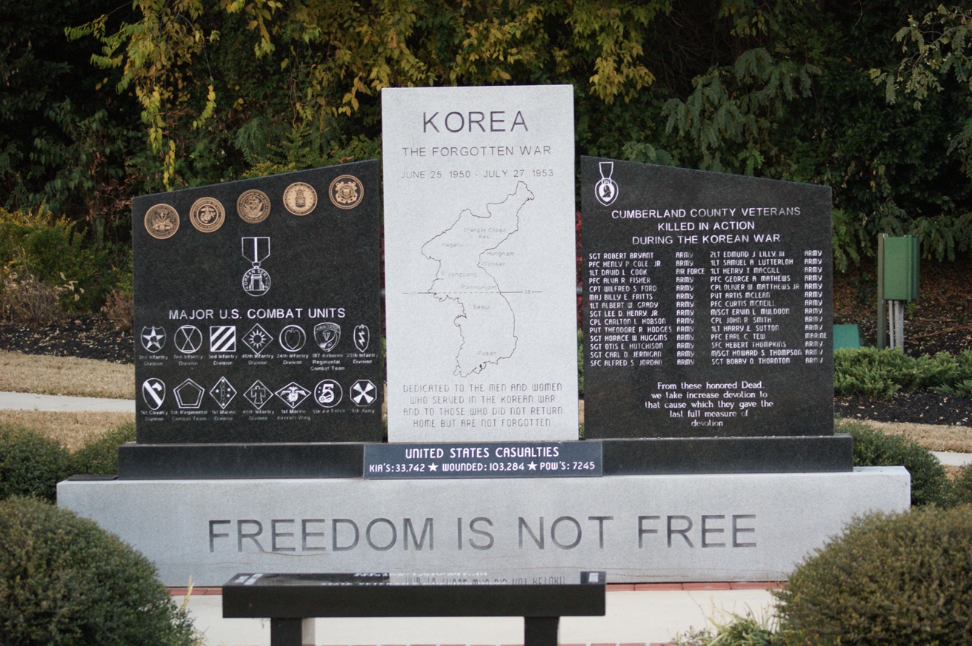
Image courtesy of: Cumberland County Korean War Memorial, Fayetteville. Courtesy of Daniel N. Jourdan
Accessed from: https://cdn.lib.unc.edu/commemorative-landscapes/media/monument/475_full.jpg.

Auburn, NY
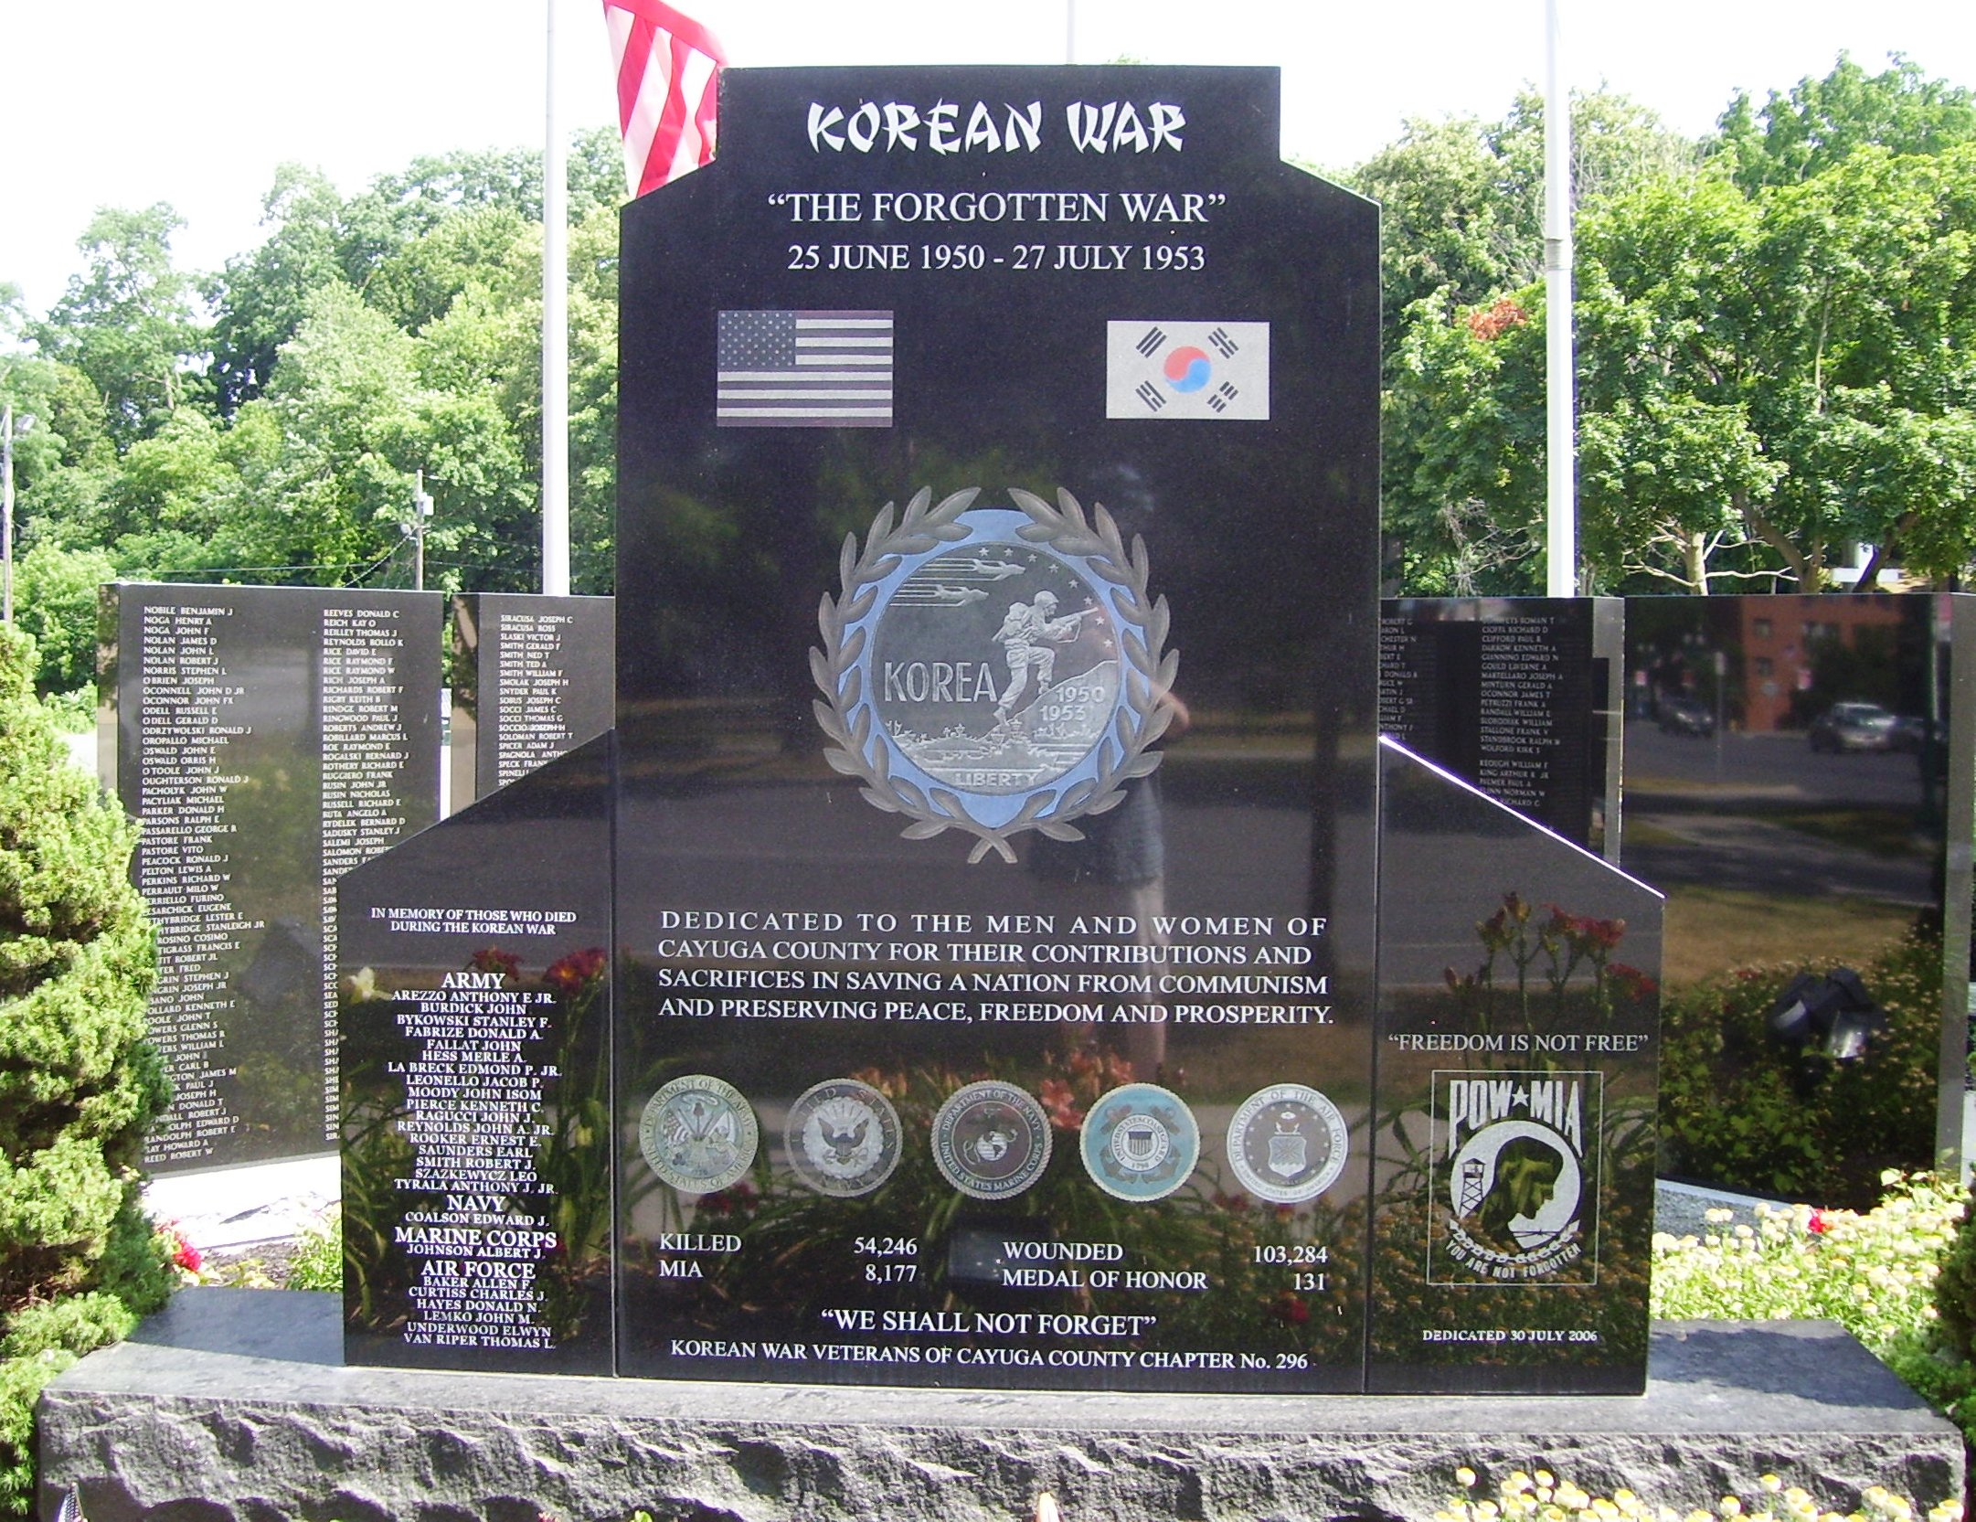
Image courtesy of: Wikimedia Commons, Beyond my Ken
Accessed from: https://commons.wikimedia.org/wiki/File:Korean_War_memorial_Auburn.jpg

Greenville, SC
Image courtesy of: Korean War Veterans Association Inc., Foothills Chapter of SC #301
Accessed from: http://www.koreanvets301.com/

Olympia, WA
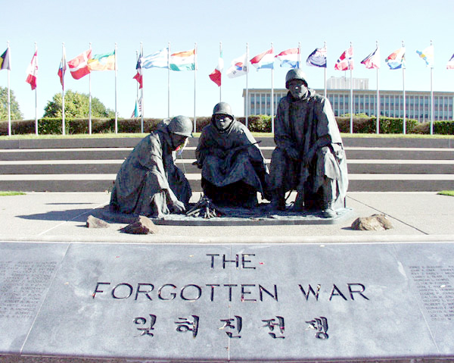
Image courtesy of Washington State Department Enterprise Services
Accessed from: http://www.des.wa.gov/sites/default/files/public/images/Facilities/MemorialsArtwork/KoreanWar02.jpg

Supporting Question 1
Featured Source | Source A: Korean War Legacy, “Memory Bank,” Timeline.
Accessed from: http://koreanwarlegacy.org/chapters/

Supporting Question 1
Featured Source | Source B: Steven Casey, book, Selling the Korean War: Propaganda, Politics, and Public Opinion in the United States, 1950-1953, 2008 (excerpt)

“Fearful that this new Cold War crisis might escalate into a far bigger conflict with the Soviet Union, the president and his senior advisers sought to keep the home front cool. They made few public statements. And what they did say was carefully restrained” (p. 19).
[Quoting Truman]: “ ‘Don't make it alarmist’ became something of a motif for his early information campaign. As one shrewd observer [from US News & World Report] noted at the time, ‘the real idea was to fix in the public eye a picture of the government in a calm mood …to keep Korea in its place: a pint-sized incident, not a full-scale war.…Official Washington was doing everything it could to keep a firm line against the communists, and keep the home front cool at the same time’” (p. 20).
“But all of a sudden, one question [at a press conference, June 29, 1950] brought a typically quick-fire response. ‘Mr. President, everybody is asking in this country, are we or are we not at war.’ ‘We are not at war,’ Truman emphatically declared, a statement he allowed reporters to quote directly. Anxious to get something more substantial, another journalist then prompted Truman with a trick that periodically worked at his press conferences: he put words into the president's mouth. Would it be correct “to call this a police action under the UN?’ he inquired. ‘Yes,’ Truman replied, ‘that is exactly what it amounts to’” (p. 28).
“As news of battlefield defeats hit home, the administration tried to channel the public debate on how America ought to mobilize in this new, more dangerous phase of the Cold War. The instinct of Truman and his senior advisers was to remain cautious: they were still keen to stop the domestic mood from overheating, lest this result in overpowering demands to escalate the Cold War, perhaps even by launching a preventive strike against the Soviet Union.
…
“Until now, domestic pressures had also seemed to stand in the way of a large defense buildup. Before Korea, Congress had clearly been in a stingy mood, and it had escaped no one's notice back in January when Truman's state of the union address had been noisily interrupted from both sides of the aisle as soon as he proposed that ‘federal expenditures be held to the lowest levels.’ Nor, more generally, did the mass of Americans seem willing to embrace the sacrifices necessary for a sustained mobilization. During the spring, even champions of NSC-68 had been pessimistic about the prospect of persuading a majority of the public to support their rearmament ideas, convinced that the popular mood was basically volatile, with many Americans all too willing to lapse periodically into a state of apathy and complacency. ‘I fear that the U.S. public would rapidly tire of such an effort,’ Edward Barrett of the State Department's PA had gloomily noted in April.
…
“The president's call [Fireside Chat, July 19, 1950] for limited economic controls was also far less radical than some officials seemed to want.
…
“[Truman] doubtless recalled the deep hostility toward wage and price regulation during World War II, when the Office of Price Administration had become ‘a target for all the frustrations and disappointments of people unaccustomed to regimentation and control,’ not to mention the 1946 midterm elections, when Republicans had successfully campaigned on a platform to swiftly terminate wartime controls. Unwilling to return to such an unpopular path in the current limited emergency, Truman concurred with his political and economic advisers, like Averell Harriman and Leon Keyserling, who ‘were profoundly convinced that the country and Congress were not yet ready for an all-out mobilization bill.’ Consequently, all that appeared in the administration's defense production measure were powers to allow the president to allocate resources and facilities for the buildup, to control consumer credit and commodity speculation, and to provide loans to small businesses to help them participate in the production of military hardware.
That the administration's mobilization plan was distinctly limited would naturally become a focal point for all the public explanations during the coming weeks. The president would not ask for sweeping powers ‘until he thinks they are essential and that Congress would grant them,’ Dr. John Steelman, assistant to the president, told one Time reporter in a background briefing. ‘That wouldn't be until we are in a real emergency and I wouldn't say that we are in such an emergency now.’ ‘We are not, at this time, calling for an all-out mobilization,’ Symington explained….
…
“Inside the White House, meanwhile, Truman remained anxious to avoid any action that might engender or exacerbate a ‘war psychosis’ among the American public.
…
“[Assistant Secretary of State for Public Affairs] Barrett stressed that: ‘the mobilization for which he [the president] is asking is for the purpose of replacing the wastage in Korea and generally improving the defense of the United States. It does not constitute full war mobilization. He therefore feels that in the passage cited it would be desirable not to relate the measures now being taken to the expectation of general war’” (p. 67-72).

Supporting Question 1
Featured Source | Source C: “Milestones along the road to mobilization,” Pathfinder News Magazine, January 10, 1951.

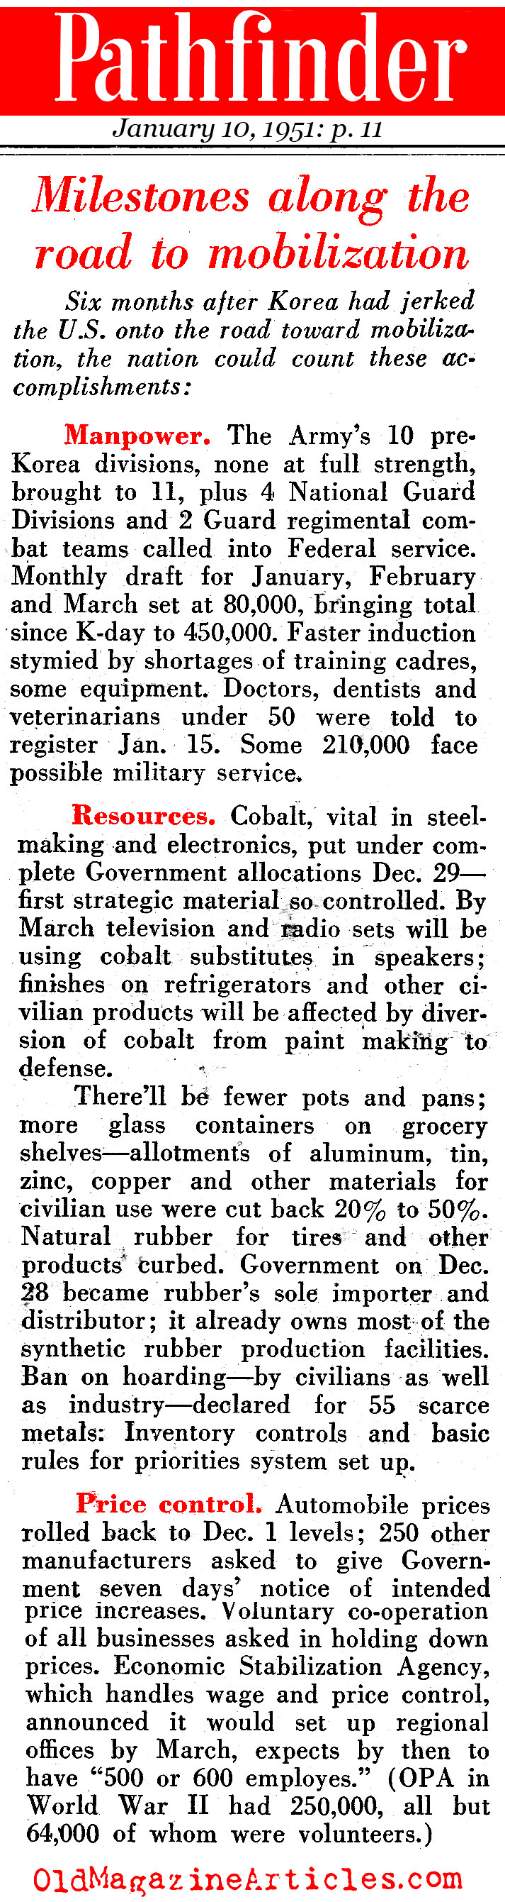
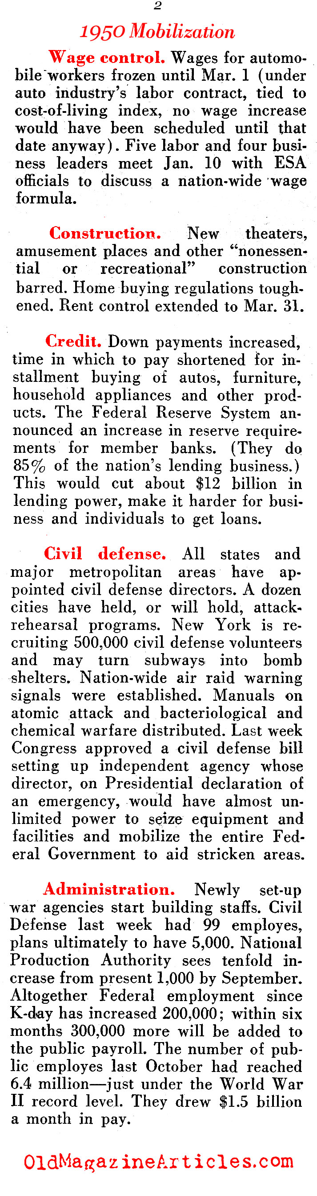

Accessed from: http://www.oldmagazinearticles.com/article-summary/korean-war-mobilization#.WC9NQuErI1g

Supporting Question 1
Featured Source | Source D: Laurence Burd, “U.S. Studying Mobilization on Home Front,” Chicago Tribune, July 14, 1950.

Washington, July 13 –
President Truman said today moves to mobilize the home front behind our Korean forces are under study, but no food rationing will be necessary. He termed foolish consumers rushing to buy food for fear of shortages.
At his weekly news conference the President told reporters he still is hopeful about the Korean campaign and that all steps needed for Victory will be taken.
Under study, he said, are bigger military spending, calling up armed reserves and the national guard, and man power mobilization.
Asked what assurance he might the public that "We are not getting the tar licked out of us." Mr. Truman replied that that never has happened to us, and it won t happen this time.

Decision Yet to Be Made
He added that the Korean Reds will be driven out of South Korea. Asked whether our forces will push beyond the 38th parallel, the boundary between North and South Korea, he said that decision will be made when we come to it.
Asked about specific action that might be taken in the way of industrial and man power controls, he said steps are under consideration and will be made if they are necessary.
The President then volunteered the statement there is no prospect of a food shortage, and that the public has nothing to worry about as far as food is concerned.
He explained that Agriculture Secretary Brannan reported to him today that large corn and wheat crops. are in prospect for this year and that we have re- serves of 1 billion bushels of corn and 700 million bushels of wheat. Also, he said, there are 3 million bales of cotton in storage.

Calls Hoarding Foolish
Asked about reports of consumers' stocking up heavily on foods in fear of shortages, Mr. Truman snapped this is foolish, there is no need for it, and he was sorry to hear it.
A reporter asked whether consumers could be assured there will be plenty of automobiles and other items. The President said he could not comment, because he was dis- cussing only things he knows something about.
The President said plans for more military funds to support the Korean war are being studied, but the figures are not complete. Asked specifically whether the re- ported military budget increase of 1 billion dollars given by Sen. Thomas [D., Okla.] is correct, the President said no sum has been fixed.
Asked whether he still considered the Korean a police action and not a war, as he said last week, the President repiled, yes.

Supporting Question 2
Featured Source | Source A: Melinda L. Pash, book, In the Shadow of the Greatest Generation: The Americans Who Fought the Korean War, 2012 (excerpt)

“Unlike their older brothers and cousins who served in World War II and returned to ticker-tape parades and welcoming bands, Korean War veterans returned quickly to a country that in their absence scarcely missed them. Though Americans initially rallied to the war drum when President Harry S. Truman called on the nation to defend South Korea from communist aggression, the lack of meaningful home front participation in the form of rationing or other personal sacrifice soon made Korea only a minor distraction for the American public. As soldiers still green to battle clung to the Pusan Perimeter, as marines fought their way out of Chosin Reservoir with frozen feet and staggering casualties, and as GIs tried to hold the line in a bloody stalemate half a world away, Americans at home went on with their business as usually, concentrating on making the most of the prosperous post-World War II economy. Fearing wartime shortages, they snapped up furniture and televisions, refrigerators and cars. In Fords and Lincolns and Chevrolets, the war drove right out of the minds of many Americans and into the middle and back pages of newspapers. Returning veterans could only wonder at the world that seemingly had forgotten them, surprised that ‘there was no evidence that the civilian population of the USA even knew (or cared) that those of us getting off the ship had seen desperate combat’” (p. 1).
[Quoting Robert Henderson, Korean War Veteran Survey, 9, Center for the Study of the Korean War]
“Perhaps understandably, average Americans found themselves too busy to pay attention to the conflict raging thousands of miles away in Korea or to the soldiers trickling home, but movie makers, novelists, and even historians proved no better at acknowledging the sacrifices made by those American servicemen and women. Throughout the war and in the years following, Hollywood produced a number of war movies, but most of them looked back to the “good war,” World War II, for inspiration
“Ten- and eleven-year-old kids when the Japanese bombed Pearl Harbor, [the Korean War generation] saw Americans join together to back the war effort, even if that meant making grave sacrifices. Sixteen million American men stepped into military uniforms ready to do their duty and lay down their lives in defense of the country and the values for which it stood. Those on the home front did their part, too. Whole towns turned out to say goodbye to their native sons being shipped off to war. Ordinary Americans, even young ones, grew Victory Gardens, saved scrap metal and paper, bought war stamps and war bonds, harvested milkweed pod for parachute making, and patriotically rallied behind their government.
…
“When asked to conserve [for World War II], Americans accepted severe rationing of gasoline, meat, butter, sugar, and flour, and they continued to support the war. For hundreds of thousands of kids, the message must have been clear; in a time of war American citizens rally together, sharing the sacrifices and keeping the trust with those whom they called to serve” (p. 10).
…
“As the [Korean] war dragged on, however, public interest and support waned.
…
“The buying frenzy that had characterized 1950, when people still worried that war would directly affect their ability to purchase sugar, shortening, or televisions, had drawn to a close, leaving Americans free to concentrate on things other than the war effort. Headlines concerning strikes, domestic events, and even UFOs, rather than war news, monopolized the front pages of most newspapers” (p. 29-30).
“Aside from a lack of political recognition, the troops in Korea had other reasons to feel like the home front had abandoned and forgotten them. Every day Americans laid down their lives in service to country on the Korean Peninsula, but back in the States people seemed completely disinterested in the war. Front-page headlines advertised ‘a growing shortage of beef, graft scandals in the Government, strikes as usual, [and] prospects of a new-car scarcity.’ The war just did not seem all that newsworthy after the early months and especially once it stalemated. As editorial cartoonist Bill Mauldin noted of the Korean War infantryman, ‘He fights a battle in which his best friends get killed and if an account of the action gets printed at all in his home town paper, it appears on page 17 under a Lux ad.’ And, more than not paying attention to the war, people on the home front actually compromised the ability of men and women to carry out their duties in Korea—at least from the perspective of those in the war zone. Of one strike a frustrated GI in theater wrote, ‘We felt it very definitely in the shortage of supplies and especially of equipment for several days. It woke me up to how closely connected all the fronts we battle on are. You begin to wonder if the old country realizes there’s a war going on over here.’ Similarly, returning from Korea, another serviceman asserted, ‘Strikes at home make the GI feel…that people are so preoccupied with their own self-interests that they seem to have forgotten that we are fighting a war. The shortages due to the shipping strike in New York last autumn could be felt in Korea within two weeks’” (125).

Supporting Question 2
Featured Source | Source B: Paul G. Pierpaoli, Jr. (2000). “Truman’s Other War: The Battle for the American Homefront, 1950-53,” OAH Magazine of History 14(3), pp. 15-19.

“When the Korean conflict ended in an armistice in July 1953, most Americans wanted nothing more than a return to normalcy. They wanted to like Ike and focus on the American Dream. So they bought television sets, went to college in record numbers, ogled Detroit’s bigfinned behemoths, moved en masse to suburbia, and gyrated themselves into the era of rock and roll. But they also forgot the sacrifice and slaughter that had taken place on the Korean Peninsula, and quickly pushed aside the scourge of McCarthyism, which the war had unleashed.
“To be sure, the Korean War was an unpopular war here at home. It was the first war that the United States did not win; thus, our nation’s collective amnesia is not at all surprising.
…
“Prior to 25 June 1950, President Harry S. Truman had no notion of fighting a major land war in Asia or, for that matter, engaging the nation in a vast and exorbitant Cold War rearmament program. In his January 1949 inaugural address, the president--always a rather staunch fiscal conservative had promised to balance the budget, decrease the national debt, keep inflation at bay, and implement his Fair Deal program, an ambitious social welfare plan that sought to address an array of problems from public housing and health care to civil rights. To accomplish this, Truman cast his lot with those who sought to keep national security and defense spending to a bare minimum. He also sought to provide America’s allies with protection from the perceived Russian threat by using the strength of the U.S. economy as a bulwark against Communism. Thus, initiatives such as the Marshall Plan, the International Monetary Fund, and the General Agreement on Tariffs and Trade (GATT) would emphasize economic—rather than military--containment of the Soviet Union.
“In other words, Truman’s hope was to focus on domestic issues by building upon New Deal-style reform, focusing on modest civil rights initiatives such as his 1948 order to desegregate the armed forces, and combating the growing perception of a Communist menace at home. However, beginning in 1949 a convergence of domestic and international events conspired against Truman’s best intentions. Even before the sudden outbreak of war in Korea, the president had begun to realize that more would have to be done to defend against Communist advances abroad. Nevertheless, it took the blunt force of Korea to push the Truman administration into action” (p. 15).
“Then, coming in rapid and relentless procession beginning in September 1949 was a series of events that shook the nation and the Truman administration. In September the Soviets surprised the world and obliterated the U.S. atomic monopoly by exploding their first A-bomb. Then came the October Communist victory in the Chinese Civil War, which was quickly followed by the permanent division of Germany.
“January 1950 brought more setbacks. First, the Soviet Union began a boycott of the United Nations to protest its nonrecognition of the new People’s Republic of China (PRC). Next came the February 1950 alliance of friendship and mutual assistance between the Soviet Union and China. At about the same time, Alger Hiss was convicted of perjury in the infamous Whittaker Chambers-Alger Hiss spy Case; Ethel and Julius Rosenberg awaited execution for espionage; and Senator Joseph R. McCarthy began his four-year-long anti-Communist witch hunt at a speaking engagement in Wheeling, West Virginia.
“Thus, by early spring 1950 two things had become clear. First, President Truman’s Fair Deal was on the ropes, for the deteriorating international and domestic political scenes were going to require a further de-emphasis of domestic imperatives. Second, Senator McCarthy’s groundless and vituperative accusations of internal communist subversion were about to poison the well of foreign policy bipartisanship and, in the process, make Truman’s job of governing ever more difficult.
“When North Korea unexpectedly lashed out and attacked South Korea on 25 June 1950, the Truman administration wasted little time in deciding to respond, with force, to the Communist aggression. Fearing a larger Communist conspiracy, which might have included a simultaneous attack against Western Europe, Japan, or other U.S. strongholds, and determined that there would be ‘no more Munichs,’ Truman committed American troops to the Korean struggle. He also began, quite fatefully perhaps, to rearm the nation along the lines prescribed in NSC-68. Thus, America’ s new military rearmament program would be targeted not so much at Korea, but at the long haul and massive build-up envisioned in NSC-68. What America was to witness during the three years of the win was actually a mobilization within a mobilization: rearmament for the immediate needs of the Korean War and, more critically, a long-term rearmament earmarked to contain Communism in every corner of the world. The United States was now on its way to constructing a permanent national security state and defense economy, if not an incipient "garrison state." With this construction, of course, came the destruction of Truman’s Fair Deal” (p. 16).

Supporting Question 3
Featured Source | Source A: John Singhose, Interview, excerpt

Interviewer: So tell me about it, when you left Korea, what did you think about the future of Korea? What did you—Did you have any idea how Korea would develop? Did you have any thought about it?
John: No, I had no idea what it was going to be like. It’s unbelievable really, I’ve seen a lot of pictures, I’ve talked to a lot of these folks that have been over there and visited, but I know one thing, that the Korean people were very industrious, good, honest, hard workers.
Interviewer: How did you know?
John: They worked with us. We had workers with us too
Interviewer: There were other workers than Kimbu Kan and Kim J Ku?
John: Oh gosh yes, we had like two dozen uh workers there, very dependable.
Interviewer: What were you thinking about you being there, I mean, you didn’t know where Korea was, not much right?
John: No
Interviewer: Annnddd when you left Korea you didn’t think about the future of Korea? You didn’t have any idea? Now, you’re back in your home and looking at all of those things happening in Korea, what do you think about whole things?
John: I think it’s a great thing they’ve done. They’re a great industrial power, and I’ve talked with a lot of folks from Korea since then and uh I’m really impressed with them. I’m impressed with the country. I’m impressed with the people.
Interviewer: Why do you think we were able to pull this out?
John: Well I know they had help from the United States and Great Britain and other countries there. We had people from Turkey there, Ethiopia, Canada. They Canadians were very helpful also working with the Koreans.
Interviewer: But despite such clear successful outcome out of the Korean War, right? Why do you think this war, the Korean War, has been regarded as forgotten, why?
John: Well, I actually see a lot of people seemed to have forgotten it but, a lot of us, we haven’t forgotten it.
Interviewer: Why?
John: Well, when I’m visiting with Ray, a lot of times we would discuss what we did over there.
Interviewer: What did you do there?
John: What did I do?
Interviewer: Yeah.
John: Well actually I was a construction Forman, but I ran a bulldozer for a good part of the time. I did demolition was too with the-
Interviewer: Yeah, I mean you told me all of this detail of your job that you did during the Korean War. Now looking back on all of those years, what do you think you did for Korea?
John: We, we trained a lot of their people for one thing. I had always hoped to make contact with this Kim J Ku and uh I had his address there and I one of the fellows from the Korean Embassy was going to see if he could look him up, but I never heard anything back.
Interviewer: What was the most difficult thing? Something you really hated while you were in Korea, what was it?
John: The extreme weather probably, but we had clothing and whatever. We were good. The weather was probably the worst, but worked with other units, marine core and the Turkish people. I didn’t work with the Ethiopians, but Ray did. I thought it was kind of good, I worked with Canadians too. It was good to work with those other people, good learning experience.
Interviewer: What do you want to say to Korean people now? Is there any message that you want to convey?
John: uh, I would like to congratulate them on the great job they did on rebuilding the country, the road networks they put in. The roads we put in were more or less just trails, ya know? But uh, I think that they have done a great job there. I would be the first to tell them that. I told a lot of the folks from the Korean Embassy that we met with from time to time.
Interviewer: So you don’t regret your service there?
John: Oh no, not at all. I learned a lot.

Supporting Question 3
Featured Source | Source B: James Warren, interview, excerpt
Interviewer: Did you, what were some of the most difficult, dangerous, rewarding and happiest memories that you recall on your stay?
James: Meeting my wife probably the best uh you know meeting a lot of good people, meeting my best friend. Being able to experience I had been to Japan with the military and I was in Korea and I found Korea to be better than Japan in the people sense. You know they seemed to be more friendly. The Korean people seemed to be more friendly and stuff than the Japanese people. You can talk to them more and the Japanese were like stuck up compared to the Korean people stuff like that. Easy to talk to them, easy to get along with and always helpful and friendly and I enjoyed that. One of the things I did as a photographer we had a change of command ceremony, the commander of the second infantry division at the time was General Jeffrey Smith and he was getting ready to be reassigned back to the states and they had assigned a new general coming from the states to take over the second infantry division so what they wanted me to do as a photographer was to go to every uh camp in the second infantry division and photograph something significant to that camp. For example if I went to this camp over here and it was primarily composed of infantry people then I would take some things that would symbolize infantry. If I went to another camp filled with artillery soldiers then I would take pictures that pertained to field artillery. And I did that to all the second infantry divisions and going up to the DMV and photographing things and the purpose of that was to brief the new general once he arrived in Korea by debriefing by showing him different places that were going to be under his command.
Interviewer: What was the impact of you being stationed in Korea and did it impact your life at all after you returned home? Besides the fact that you met your wife?
James: That was probably the biggest impact of all.
Interviewer: Is there anything that you learned or that you took with you from Korea or being surrounded by the Korean people maybe?
James: I’m sure I probably was impacted in more ways than I can think of at the time and stuff like that but what I really appreciate about the Korean people even today is their closeness and their values like all Koreans are friends to each other, that I have experienced and we need to have more of that in all people. Especially in my race of people we need to be more of that family, friend feel like in relationships and stuff. So I learned that from meeting people and working with Korean people while I was stationed in Korea.
Interviewer: Have you been back to Korea?
James: I was stationed there twice and have not been back. My wife went back many times but I did not go with her or anything like that and she communicated with family by telephone. I met some of the family while I was stationed there but I haven’t been back. That was probably one of the things that we were gonna look at doing if she got better health wise.
Interviewer: So this is just kinda a question I have, In 2013 we witnessed the 60th anniversary of the armistice which was signed by China, North Korea and the UN on July 7, 1953. There is no war in modern history that has lasted 60 years after an official cease fire. What do you think we have to do to put a closure on it?
James: You know, I don’t know. To close it you have to put the country back together and not have a North and South just Korea. I don’t know how you could achieve that. North Korea is not going to say here you go and stuff and they are not going to negotiate so I don’t know. I don’t know what you could do. I wish I could answer that question.
Interviewer: Would you support a kind of movement to petition the end of war officially? Or maybe replace the armistice with a peace treaty?
James: That is a hard one. Uh because if you have North and South agreeing to things…you do your thing and I do my thing that probably would work out but you cannot trust North Korea. My understanding is the North wants to be unified so if South Korea was satisfied and said just give me a peace treaty we will let them live their life and we will live our life the North would not go forward with that. They would all be instigating doing things. So I would say so let the armistice continue until such time the country can be unified and in the end you will have peace.
Interviewer: Do you think it is important for younger generations to understand what the Korean war was and that it is still going on today unofficially?
James: yes, one of the things um this is my understanding of the Korean War Veterans association. The Korean War is called the Forgotten War. It is the mission of the Korean war veterans association to not let the people forget that. Many people died and sacrificed so you just can’t forget that. The Korean soldiers are dying out now so when there gone the memory of what they did will be gone. So what they have done is incorporate people like me who served in Korea but who didn’t serve in the Korean War so we can keep their story alive so that it won’t be forgotten. They do things to try to keep in the public eye so that it is not a forgotten war and should never by a forgotten war. They do things like a program called Tell America…where they go into schools and they tell about the Korean War and the things they did in the Korean War to the schools. The have received a lot of great response from that. So they must, its historical that all history must be repeated so people won’t forget and repeat.
Interviewer: Why do you think the Korean War in your opinion is known as the Forgotten War?
James: I really don’t know, I think people, First of all we came out of WWII and people were tired and war weary and not too long after that we entered the Korean War and because it wasn’t so much a win situation but the way it did North and South it’s easy to be placed under WWI and WWII. The main thing is why its forgotten is they never really called it a war. It was kinda like a police action. We do police action and stuff and so if you view the phrase over time and say it’s a police action and its actually not a war then people gonna remember war but not a police action. And people forget that when they talk about war sometime so that’s why I think its forgotten. But by being in the association I know those guys who in the air doing things, on the ship doing things and the ground doing things and I heard their stories. I mean it’s a story worth retelling.
Interviewer: Um earlier you mentioned something about the legacy of Korean War veterans during the Korean War. What do you think that legacy is?
James: Uh that the people who fought and died and the people who sacrificed would not be forgotten. I think that’s the legacy.
Interviewer: And uh do you think the Korean War veteran’s digital memorial that we are doing here interviewing veterans is important? I mean
James: Yes, it is very important because it serves to remind us of the war that we don’t want to be forgotten. It is a tribute to those who made the ultimate sacrifice. And to those who fought and lived it’s a tribute to those who supported that. It is not always the guy on the ground or the guy flying in the air its all the support that the guys who are doing it. It is a tribute to all of those who had anything to do with the Korean War. Let me just say this about the Korean people they are truly thankful for what the Korean War veterans did to make their country a free country and the way it is. They express it all the time. They express it here in church because they honor those veterans here every year. We have been to activities in Dallas where they reiterated how much they appreciate what the Korean War veterans have done for their country what it is today and stuff. When you hear those people say that you know they are saying it from the heart.
Interviewer: Is there anything else that you would like to share, maybe memories or messages or something to do with your occupation that you would like to have preserved?
James: uh the most important when I re-enlist in the military I was a young man and had no idea what he wanted to do with himself. I was contemplating on whether or not I should go to college or should I just get me a regular job. I had no way and my friends suggested the military so I enlisted in the military just to find myself. After being in the military that might be what you want to do or get an education but it instills patriotism in you. The fact that you want to serve your country and the result of the willingness that you may end up in a war or you may end up dead. I would like to think I am a true patriot because of the time I spent in the military. You don’t have to be in the military to be a patriot but it made his patriotism greater. All the other veterans should be thanking us.

Supporting Question 3
Featured Source | Source C: Kelley Everett, interview, excerpt

Interviewer: So you had no prior knowledge really of what had happened between ‘50 to ‘53-
Kelley: I knew that there was a war, but go ahead.
Interviewer: Yeah, so when did you or how did you hear about it, learn about it more anyways?
Kelley: What, the Korean War?
Interviewer: Mhm.
Kelley: Mainly through history, TV, things of that nature.
Interviewer: So did they teach you about it in school at all whenever you were growing up and before your enlistment? Were they teaching it in schools yet?
Well they weren’t teaching it, they were more teaching World War I and World War II back then. The Korean War was a recent event, it happened in the 50s so and I was in school, I think I was in like the first grade in the 50s.
Interviewer: Do you have any messages for younger generations or do you feel it’s important for younger generations anyways to know the sacrifices and contributions made in Korea?
Kelley: I think that there were sacrifices of many soldiers that are traumatized and still suffering today from that war and all the other wars before.
Interviewer: Do you think that it’s important and necessary for us to preserve the interviews of these veterans and their legacy?
Kelley: Very important, yes I do.
Interviewer: And why do you think, in your opinion, the Korean War is known as the forgotten war?
Kelley: Well, it was after the big one: World War II, and a lot of soldiers that came out of Korea never got the benefits or the just treatment that they should’ve gotten from being ,what they called at that time, battle shocked or battle fatigued. I think the military environment is a great environment, great experience and I would think that every American should, how should I say, experience it. But it is a traumatic experience when you have to go places and experience different cultures.
Interviewer: Is there anything else, any other stories or memories, messages that you had during your stay or anything else you would like to share to preserve your legacy?
Kelley: I think Korea is a great place. I don’t regret one moment of my time in Korea. I gained a lot of insight that I would never have received had I not experienced that.

